
COUNCIL ASSESSMENT REPORT
SOUTHERN REGIONAL PLANNING PANEL

PANEL REFERENCE & DA NUMBER | PPSSTH-302 & DA.2023.0420
PROPOSAL | Alterations and additions to Jerrabomberra High School comprising the construction of a new school building (Block E), an extension to the existing car park (34 additional car spaces and 114 bicycle spaces), a large outdoor play space, internal alterations to existing Block B and associated infrastructure and landscape works
ADDRESS | Lot 2 DP 1277158 No 101 Environa Drive Jerrabomberra
APPLICANT | School Infrastructure NSW (NSW Department of Education) (c/o Mecone)
OWNER | NSW Department of Education
DA LODGEMENT DATE | 15 September 2023
APPLICATION TYPE | Crown Development Application & Integrated Development
REGIONALLY SIGNIFICANT CRITERIA | Section 2.19(1) and Clause 4 of Schedule 6 of State Environmental Planning Policy (Planning Systems) 2021 declares the proposal regionally significant development - Crown DA over $5 million and Clause 5(b) educational establishment with a CIV of more than $5 million.
CIV | $40,206,843.00 (excluding GST)
CLAUSE 4.6 REQUESTS | Clause 4.3(2) of Queanbeyan-Palerang Regional Local Environmental Plan 2022 – height of buildings
KEY SEPP/LEP | - State Environmental Planning Policy (Planning Systems) 2021 (Planning Systems SEPP)  - State Environmental Planning Policy (Biodiversity & Conservation) 2021  - State Environmental Planning Policy (Resilience & Hazards) 2021  - State Environmental Planning Policy (Transport & Infrastructure) 2021  - Queanbeyan-Palerang Regional Local Environmental Plan 2022 (QPRLEP 2022)  - South Jerrabomberra Development Control Plan
TOTAL & UNIQUE SUBMISSIONS KEY ISSUES IN SUBMISSIONS | There were no submissions received.
DOCUMENTS SUBMITTED FOR CONSIDERATION | Statement of Environmental Effects & Clause 4.6  Architectural Design Plans  Civil engineering plans  Landscape plans  Traffic Impact Assessment
SPECIAL INFRASTRUCTURE CONTRIBUTIONS (S7.24) | Nil
RECOMMENDATION | Approval
DRAFT CONDITIONS TO APPLICANT | Applicant agrees to the draft conditions (Crown DA)
SCHEDULED MEETING DATE | Electronic Determination
PLAN VERSION | Revision D (26 July 2023)
PREPARED BY | Kim Johnston (Consultant Planner – Council)
DATE OF REPORT | 15 April 2024

EXECUTIVE SUMMARY

The development application (DA.2023.0420) seeks consent for alterations and additions to the existing Jerrabomberra High School including a new building (Building E), additional student and staff numbers and additional car and bicycle parking (34 additional spaces). Alterations to an existing building on the site (Building B) as well as associated earthworks, landscaping and servicing are also proposed. The applicant is School Infrastructure NSW (SI NSW) making the application a Crown DA.

The site is approximately 10km southeast of Canberra and 1 kilometre from the NSW/ACT Border, within the South Jerrabomberra urban release area to the south west of Queanbeyan. The site is located on the eastern side of Environa Drive and is irregularly shaped with two road frontages, Lexcen Avenue forming the northern boundary and Environa Drive forming the western boundary. The site has a total area of approximately 4.5 hectares and is within an area of mixed land uses including residential development, public open space, schools and future commerical uses. The site is subject to the South Jerrabomberra DCP, which includes a structure plan which notes the site as being for a proposed high school.

Development consent for the construction and operation of a new high school on the site with a capacity of 500 students, was issued by the Department of Planning and Environment as a State Significant Development application (SSD 24461956) on 13 July 2022 which is now operational at the site. The current proposal comprises Stage 2 of this school and is to provide the additional facilities required to increase the school’s capacity from 520 students (Stream 3) to 1000 students (Stream 5).

The application is referred to the Southern Regional Planning Panel as the development is ‘regionally significant development’, pursuant to Clause 4 of Schedule 6 of the Planning Systems SEPP as Crown development with a capital investment value of more than $5 million and Clause (5)(b) as an educational establishment with a CIV of more than $5 million. The application is also a Crown DA pursuant to Sections 4.32(2)(a) and 4.33 of the Environmental Planning and Assessment Act 1979 (EP&A Act) as it is a development application made by or on behalf of the Crown (SINSW). The application is also integrated development pursuant to S4.46 of the EP&A Act as a Bushfire Safety Authority is required, which has been issued.

The site is located within the RE2 Private Recreation zone and B7 Business Park zone pursuant to Clause 2.2 of the QPRLEP 2022, with the portion of the site for the proposal within the RE2 zone. The proposal is permissible with consent pursuant to Clause 2.5 of the QPRLEP 2022 as an additional permitted use and Section 3.36(3) of the Transport & Infrastructure SEPP as it is to be carried out on land within the boundaries of an approved school. The site is affected by the probable maximum flood and is bushfire prone land.

The existing development comprises two (2) storey school buildings, sports facilities, vehicle and pedestrian areas and parking within the northern portion of the site. The proposed extension (Stage 2) is proposed in the southern portion of the site. The application was placed on public exhibition and there were no submissions received.

A Panel briefing was held in October 2023 where several key issues were discussed including statutory triggers for regionally significant development and consistency with the SSD approval, building height and the Clause 4.6 request, site zoning and context, operational arrangements and the overall design scheme. These matters are considered in this report and have been adequately addressed.

The key issues identified included building height, built form and urban design, traffic and car parking, acoustic issues, earthworks, waste management and safety and security matters, which have been considered in detail in this report and found to be satisfactory subject to the recommended conditions of consent. The Clause 4.6 for maximum building height is supported as outlined in the LEP assessment in this report.

The recommended consent conditions are consistent with the SSD approval, subject to draft condition 13 which requires modification to the SSD approval pursuant to Section 4.17(1)(b) and (5) of the EP&A Act and Section 67 of the Environmental Planning and Assessment Regulation 2021 (Regulations). This condition is required as the ground floor of the existing Building B is currently approved as food technology classrooms which are now proposed to be science labs in the current development application. The applicant accepts the draft conditions, including Condition 13, which are included at Attachment A.

Assessment under Section 4.15(1) of the EP&A Act concluded that the proposal is generally consistent with the relevant planning controls and the site is considered suitable for the development. There are unlikely to be any significant adverse impacts arising from the proposal subject to the recommended draft conditions and the proposal is considered to be in the public interest given enhanced educational opportunities are provided.

Following a thorough consideration of the application, it is considered that the proposal has adequately addressed potential impacts and relevant recommended consent conditions are provided for the Panel’s consideration. The proposal is consistent with the planning controls and the jurisdictional preconditions to the grant of consent have been satisfied.

Accordingly, the development application is recommended for approval subject to the conditions, which are supported by the applicant as a Crown DA provided at Attachment A of this report.

•
Contents

1. BACKGROUND 5
1.1 Site History 5
1.2 Consent History 7
1.3 Justification for the development and Progress of Stage 1 9
2. THE SITE AND LOCALITY 9
2.1 The Site 9
2.2 The Locality 14
3. THE PROPOSAL 16
3.1 The Proposal 16
3.2 Progress of the Development Application 24
4. STATUTORY CONSIDERATIONS 25
4.1 Environmental Planning Instruments, proposed instrument, development control plan, planning agreement and the regulations 31
4.2 Section 4.15(1)(b) - Likely Impacts of Development 69
4.3 Section 4.15(1)(c) - Suitability of the site 71
4.4 Section 4.15(1)(d) - Public Submissions 71
4.5 Section 4.15(1)(e) - Public interest 71
5. REFERRALS AND SUBMISSIONS 72
5.1 Agency Referrals and Concurrence 72
5.2 Council Officer Referrals 74
5.3 Community Consultation 74
6. KEY ISSUES 74
6.1 Built Form and Urban Design 74
6.2 Traffic & Parking 75
6.3 Acoustic 80
6.4 Earthworks 80
6.5 Waste Management 83
6.6 Safety, Security and Crime Prevention 85
7. CONCLUSION 87
8. RECOMMENDATION 87

BACKGROUND

Site History

The site is located within the South Jerrabomberra urban release area, which is located south west of Queanbeyan between the existing suburb of Jerrabomberra and the Australian Capital Territory (ACT) border. The area is located in close proximity to existing industrial lands in the ACT (Hume industrial area) and under flight paths of Canberra Airport. The development of the area is to cater for the expected population growth given its strategic location adjacent to Canberra and the significant population growth in Queanbeyan.

The South Jerrabomberra urban release area is expected to have 1,500 new dwellings, a local centre, green spaces (including conservation areas), a new high school, a Regional Sports Complex and an Innovation sub precinct. The Master Plan outlines the general location of land uses, having regard to aircraft and industrial noise, bushfire, biodiversity and topography (Figure 1).

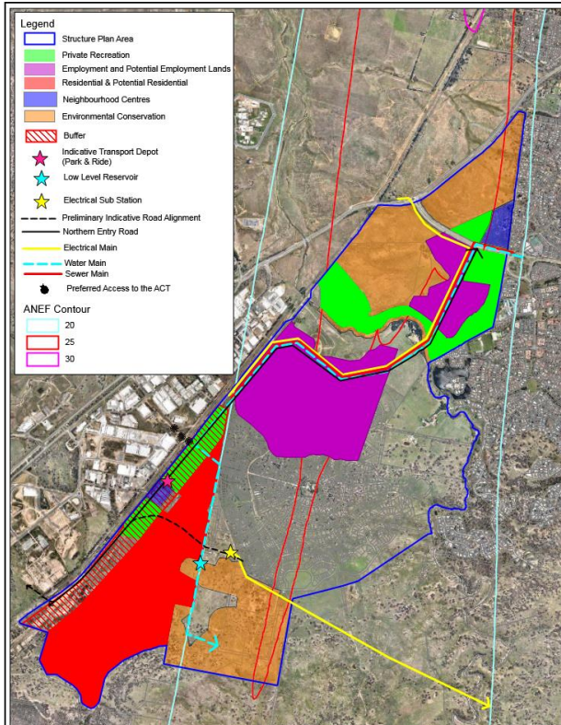
The site
Figure 1: South Jerrabomberra Master Plan (Source: Map 1, SJDCP)

The Department of Regional NSW has prepared a draft master plan for the South Jerrabomberra Regional Job Precinct created under the NSW Government’s Regional Job Precincts program, an extension of the Special Activation Precinct program. The Draft master plan sets out the strategic merit of South Jerrabomberra as an employment precinct and summarises the key development opportunities. The draft master plan is focused on driving long-term economic prosperity through the generation of up to 4,000 jobs in a variety of industries including advanced manufacturing, defence, aerospace, cyber security, and light industrial, as well as jobs and services that support these industries and their workers. The precinct can contribute to and leverage from the existing and growing clusters of defence, space and cyber security industries given the proximity to Canberra.

The site is within the Education sub-precinct (Figure 2), which adjoins the Poplars Innovation Sub Precinct, a joint venture between the NSW State Government, Council and Poplars Developments. This area includes a 35 hectare Innovation Precinct (business park), 10 hectares of retail and services precinct, over 100 hectares of conservation area (grasslands reserve) and a Learning Precinct.

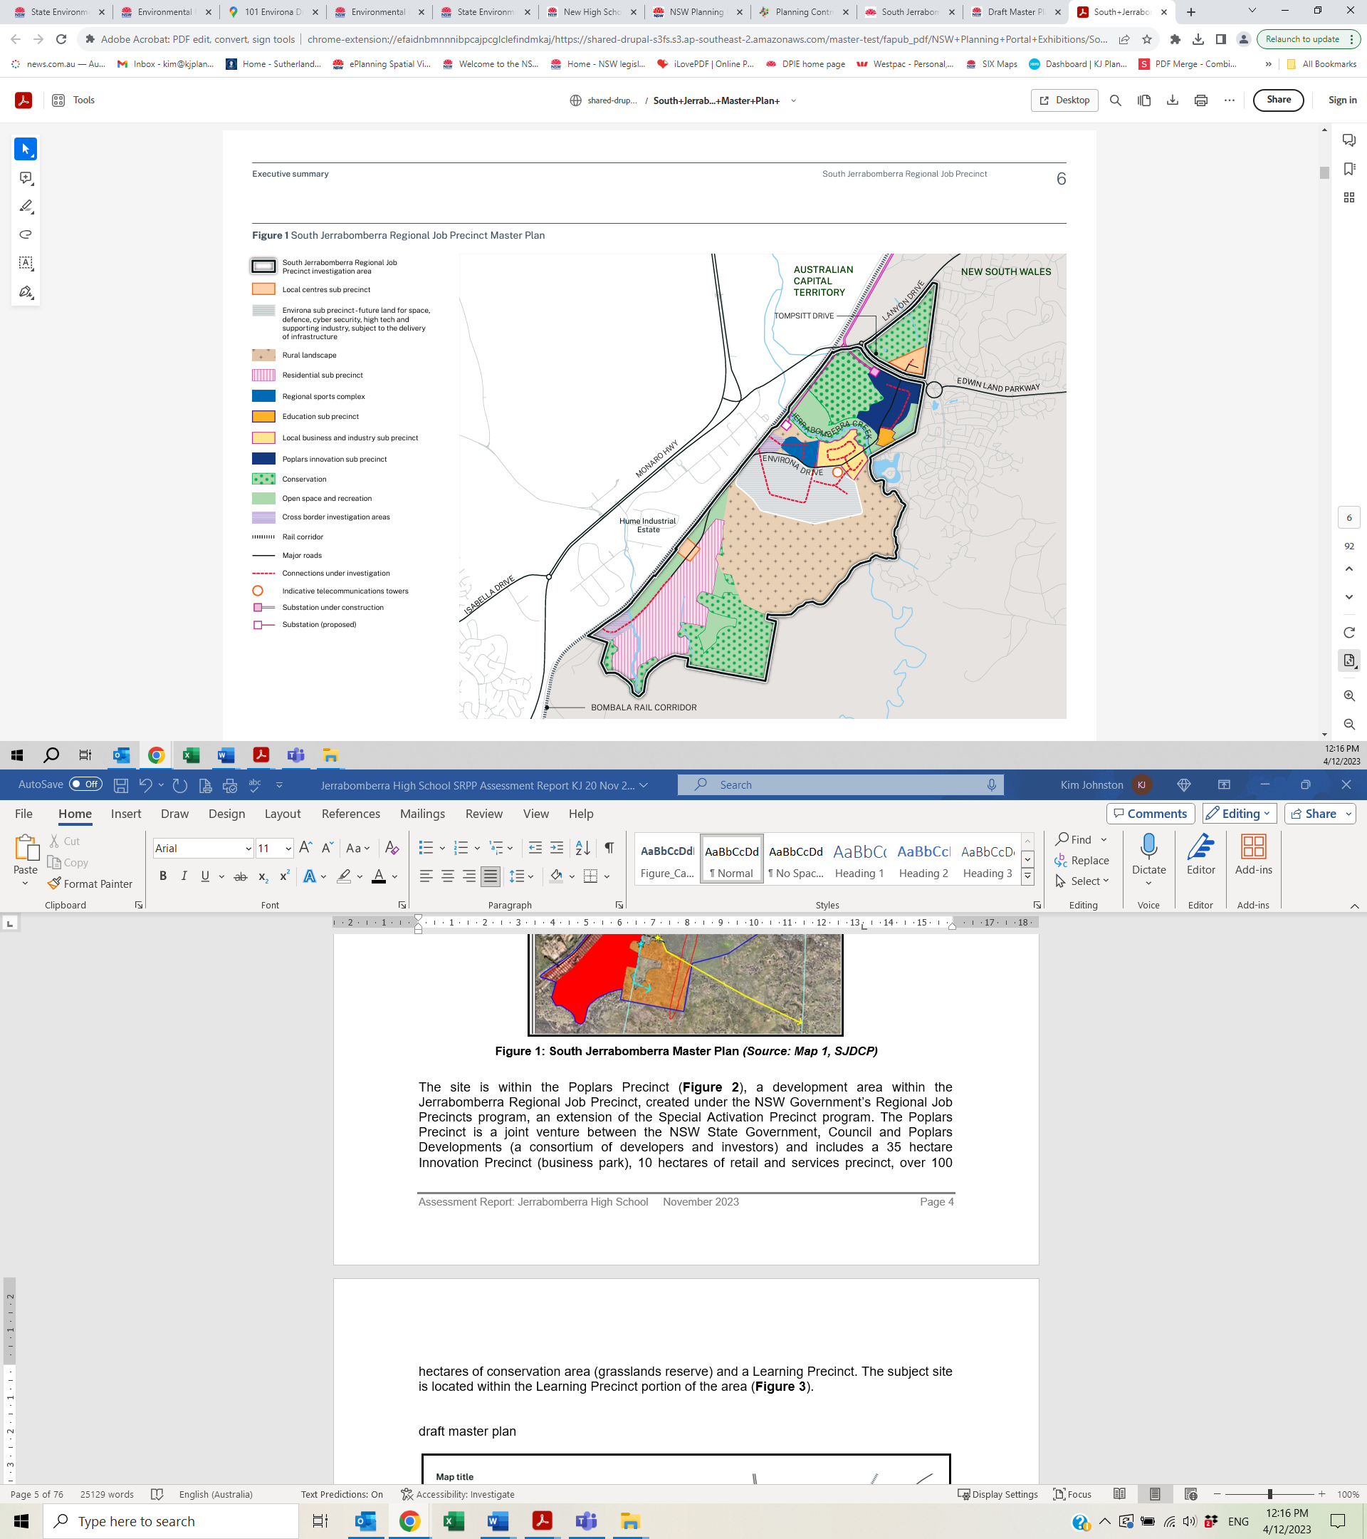
The site – education sub precinct
Figure 2: South Jerrabomberra Regional Job Precinct (Source: Draft Master Plan, Department of Regional NSW, September 2023)

The draft master plan describes the education sub precinct as:

A comprehensive high school offering science, technology, engineering, and mathematics subjects opened in 2023 commencing with Year 7 and 8 in temporary buildings at Jerrabomberra Public School.

The permanent school buildings within the Education sub precinct catering for 500 students are currently under construction and expected to be completed at the end of 2023. The school’s future expansion will double its permanent capacity to 1000 students.

The high school will include an indoor sports facility, two outdoor soccer pitches and outdoor play areas. The high school is located approximately 600 metres west from the established Jerrabomberra Primary School and the eastern boundary will include an access path that will connect to the primary school through an existing walking and cycling trail.

Consent History

The site contains a recently constructed high school, with Stage 1 opened to Years 7 and 8 in February 2024. The site has development consent for a high school as state significant development which has also been modified on two occasions, outlined below.

SSD 24461956

Development consent for the construction and operation of a new high school at Jerrabomberra was issued by the Department of Planning and Environment (DPE) as delegate of the Minister for Planning as a State Significant Development application (SSD) SSD 24461956 on 13 July 2022 (effective from 25 July 2022). This application was for SSD pursuant to Section 4.36 of the EP&A Act and Clause 15 of Schedule 1 of the then State Environmental Planning Policy (State and Regional Development) 2011, as was in force immediately prior to the lodgement of the application. The legislative context has since changed and is outlined in Section 4 of this report.

The approval for the new high school at the site provides for a capacity of 500 students from Year 6 to Year 12 and 44 staff, comprising the following:

- Site preparation including bulk earthworks
- Construction of two buildings with a total gross floor area of 6,645m² comprising:
- Building A: two to three storey L-shaped building, with one wing oriented north-south along Environa Drive and an east-west wing along the northern road, containing the administrative facilities, library, and learning spaces and amenities
- Building B - two storeys in height to the east of Building A, containing a gym/hall and canteen;
- Covered outdoor learning, playground areas and outdoor games courts;
- Car (44 spaces) and bicycle parking (114 spaces), drop-off/pick-up facility, bus bays, vehicle entry areas and pedestrian upgrades; and
- Associated works including landscaping, drainage, walkways, central plaza, signage and fencing.

DPE identified traffic, transport and parking, built form and urban design as key issues which had been adequately addressed in the Environmental Impact Statement and the Response to Submissions. This SSD application was referred to state and local agencies, including Council, who initially objected to the proposal in relation to traffic, transport and parking concerns. Amended plans were provided which included minor building design amendments, additional car parking and the provision of additional/amended traffic and parking analysis, noise and vibration and ecological information. Council and Transport for NSW (TfNSW) supported the amended proposal, subject to its recommended conditions of consent (Figure 3).

Modification 1 to SSD 24461956

A modification to SSD 24461956 was approved on 18 May 2023 for minor internal layout changes to the science faculty on the first floor of Building A pursuant to Section 4.55(1A) of the EP&A Act. The changes involved the provision of an additional science laboratory (to provide a total of 2 labs) by rearranging the walls within the approved space, with no external changes proposed. The only condition changes were to the approved plans.

Modification 2 to SSD 24461956

A second modification was approved on 27 September 2023 to undertake minor changes to the approved development pursuant to Section 4.55(1A) of the EP&A Act arising from design development and input from stakeholders. These changes included an extension to the approved carpark to provide a drop-off area for students with a disability, minor internal changes and façade refinements to Buildings A and B (windows and skylights) and Building A south wing shifted south by 300mm, minor external adjustments to the covered outdoor learning area roof between Block B and A and minor revisions to kerb-side parking on the south side of Lexcen Avenue. The only condition changes were to the approved plans, with the current approved plan illustrated in Figure 4.

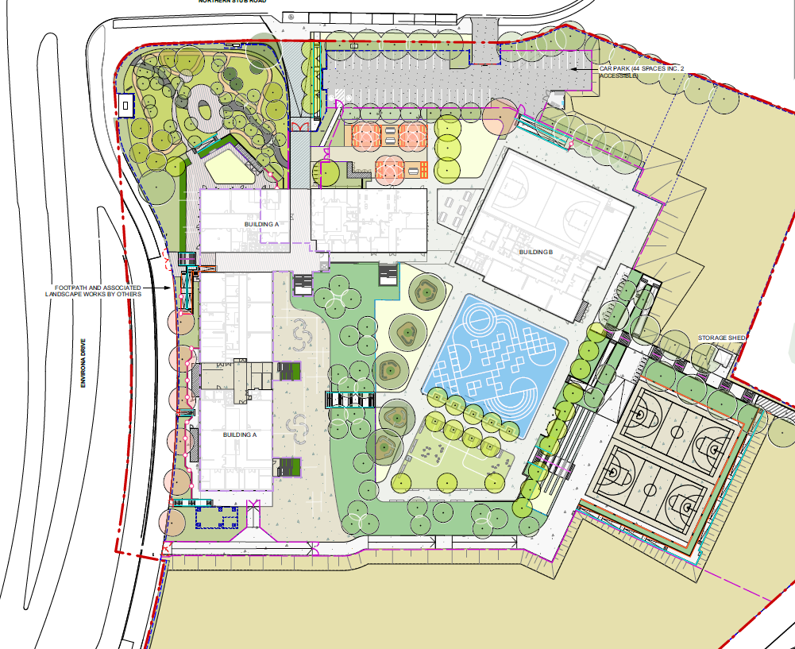
Figure 3: Approved School on the site (Source: Major Projects register - SSD 24461956)

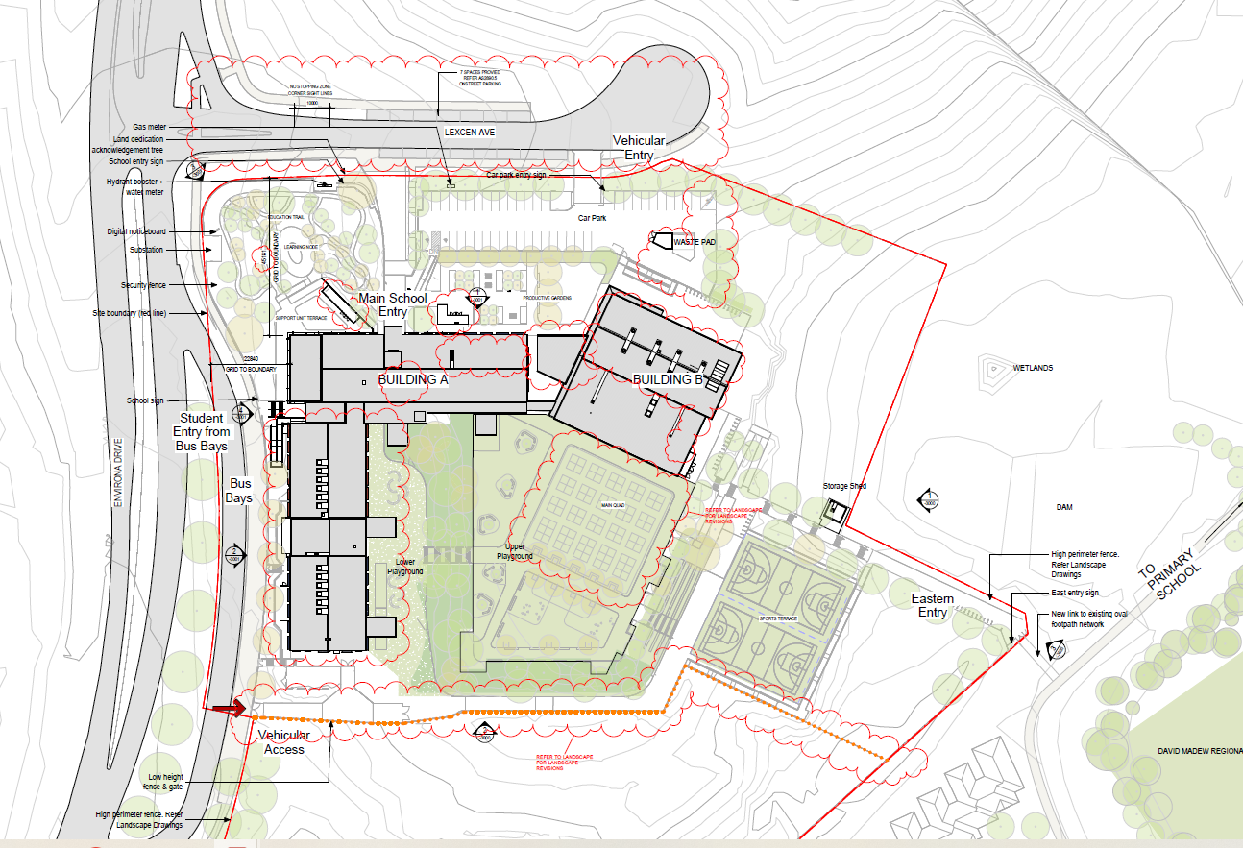
Figure 4: MOD 2 approved plan (Source: Major Projects register - SSD 24461956)

Relevant consent conditions

A review of the consent conditions from Stage 1 (SSD 24461956) has been undertaken and the current proposal is consistent with this SSD approval with the exception of Condition A2 (approved plans) arising from the proposed internal changes to Building B. This condition will require amendment as there are internal alterations proposed to Block B (previously referred to as Block A), which can be undertaken pursuant to Section 4.17(1)(b) and (5) of the EP&A Act. This is included in the draft recommended consent conditions in Attachment A.

Subdivision Approval
Council granted consent on DA 332-2015 for the subdivision of Lot 1 DP 1263364 into 2 new lots in March 2021. This subdivision was undertaken to provide separate title to the Department of Education for the purposes of constructing a high school. Lot 1 in this subdivision will remain as residual land for the interim with the probability of private recreation and business development in the future. The consent included conditions relating to biodiversity, infrastructure and site servicing, with Council issuing a Subdivision Certificate in November 2021. This new lot is not yet registered with the existing land title being Lot 1 in DP 1263364 with Lot 2 in DP 1263364 being the proposed (but not yet registered) lot.

Justification for the development and Progress of Stage 1

The current proposal comprises Stage 2 of the school and is to provide the additional facilities required to increase the school’s capacity from 520 students (Stream 3) to 1000 students (Stream 5). As some Stream 5 core facilities such as administration, staff amenities and community hall have been provided in Stage 1, they are not proposed (or required) in Stage 2.

THE SITE AND LOCALITY

The Site

The site is located approximately 10km southeast of Canberra and 1 kilometre from the NSW/ACT Border within the Queanbeyan-Palerang Regional Council area (Figure 5). The site is legally described as Lot 2 in DP 1277158 and is known as No 101 Environa Drive, Jerrabomberra (site). The site is located on the eastern side of Environa Drive within the Poplars Precinct. The site is irregularly shaped and has two road frontages, Lexcen Avenue forming the northern boundary of 115 metres and Environa Drive forming the western boundary (approximately 140 metre frontage).

The southern boundary adjoins vacant land, measuring approximately 125 metres long and comprises a wetland area. The eastern boundary adjoins a low density residential area of Jerrabomberra as well as a dam, with Jerrabomberra Primary School located further to the east. The site has a total area of approximately 4.5 hectares.

The site slopes down from the approved car park (Stage 1) along the northern boundary on Lexcen Avenue (RL 606) to the southern boundary (RL 591.5) by around 14.5 metres. The northern section of the site slopes to the east, with slopes ranging between 10-15% and varies by 8 metres. The southern section of the site, primarily occupied by a large stockpile since the commencement of Stage 1 works, slopes both to the south and east-west with the stockpile sheeting flows each direction due its central location, with slopes in each direction ranging between 8-45% and varies by 9 metres.

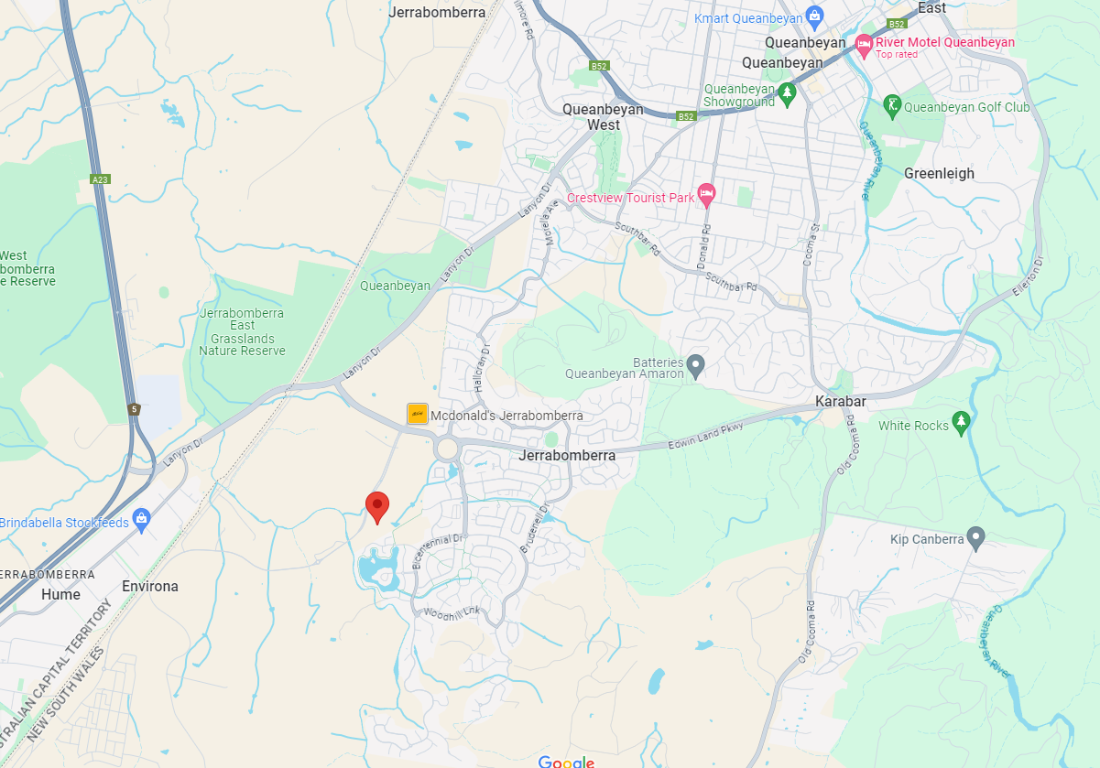
Queanbeyan
NSW/ACT border
The site
Figure 5: Site location (Source: Google Maps)

The upper playground approved in Stage 1 forms a plateau (RL 603.925) with the remaining playground falling to the south, east and west. The site is elevated with good views out to the south and west. The existing development on the site comprises the approved Stage 1 of the school which is now completed and occupied by the school (Figures 6 - 11). The southern portion comprises cleared land of grassed area with scattered shrubs and various stockpiles of materials excavated from Stage 1 and nearby roads (Figures 12 & 13).

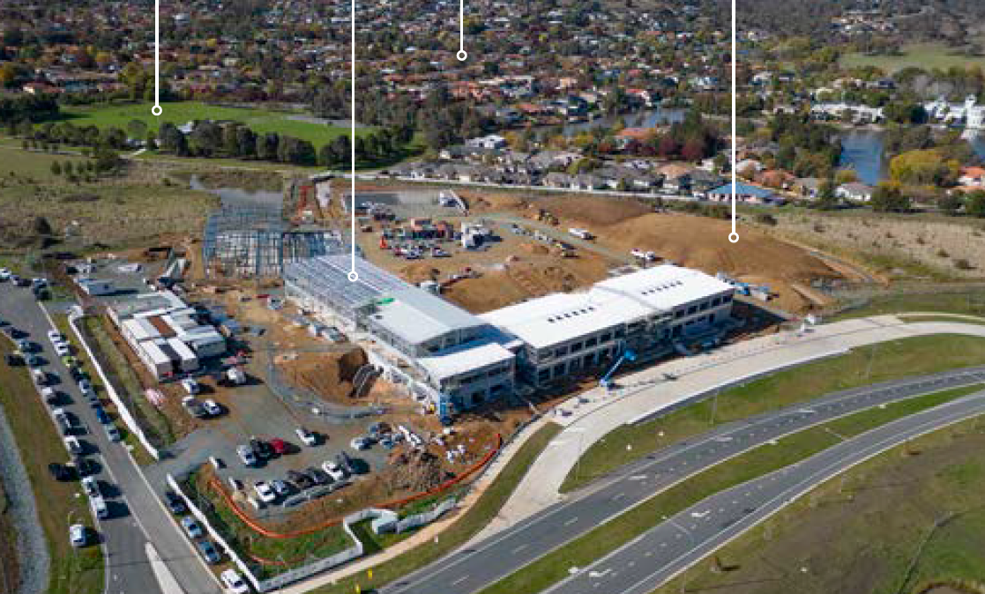
Approved car park for Stage 1
Approved Stage 1
Approved bus bays
Proposed Stage 2
David Madew Park
Figure 6: The site with Stage 1 in the foreground (Source: Architectural Design Report, TKD Architects, July 2023)
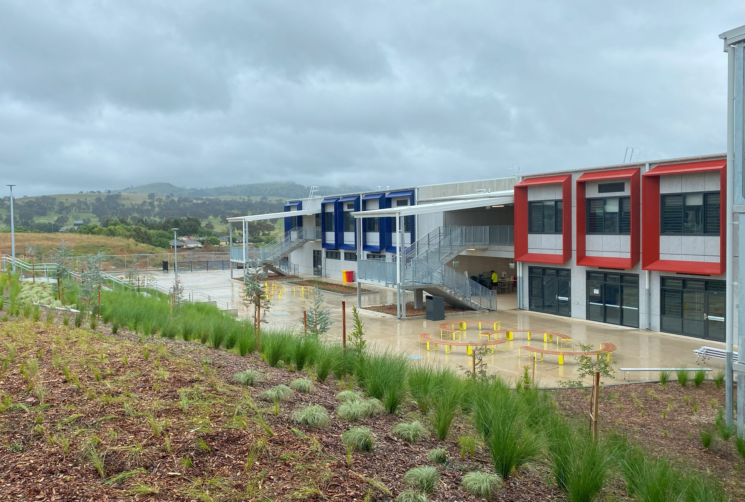
Figure 7: The recently completed Block A with proposed Stage 2 in the distance

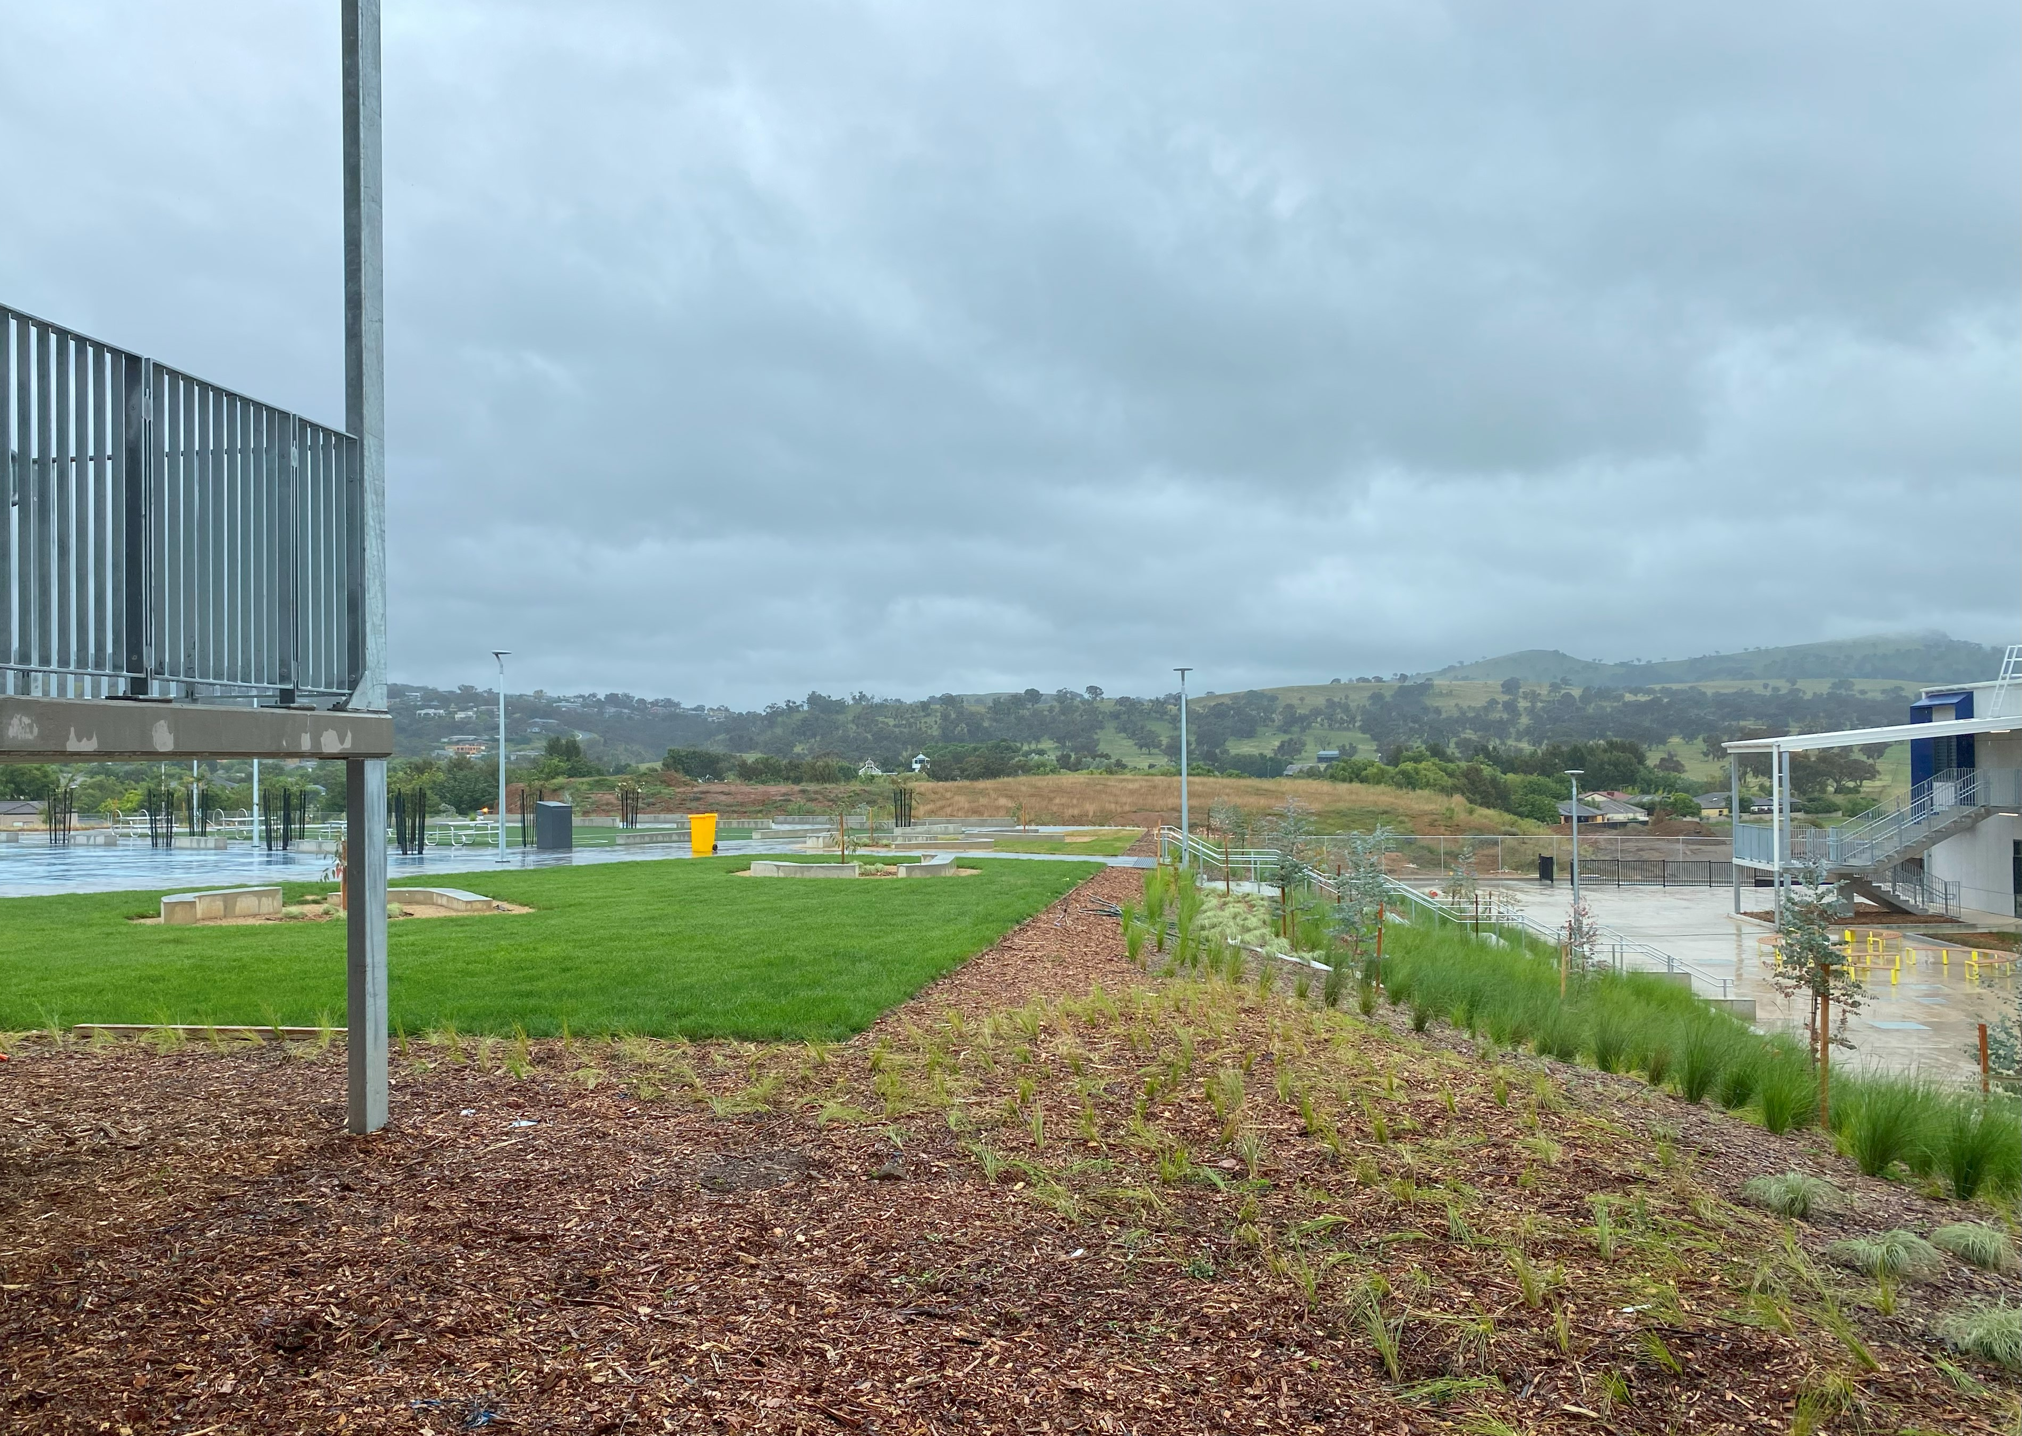
Figure 8: Looking south from stage 1 towards proposed stage 2
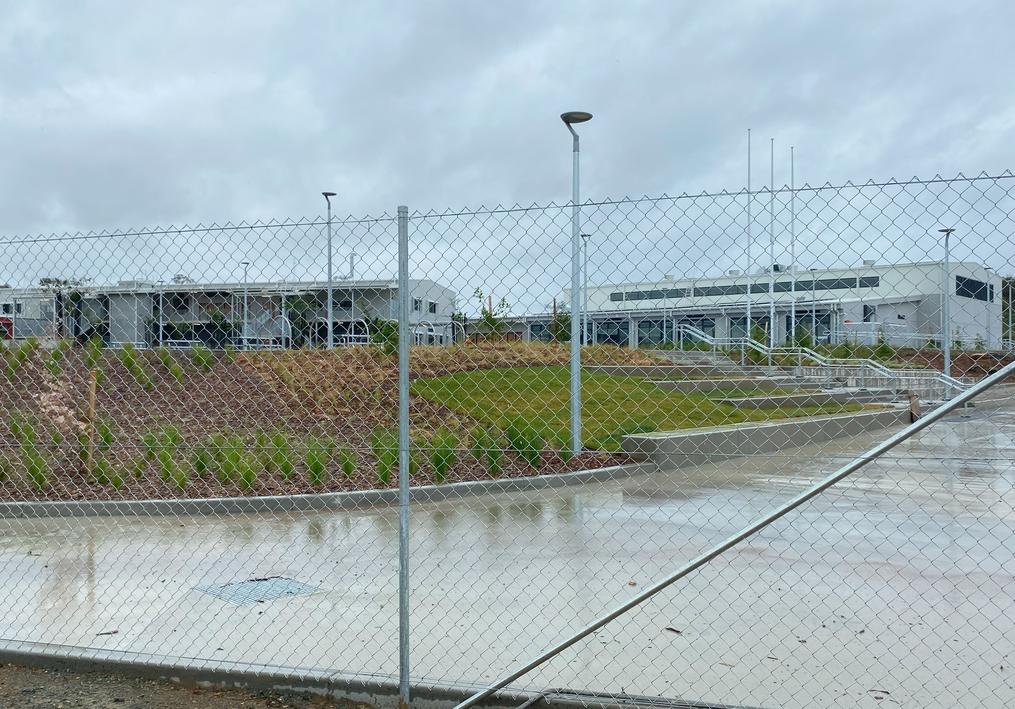
Figure 9: Looking east towards Blocks C & D and the boundary between Stages 1 and 2
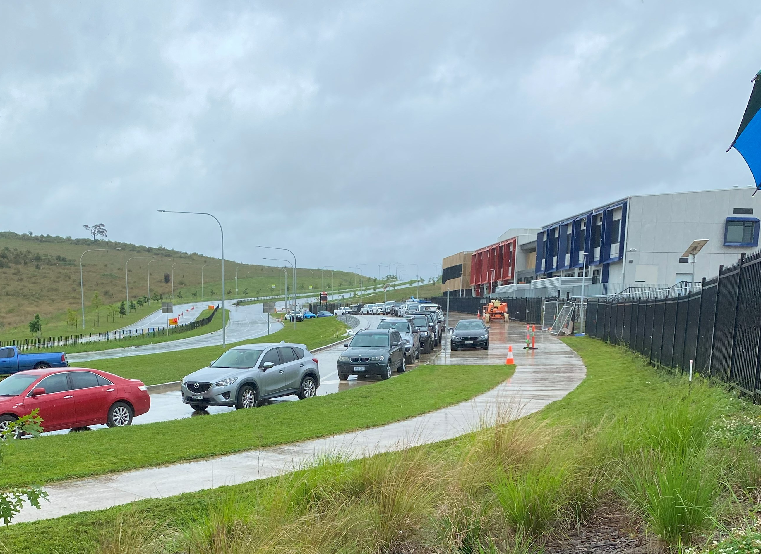
Figure 10: Environa Drove (western) boundary of the existing school
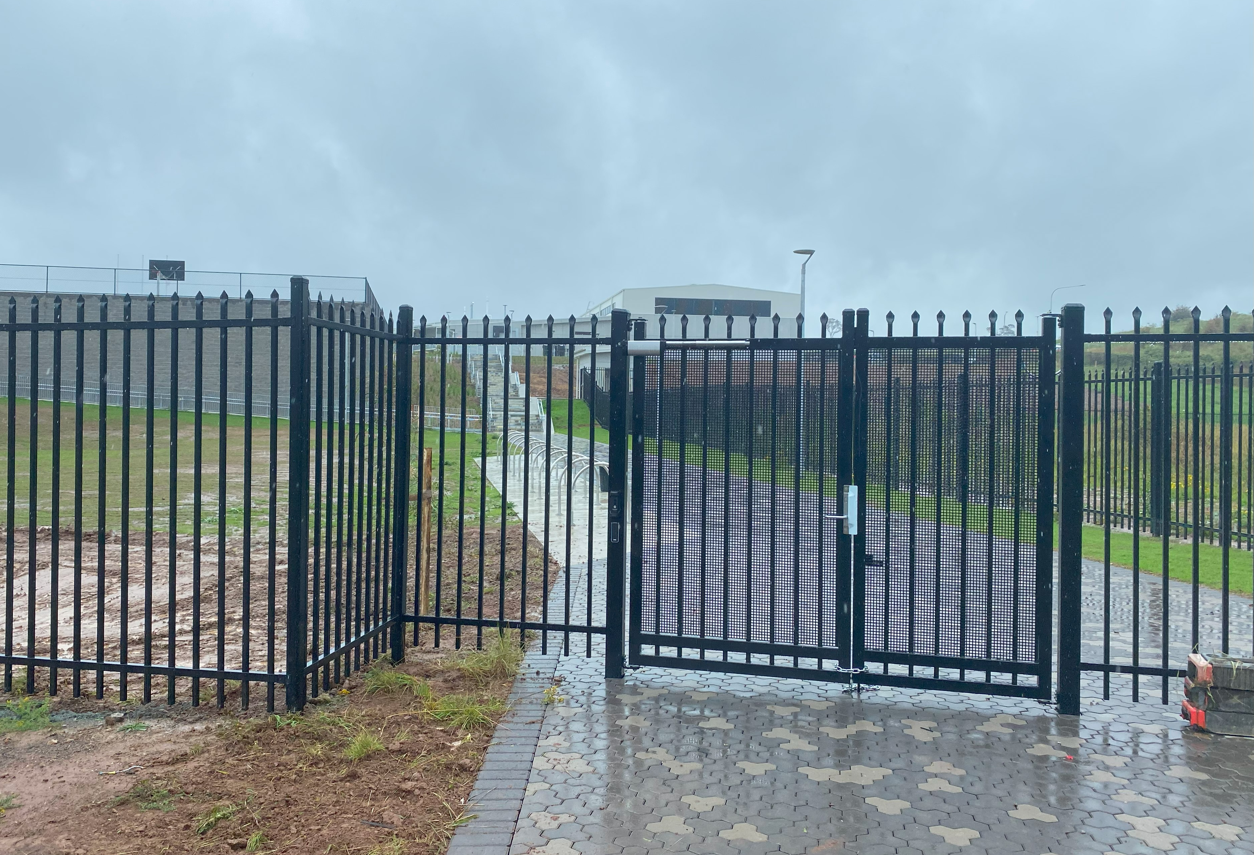
Figure 11: Eastern boundary of the existing school adjoining rear of properties along Palm Court
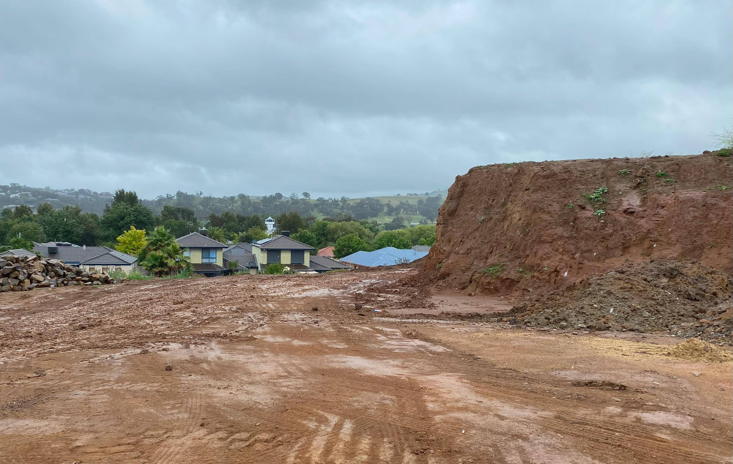
Figure 12: Southern portion of the site - existing stockpiles

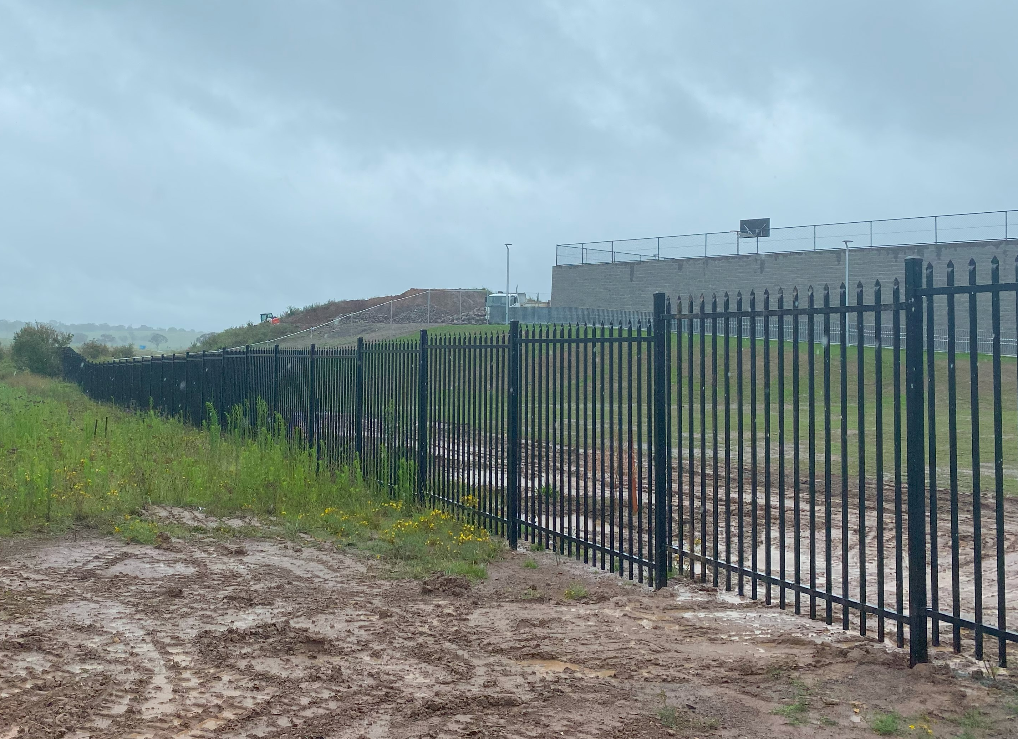
Figure 13: Southeast boundary of the existing school looking towards Stage 2

The existing road network in the vicinity of the site consists of Environa Drive, a local road with one lane in each direction, connects with Tompsitt Drive, a sub-arterial road located approximately 700 metres to the north of the site, comprising two (2) lanes which provides the primary connection to Jerrabomberra from the ACT. Lexcen Avenue is a local road providing through access from Environa Drove to Nicholas Court near the intersection with Tompsitt Drive to commercial/residential properties to the north of the site.

The primary pedestrian and bicycle access points to the site are via Environa Drive and Lexcen Avenue. There is also a pedestrian access point from the east, which connects to the existing oval footpath network. The existing vehicular access to the site is from Lexcen Avenue, while there is an additional vehicle access point from Environa Drive for deliveries and emergency vehicles.

The site is located within an area with a good network of footpaths including:

- along the northern side of Coachwood Avenue and on the eastern side of Jerrabomberra Parkway (to the northeast of the site).
- Signalised pedestrian crossing at the intersection of Tompsitt Drive and Henry Place.
- School crossings are designated at the front of Jerrabomberra Public School on Coachwood Avenue and Firethorn Place.
- At the end of Coachwood Avenue, there is a pedestrian path along the southern boundary of the school site, running alongside David Madew Oval, with an approximate width of 1.2 metres.

A bus is currently being constructed as part of Stage 1 along the Environa Drive frontage of the site as a separated layover from Environa Drive. The bus bay length is approximately 105 metres and can accommodate up to seven buses, facilitating additional bus route services for the high school. Suitable bus routes will be developed in collaboration with TfNSW during the detailed design phase, to address the transportation needs of both the high school and the adjacent primary school. A bus stop is also provided along Coachwood Avenue, at the front of Jerrabomberra Primary School.

The bus bay is designated and restricted as a 'Bus Zone' during specific school peak periods, including between:

- 8 am – 9:30 am on school weekday mornings.
- 2:30 pm – 4 pm on school weekday afternoons

There are also public bus services which operate from the bus zone outside the school and the primary school.

There are a number of additional improvements to be made to the existing footpath network in the area required under the Stage 1 approval for the School as outlined in Section 1.2 of this report. On-street car parking is generally available in the Lexcen Avenue and on Coral Drive near Jerrabomberra Public School (JPS). There are 15 spaces along Lexcen Avenue, and around 16 spaces outside school peak periods along Environa Drive within the bus bay.

The site is bushfire prone land, affected by the Probable Maximum Flod (PMF) and located between the 20 and 25 ANEF contour for aircraft noise. The site is also located within a sub-alpine environment. These constraints are considered in this report.

The Locality

The locality consists of a mix of land uses including residential development, public open space, schools and future commerical uses (Figure 14). To the east and south of the site consists of low density residential developments (Figure 15) as well as Jerrabomberra Public School to the northeast. Grazing land and natural grasslands exist to the north, southwest and west, with the areas north and west of the site proposed to become an innovation precinct for business park uses. Jerrabomberra town centre is located to the north east of the site.

David Madew Regional Park adjoins the site to the southeast which consists of soccer and softball fields as well as tennis courts, half-court basketball and a playground. Car parking is also provided for the Regional Park with a pathway connecting the park to the school (Figure 16). Jerrabomberra Creek is located approximately 150m to the southwest of the site, with a small dam adjoining the site to the southeast. This dam forms part of a watercourse and broader wetland, with Lake Jerrabomberra, an artificial lake, located approximately 200 metres south of the site.

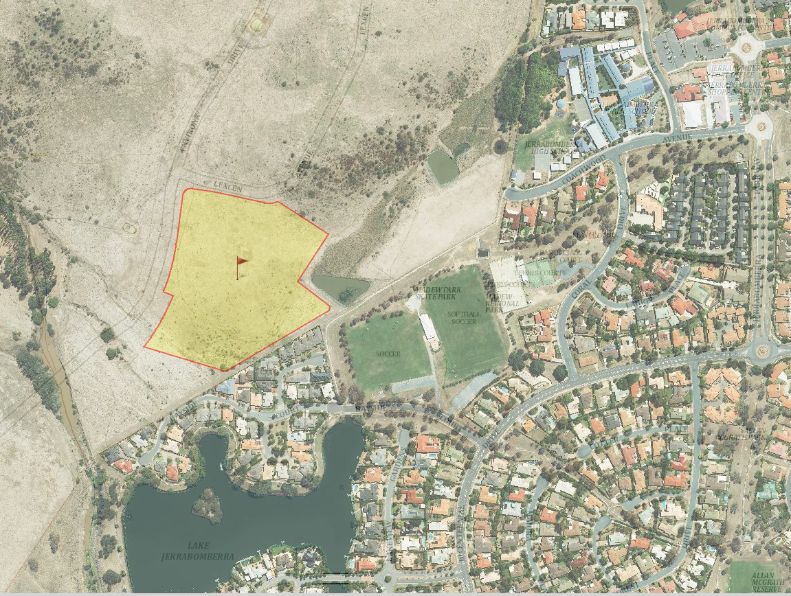
Jerrabomberra Creek
Lake Jerrabomberra
Future innovation precinct
Jerrabomberra town centre
The site
Jerrabomberra Creek
David Madew Regional Park
Jerrabomberra Public School
Figure 14: The Locality (Source: SIX Maps)

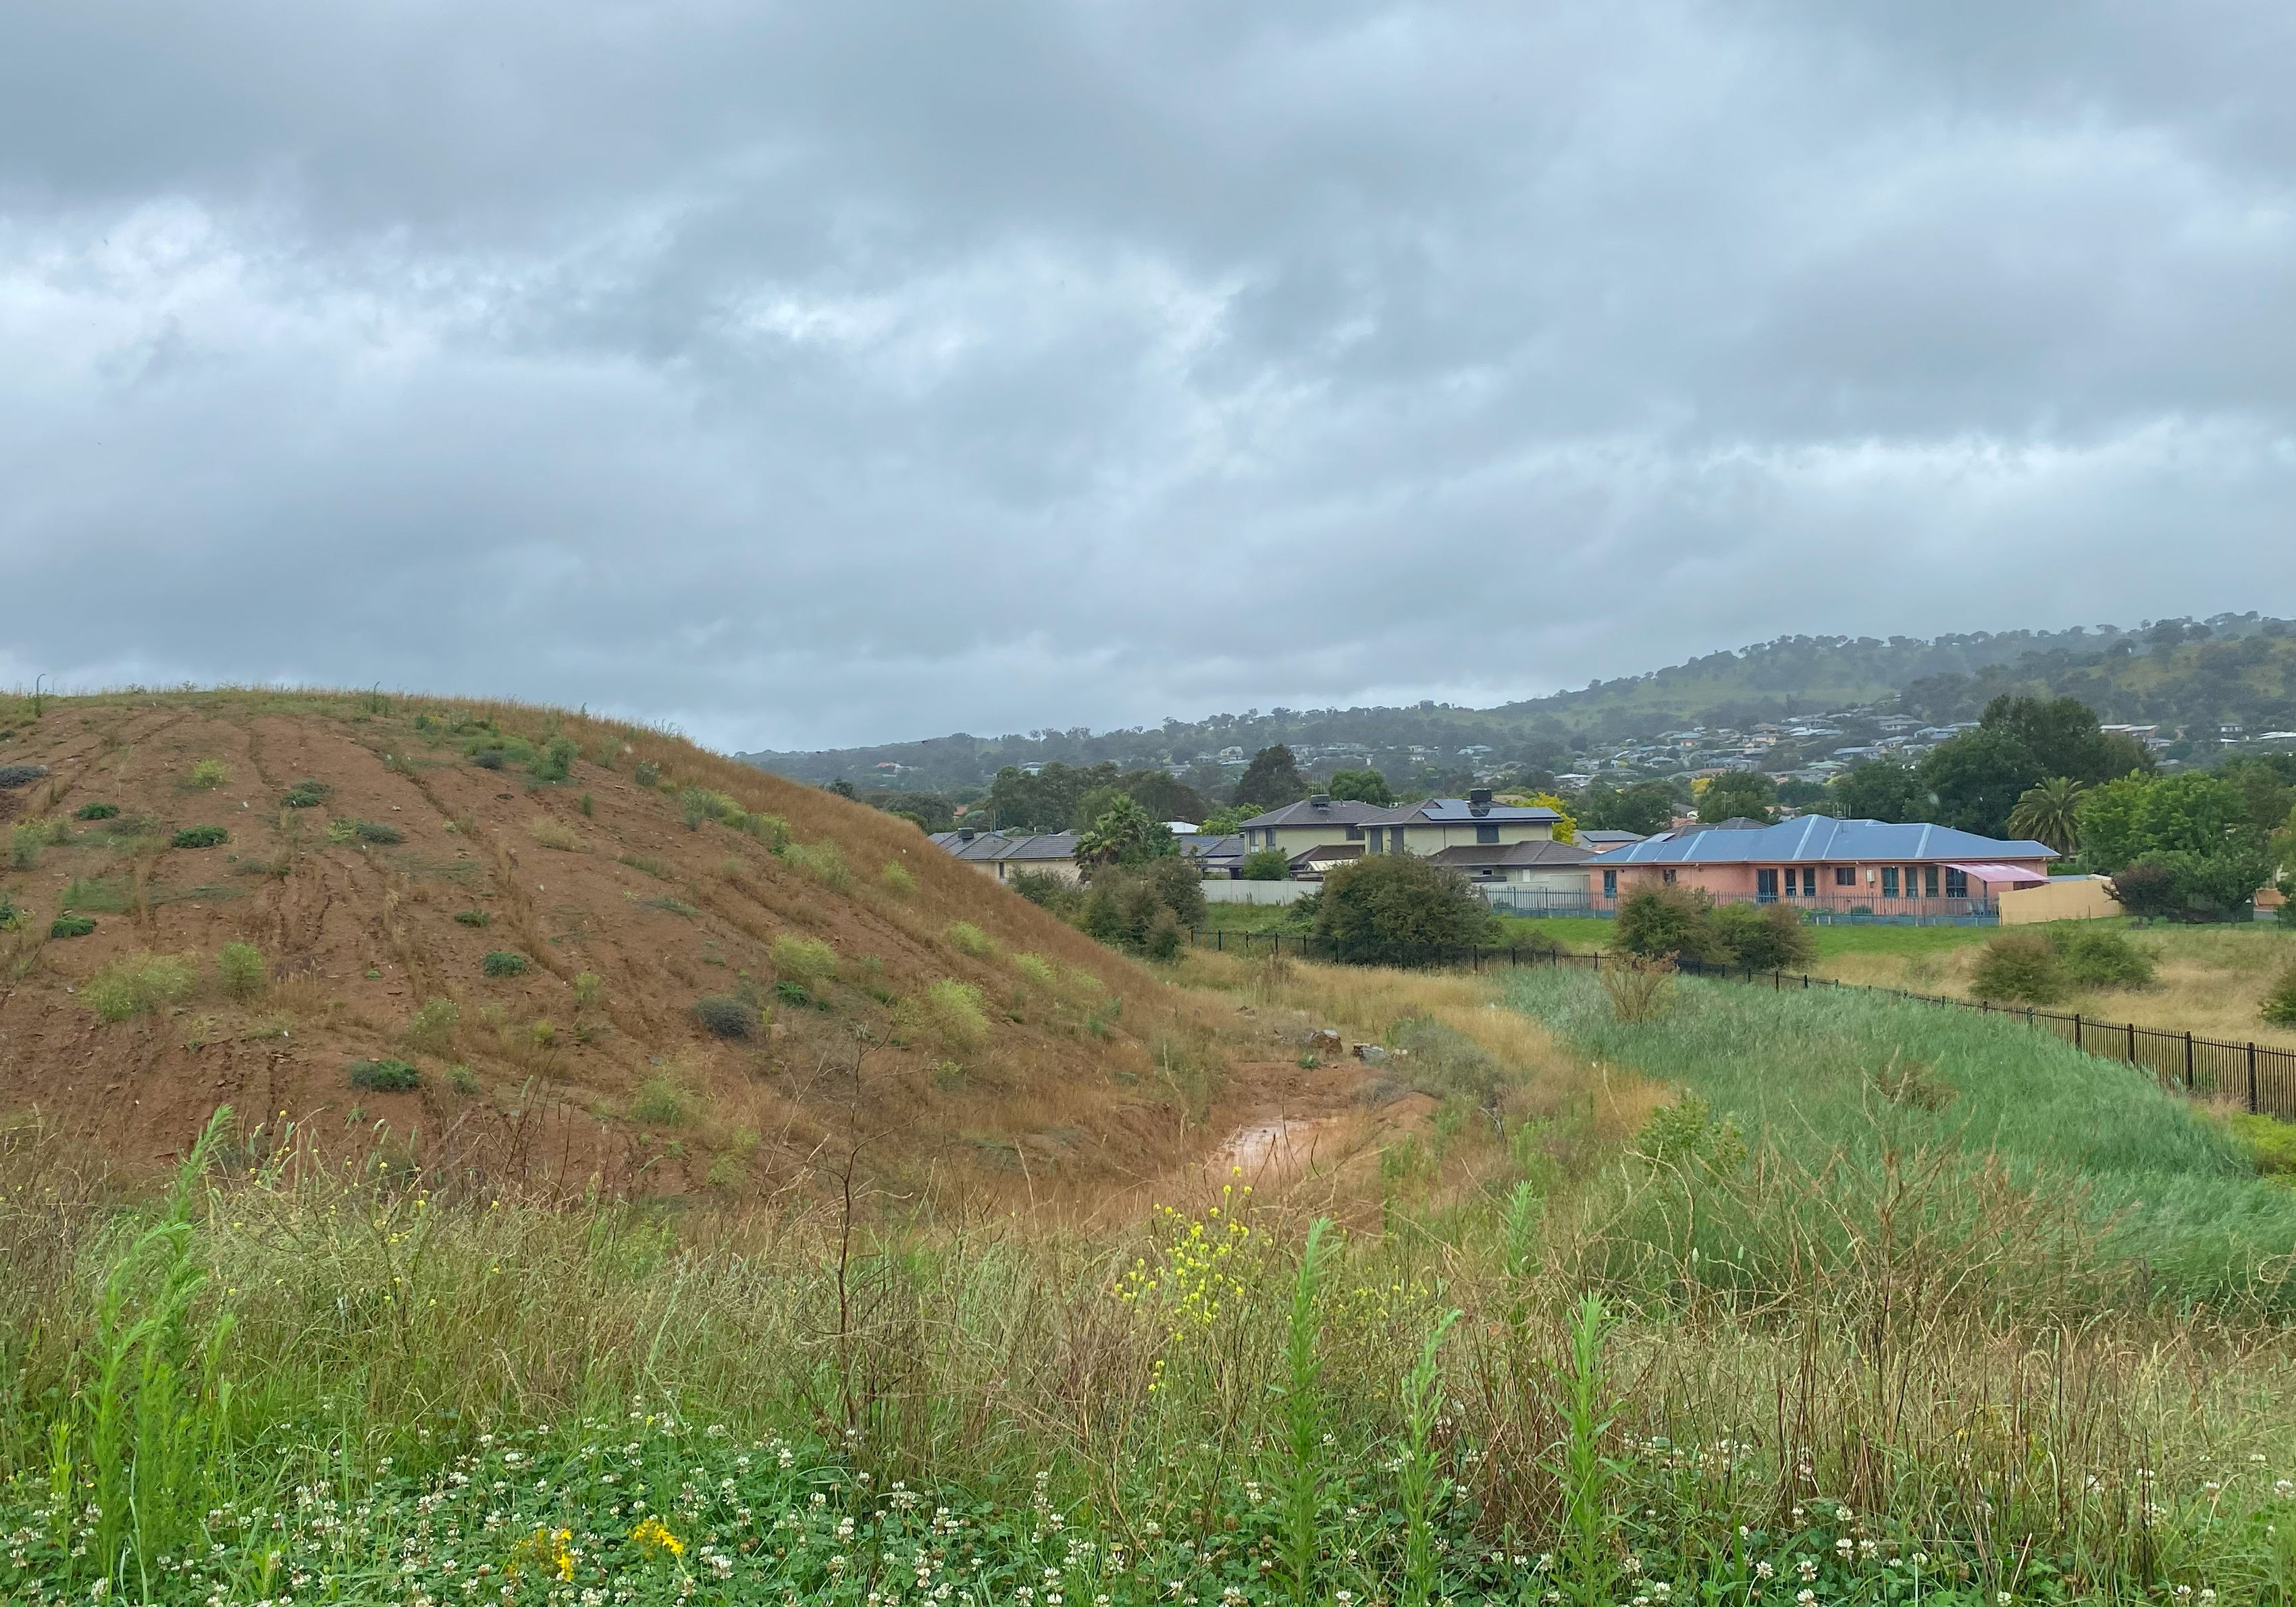
Figure 15: Residential development the south of the site
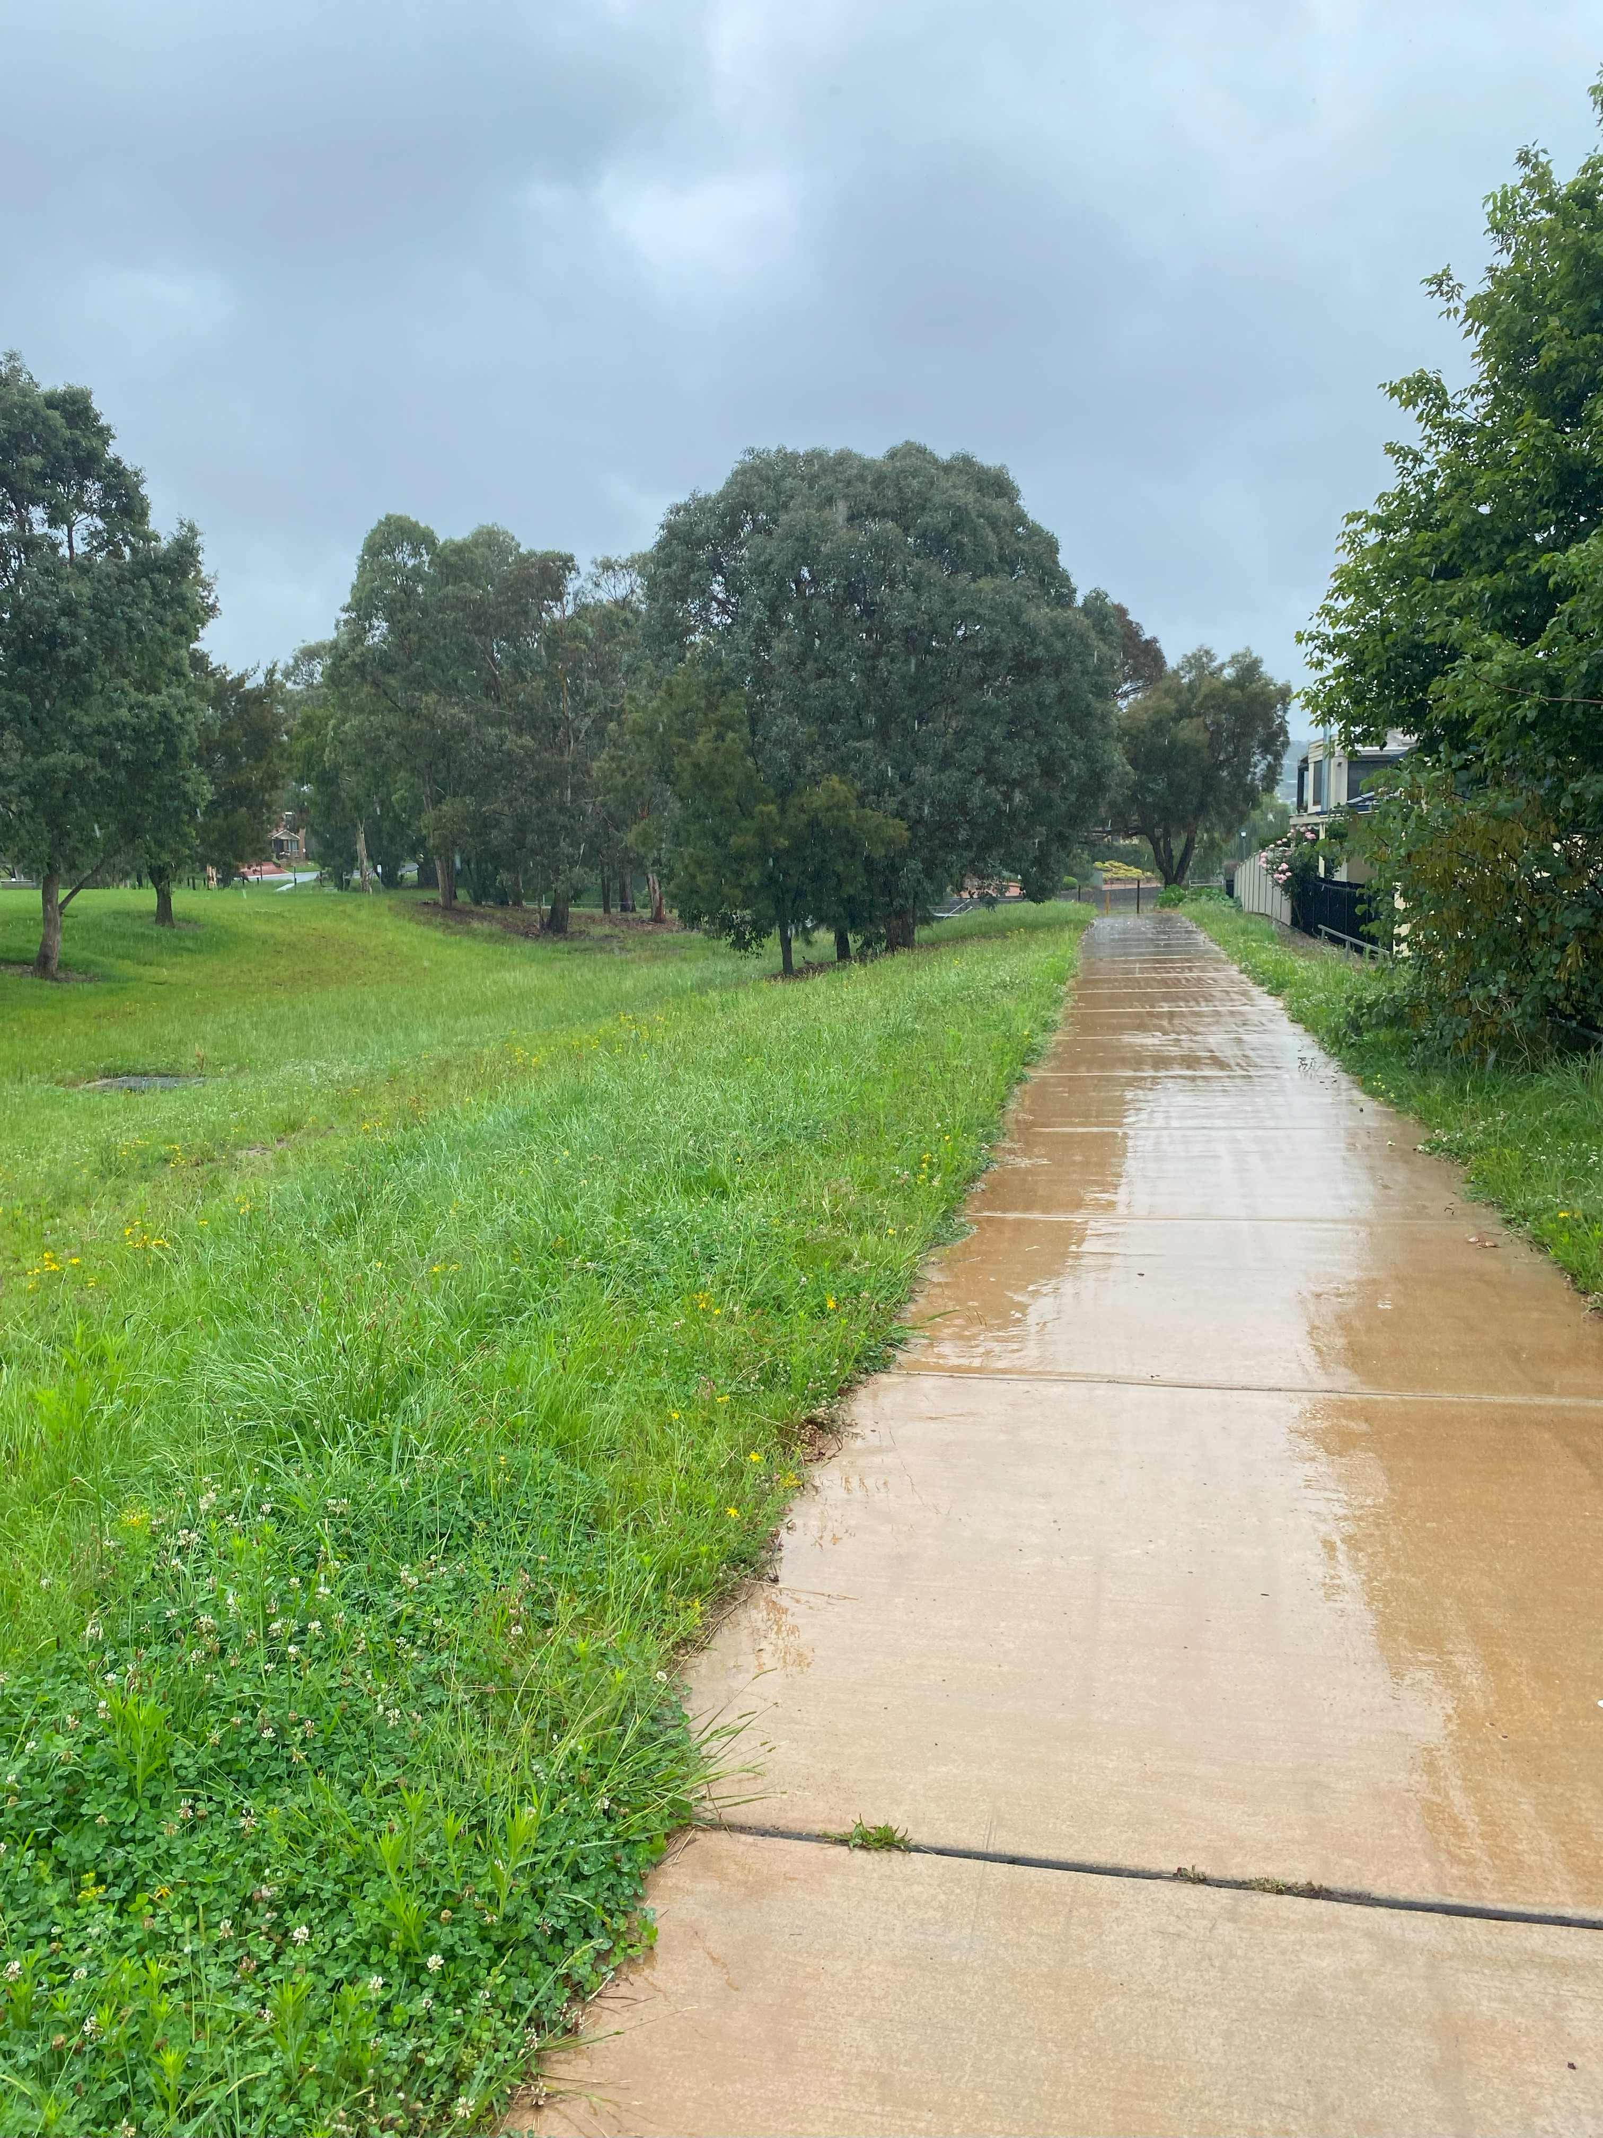
Figure 16: Pathway to David Madew Park

THE PROPOSAL

The Proposal

The proposal seeks consent for alterations and additions to the existing Jerrabomberra High School (School) including a new building, additional student and staff numbers and additional parking to accommodate projected demand for high school spaces in the area.

Specifically, the proposal involves:

- Site preparation works including regrading and compaction of the large stockpile on the site to engineering advice to provide an accessible space for the new buildings, the car park extension and outdoor facilities. The proposed bulk earthworks involve 18,575m³ of cut and 14,475m³ with the balance of 4,100m³ to be disposed off-site;

- Construction of a new school building, Block E, containing general learning spaces, kitchen, workshops and ancillary facilities (including a covered walkway to Block A);

- Internal alterations to the ground floor of Block B (already approved and constructed in accordance with SSD- 24461956) to replace the existing kitchen, food and textiles facilities with a new science lab, general learning spaces, and ancillary facilities.

- Construction of an extension to the existing carpark with provision for an additional 34 car parking spaces;

- Provision of 114 bicycle parking spaces and the reconfiguring of the existing vehicle layback and gate providing access to Environa Drive;

- Construction of a large outdoor turf play space (3.391m²) for student use adjoining proposed Block E;

- Increase in student numbers from 530 to 1,000 and staff from 46 to 78; and

- Associated civil and landscape works.

An existing 225 diameter PVC sewer main traverses the southern section of the site in an east-west direction centrally across the site. This sewer main is to be diverted around the proposed works under a Section 68 application.

Details of the proposal are oultined below and the key development data is provided in Table 1 below. The proposal is illustrated in Figures 17 and 18 and in the accompanying architectural plans.

Table 1: Development Data
Control | Proposal
Site area | Approx. 4.5ha
GFA | - Proposed - 2,753m² (proposed Block E)  - Existing - 6,645m²  - Total (including new building) - 9,398m²
Max Height | 17.495 metres (south elevation  (Max – 8.5m for a small area)
Car Parking spaces | 34 (proposed spaces) plus 44 (existing spaces) – total 78 car spaces
Student and Staff Numbers | - Increase in student number from 530 to 1,000  - Increase in staff numbers from 46 to 78

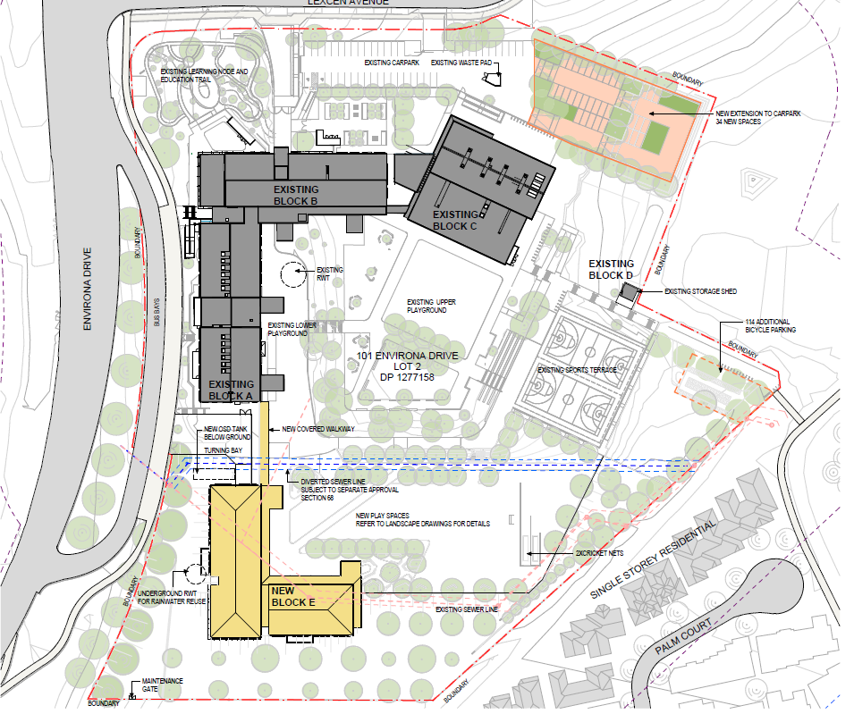
Figure 17: Proposed Development (Source: Architectural Design Report, TKD Architects, July 2023)

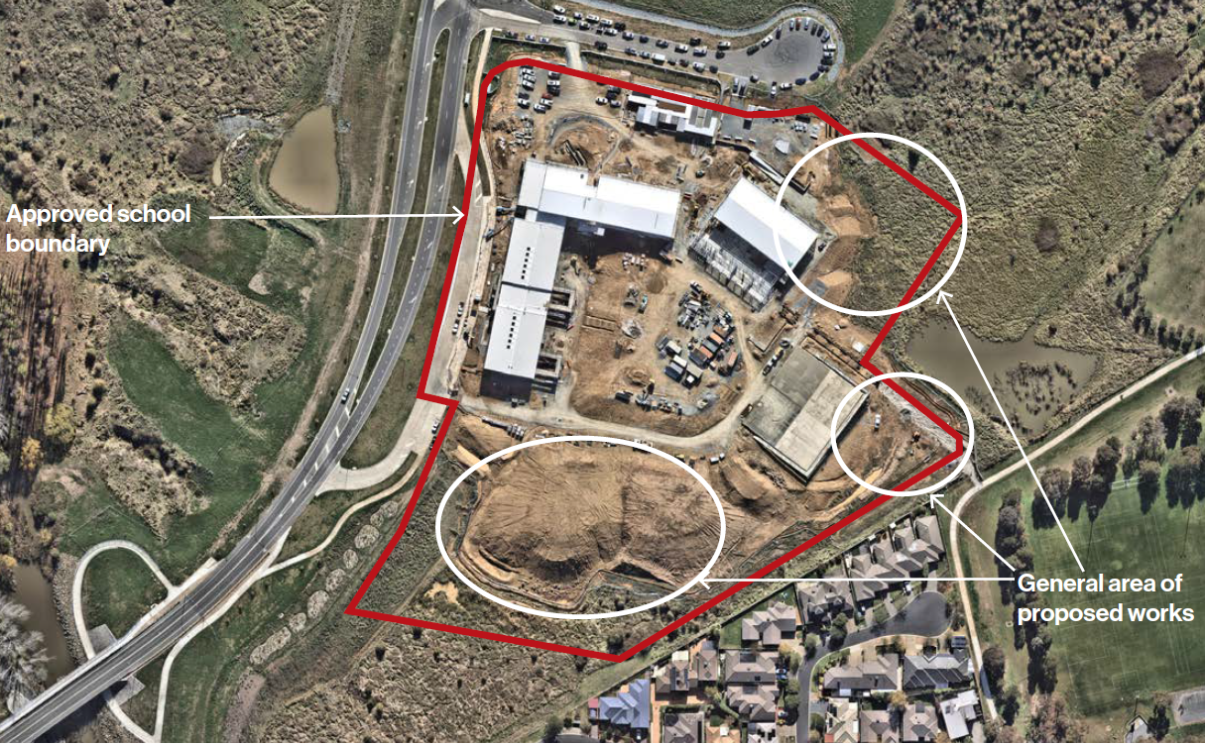
Figure 18: Proposed Development overlay with existing site (Source: Architectural Design Report, TKD Architects, July 2023)

Proposed New Building – Block E

The proposed new school building comprises two (2) storeys, consisting of a lower ground floor and ground floor, identified as Block E. The total gross floor area is 2,753m² and the maximum height above existing ground level is 17.495m, primarily resulting from the steep slope of the southern portion of the site. The proposal exceeds the height limit which is considered in the LEP assessment. The DoE mandates that all new school buildings, whether for an existing or a new school, must attain at least a 4 Star Green Star rating.

The Educational Facilities Standards and Guidelines (EFSG) prepared by the NSW Department of Education provides information and tools required to design and build new schools assets, utilising a set of standard components. It also provides guidance for undertaking school upgrades, based on a clear set of design principles and space requirement.

The building has been designed in accordance with the EFSG as an L-shape to provide a sheltered playground area as well as to provide an outlook from the building towards the grasslands. The building also shields the school from the road and westerly winds. The building has been designed to be at a similar level to the existing Building A on the site (Figures 19 to 21).

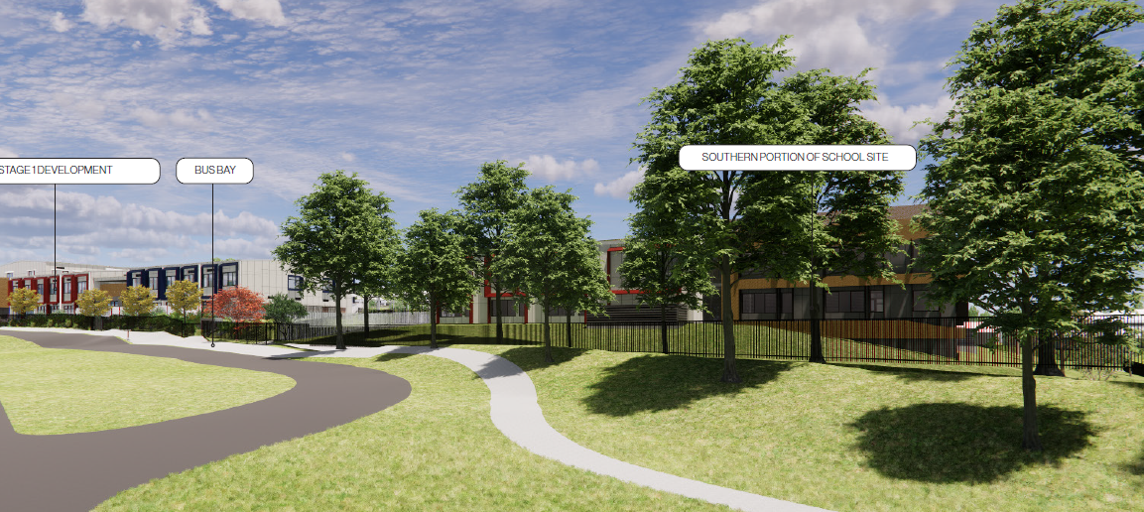
Figure 19: Proposed Block E (Source: Architectural Design Report, TKD Architects, July 2023)

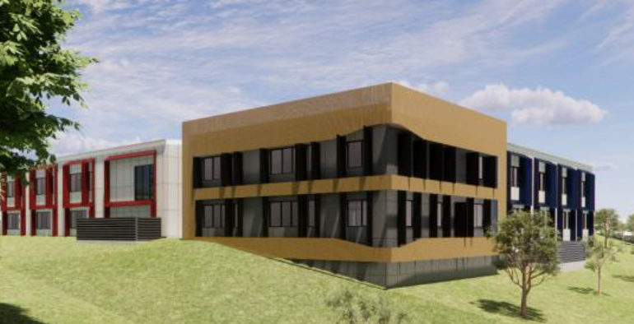
Figure 20: Proposed Southwest corner (Source: Architectural Design Report, TKD Architects, July 2023)

Figure 21: Proposed Block E looking Southwest (Source: TKD Architects, Revision D)

The proposed lower ground floor of Block E contains:

- General learning facilities comprising 4 x general learning rooms, a learning common room and a multipurpose space room in the northern section;
- Student amenities (including 1x accessible bathroom) in the central area;
- Multimedia and library facilities comprising a multipurpose space, workshop, store and studio and a general learning library area in the southwest corner;
- Food and textiles facilities comprising two (2) general learning rooms, a semi-commercial kitchen and pantry area, two (2) food and textile preparation rooms, an indoor bistro, a vocational education (‘vet’) kitchen and a laundry in the south-eastern corner of the building; and
- Services and storage facilities (including 2x plant rooms), stairwells and lift access.

The proposed ground floor of Block E contains:

- General Learning Facilities comprising 5 x general learning rooms, a learning common room and a multipurpose space room;
- Student amenities (including 1x accessible bathroom) in the central area;
- Staff Facilities including a staff room and amenities (including 1x accessible bathroom) and a Health/PE general learning room in the southwest corner;
- Seniors Learning area comprising five (5) seniors general learning rooms, a learning commons room, a multipurpose space in the south-eastern corner of the building;
- Services and storage facilities, stairwells and lift access.

Ground-level pedestrian pathways are provided to enable student and staff circulation, and a covered pedestrian pathway connecting Block E to Block A is also proposed. External gallery access is also proposed along the eastern elevation of the building for both levels. The proposed lower ground and ground floors of the proposed new building are illustrated in Figures 22 and 23.

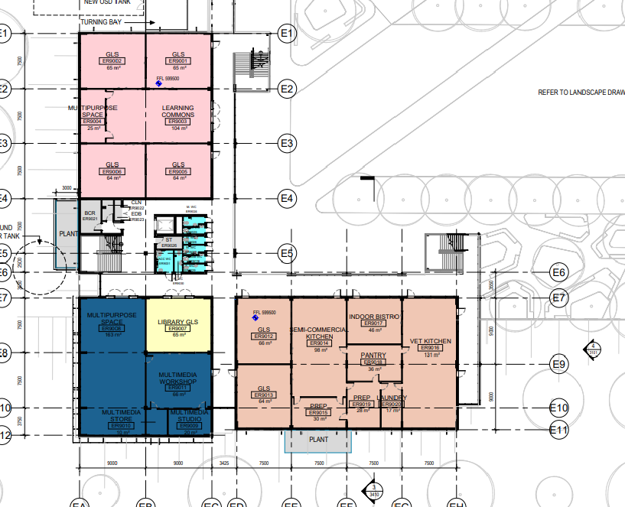
Figure 22: Lower Ground floor (Source: TKD Architects, Revision D)
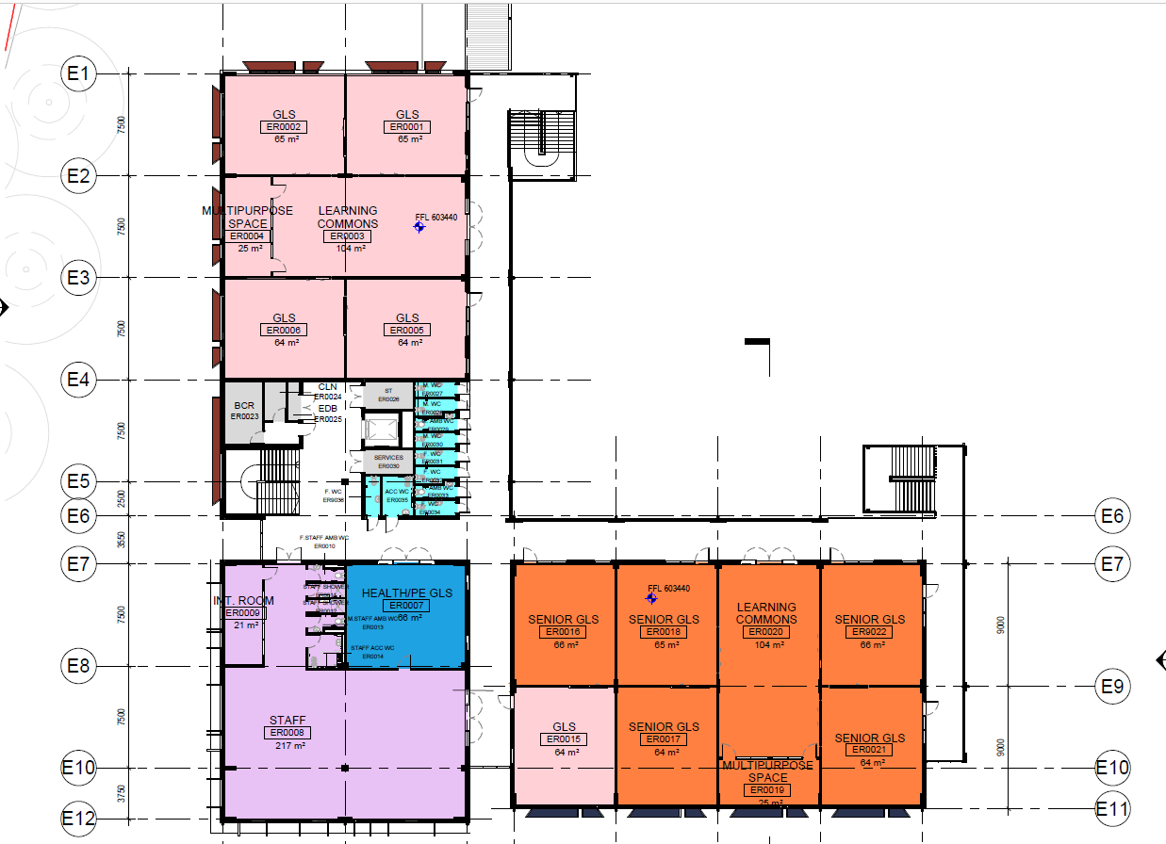
Figure 23: Proposed first floor (Source: TKD Architects, Revision D)

Alterations to Existing Block B

The proposal also includes internal alterations to the ground floor of Block B which was approved in Stage 1 as Block A. This building is now referred to as Block B in this application, while the approved Block B is now referred to as Block C in this application. The proposed alterations are to replace the existing kitchen and textiles facilities with a new science lab, general learning spaces, and ancillary facilities. The food and textiles facilities are proposed to be provided on the lower ground floor of Block E (outlined above). The proposed changes are illustrated in Figures 24 and 25.

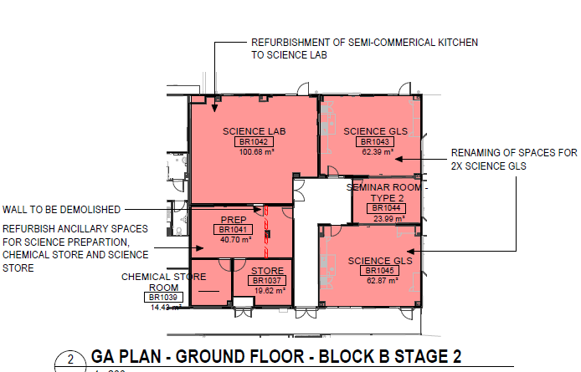
Figure 24: Proposed Block B - ground floor (Source: TKD Architects, Revision D)

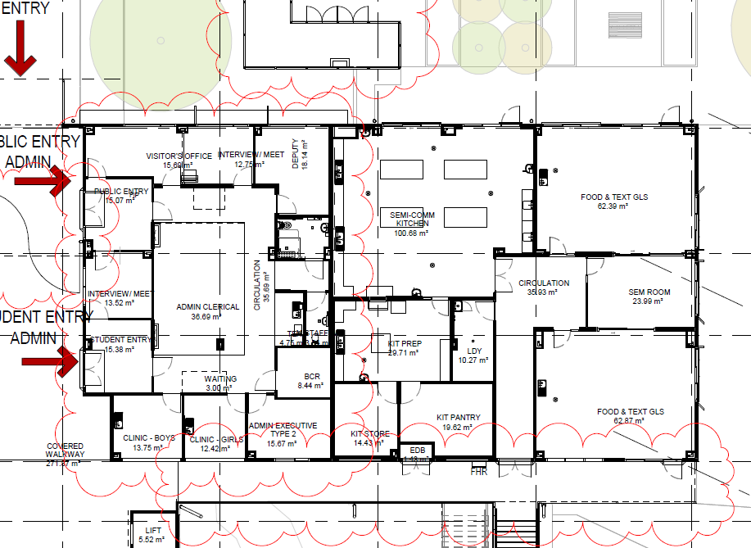
Figure 25: Approved ground floor - Block B (originally ‘Block A’) (Source: Major Project Portal)

Landscaping

The proposed landscaping is to be undertaken as outlined in the Landscape Plan (Figure 26) and is proposed to surround the new car park, around Block E and the outdoor play space. No trees are proposed to be removed, and a total of 102 trees are proposed to be planted, consisting of 69 native canopy trees and 33 exotic canopy tree.

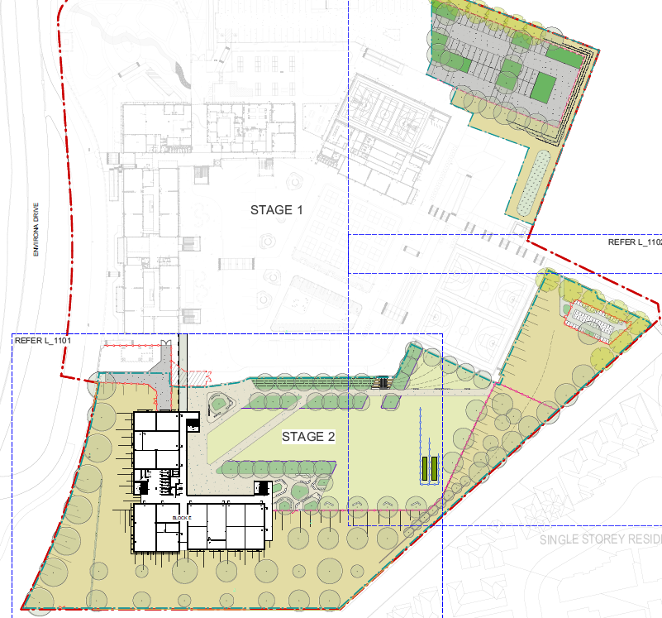
Figure 26: Proposed Landscaping (Source: TKD, Context, Revision A, 27 July 2023)
Vehicle and Pedestrian Access and Car Parking

The existing vehicle and pedestrian access and car parking is illustrated in Figure 27. The proposal involves the construction of an addition of 34 car parking spaces to the existing car parking area in the north eastern corner of the site. The car parking and access is considered further in the key issues section of this report.

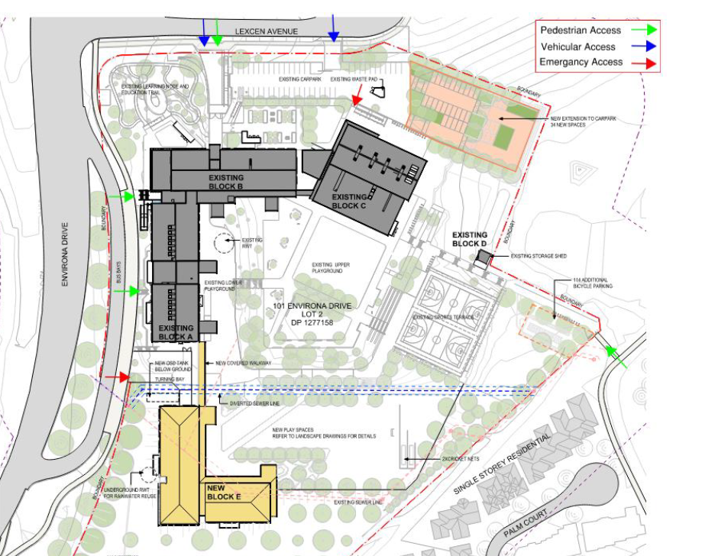
Figure 27: Proposed Site Access (Source: Traffic Report, TTW 28 July 2023)

Stormwater Management

The proposed stormwater management measures include diverting runoff from new roof areas to a new rainwater tank for reuse in external demands (irrigation). A “Stormfilter” Chamber with Stormfilter cartridges for stormwater treatment is proposed with an OSD tank to temporarily detain runoff and reduce peak flow discharge to the Environa Drive existing overland flow path (south of the site) and the existing dam via site discharge pit.

The OSD will be applied to reduce peak flow rates to existing levels. Areas that cannot drain to the new rainwater tank and OSD tank will be directed to landscaped depressions to promote detention and infiltration.

Progress of the Development Application

The progress of the development application since lodgement in September 2023 is outlined below in Table 2.

Table 2: Chronology of the DA
Date | Event
15 September 2023 | DA lodged
18 October 2023 | DA referred to external agencies – RFS, DPE (Water) and Essential Energy
9 October 2023 | Exhibition of the application (until 6 November 2023)
4 October 2023 | Panel briefing – key issues discussed included  - Development history of the site (SSD & modifications), pathway for Cl 4.6 (height) >10%, Council capacity to assess application, RSDA trigger and determination pathway;  - Applicant presented proposal and discussed interactions across multiple consents, including management of potential conflicts of consent conditions and consistency of any future consents with current SSD consent conditions.  - Clarification of development staging and operational arrangements, proposed increase in student population, overall design scheme, proposed building height.  - Panel to arrange a site visit in early 2024.
7 November 2023 | Canberra airport response received - no objections
17 November 2023 | RFS Response received – no objections
17 November 2023 | Essential Energy received – inadequate information
17 January 2024 | Site inspection by the Panel and independent planning consultant.
20 February 2024 | DA referred to Transport for NSW (Transport & Infrastructure SEPP)
28 February 2024 | Comments received from Department of Planning and Environment (Water) – Controlled Activity Approval Exemption
11 March 2024 | Referral comments from Transport for NSW – no objections.
7 May 2024 | Agreement with SINSW on draft conditions.

STATUTORY CONSIDERATIONS

When determining a development application, the consent authority must take into consideration the matters outlined in Section 4.15(1) of the Environmental Planning and Assessment Act 1979 (EP&A Act). These matters as are of relevance to the development application include the following:

- the provisions of any environmental planning instrument, proposed instrument, development control plan, planning agreement and the regulations
(i) any environmental planning instrument, and
(ii) any proposed instrument that is or has been the subject of public consultation under this Act and that has been notified to the consent authority (unless the Planning Secretary has notified the consent authority that the making of the proposed instrument has been deferred indefinitely or has not been approved), and
(iii) any development control plan, and
(iiia) any planning agreement that has been entered into under section 7.4, or any draft planning agreement that a developer has offered to enter into under section 7.4, and
(iv) the regulations (to the extent that they prescribe matters for the purposes of this paragraph),
that apply to the land to which the development application relates,
- the likely impacts of that development, including environmental impacts on both the natural and built environments, and social and economic impacts in the locality,
- the suitability of the site for the development,
- any submissions made in accordance with this Act or the regulations,
- the public interest.

These matters are further considered below. The type of development application is also considered below as well as other statutory matters.

Integrated Development

Rural Fires Act 1997 - Bushfire

The proposal is considered to be integrated development pursuant to Section 4.46(1) of the EP&A Act as it requires a Bushfire safety Authority from the NSW Rural Fire Service (RFS) pursuant to Section 100B(3) Rural Fires Act 1997. The proposal is classified as a ‘Special Fire Protection Purpose’ development pursuant to Section 100B(6) of the Rural Fires Act 1997 as it proposes a school and is located on bushfire prone land (Figure 28), Vegetation category 3, comprising grasslands.

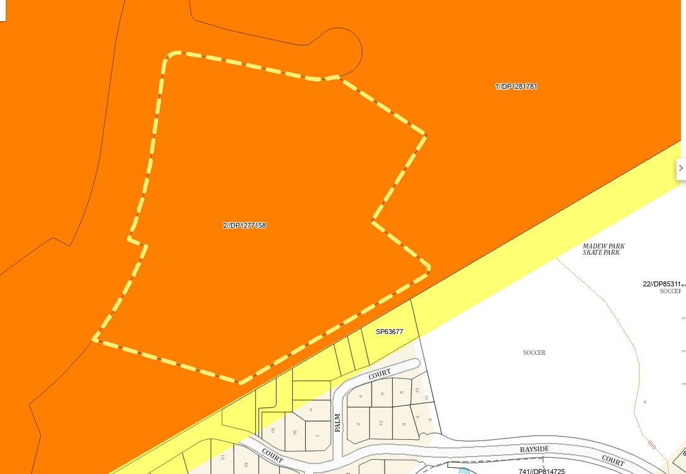
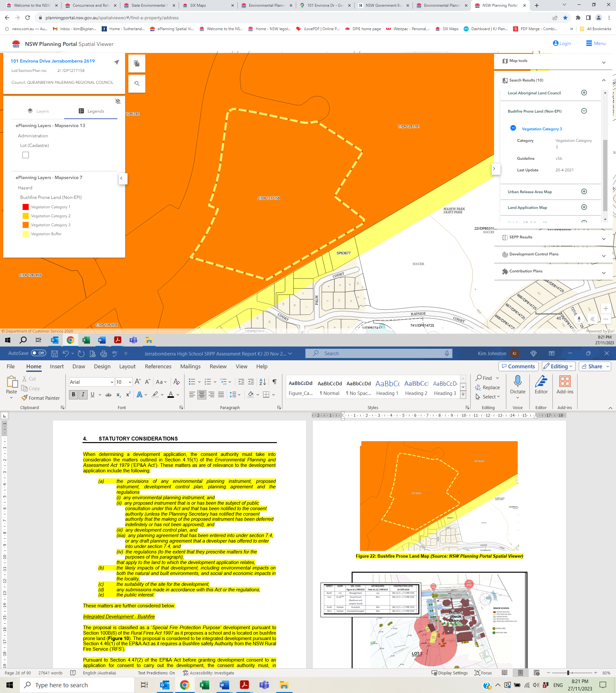
Figure 28: Bushfire Prone Land Map (Source: NSW Planning Portal Spatial Viewer)

A Bushfire Protection Assessment prepared by Ecological Australia dated 15 September 2023 (Bushfire Report) has been provided with the following conclusions (Figure 29):

- There is unmanaged grassland to the north, north-east, south and west within both the ‘Poplars Innovation Precinct’ (north, north-east and south) and beyond Environa Drive to the west. Unmanaged grassland is classified as ‘Grassland’ by PBP.

- There is a narrow strip of grassland vegetation (≤10 m) between the south-eastern boundary of the school property and the existing residential subdivision to the south-east. However, this will be separated from grassland to the north-east by a pedestrian walkway between the school and the adjoining subdivision, which is not wide enough to carry a fire of sufficient intensity to warrant consideration and does not require any bushfire protection measures.

- A temporary APZ easement has been negotiated with the owners of the adjoining ‘Poplars Innovation Precinct’ to the south of the school site, which will be 50 metres wide along the southern side of the school boundary and provides a total APZ of more than 70 metres to the south of the proposed Stage 2 building. The APZ easement may be extinguished when the land to the south is developed providing that the development includes APZ commensurate management.

- In all other directions there are managed lands in the form of existing residential development, playing fields and public road infrastructure.

- The Bushfire Attack Level (BAL) is BAL-LOW and in accordance with PBP there is insufficient bushfire threat to warrant specific bushfire protection measures

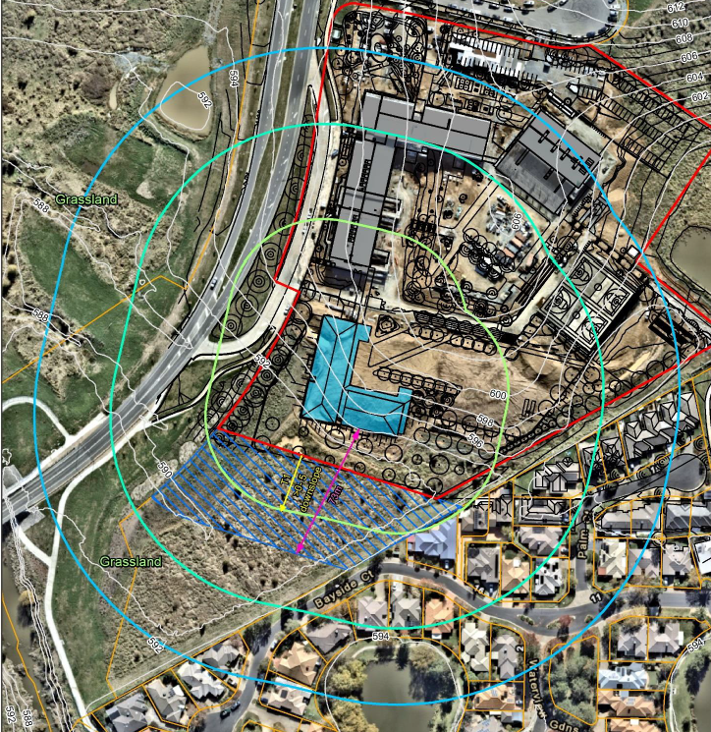
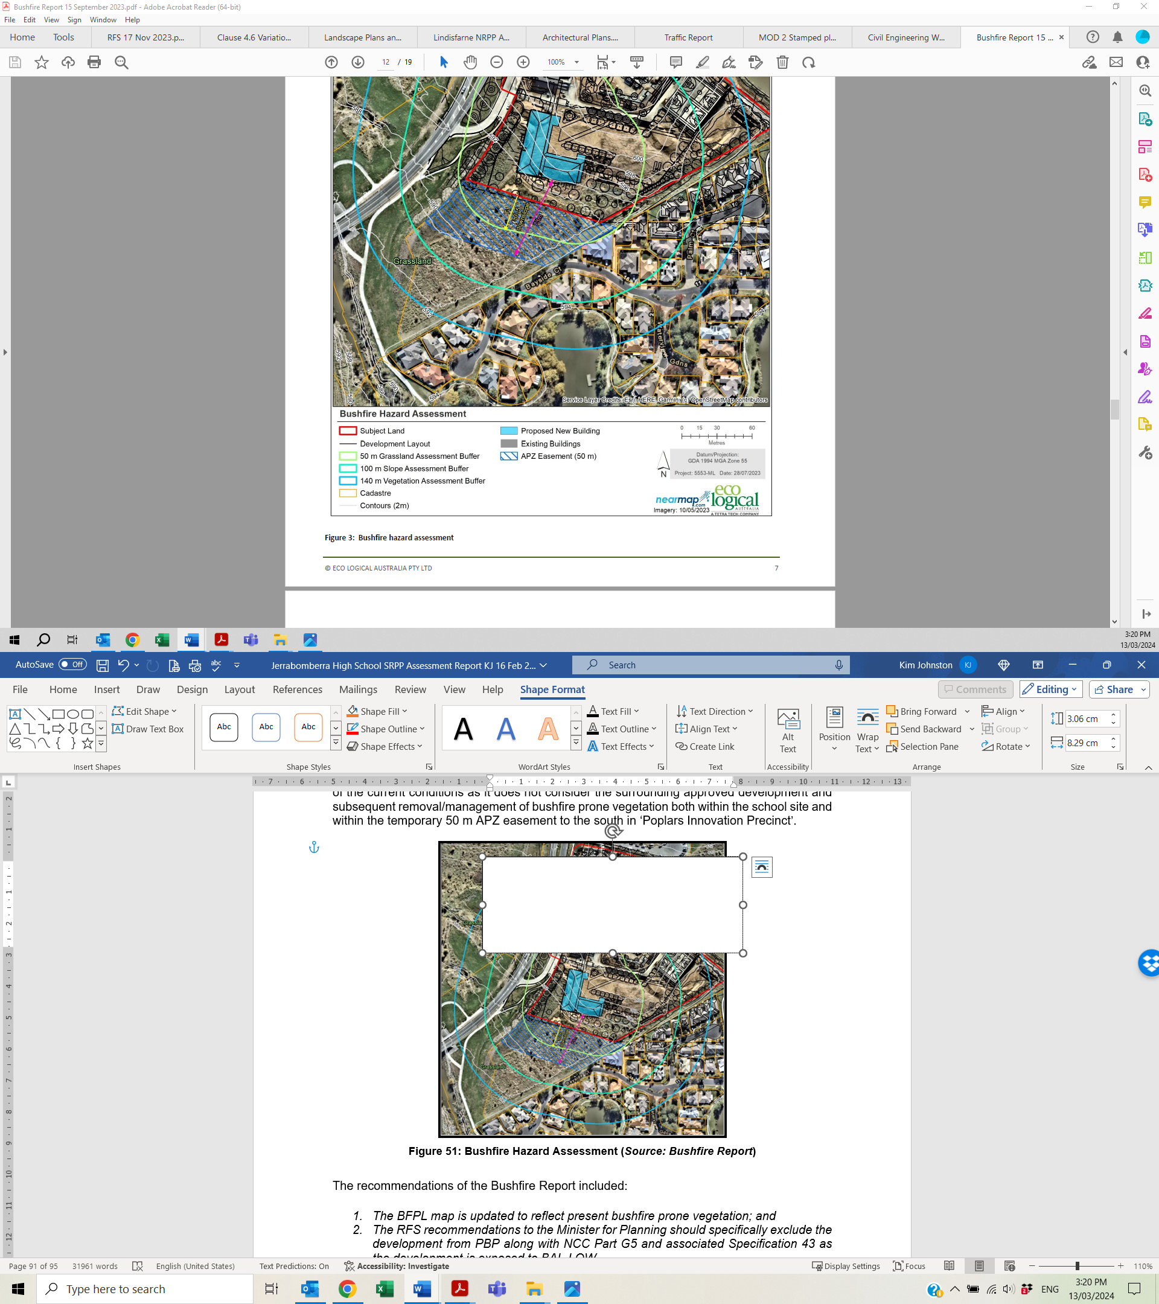
Figure 29: Bushfire Hazard Assessment (Source: Bushfire Report)
The application was referred to the RFS on 18 October 2023 and a Bushfire Safety Authority (BFSA) was provided dated 17 November 2023, subject to conditions, which are included in the recommended conditions in Attachment A. Therefore, the bushfire hazard has been adequately considered.

Water Management Act 2000

The proposal involves works within 40 metres of a waterway and therefore a controlled activity approval is required for works on ‘waterfront land’. However, DPE (Water) advised that pursuant to Section 41 of the Water Management Act (General) Regulation, Works undertaken by public authorities are exempt and therefore a controlled activity approval is not required.

Crown development

Pursuant to Sections 4.32(2)(a) and 4.33 of the EP&A Act and Section 294(a) of the Regulations, this application is a Crown development application as it is a development application made by or on behalf of the Crown (SINSW). Section 4.33(1), a consent authority (other than the Minister) must not refuse its consent to a Crown development application, except with the approval of the Minister, or impose a condition on its consent to a Crown development application, except with the approval of the applicant or the Minister. The application is recommended for approval as outlined in this report. SINSW have reviewed the draft conditions and have provided advice that the conditions are satisfactory following resolution of concerns raised in relation to a small number of conditions.

Pursuant to Section 6.28(2) of the EP&A Act, Crown building work cannot be commenced unless the Crown building work is certified by or on behalf of the Crown to comply with the Building Code of Australia in force as at the date of the invitation for tenders to carry out the Crown building work, or in the absence of tenders, the date on which the Crown building work commences. A Construction Certificate is not required for Crown building work that is certified under this Part to comply with the Building Code of Australia pursuant to Section 6.7(2)(b) of the EP&A Act. Relevant conditions have been included in the recommended conditions in Attachment A.

State Significant Development

State significant development is declared by Section 4.36 of the EP&A Act and Schedules 1 and 2 of State Environmental Planning Policy (Planning Systems) 2021 (Planning Systems SEPP). Clause 15 of Schedule 1 of the Planning Systems SEPP states:

15 Educational establishments

- Development that has a capital investment value of more than $20 million that—
- is for the purpose of a new school, or
- involves the erection of a building for an existing school on land that, immediately before the commencement of the development, was not used for the purposes of a school.
- Development for the purposes of the erection of a building, or alterations or additions to an existing building, at an existing school that has a capital investment value of more than $50 million.
- Development for the purposes of a tertiary institution, including an associated research facility, that has a capital investment value of more than $50 million.
- This section does not apply to development that consists only of development for the purposes of campus student accommodation within the site of a school or tertiary institution.
- This section, as in force immediately before the commencement of State Environmental Planning Policy (Educational Establishments and Child Care Facilities) Amendment 2021, Schedule 2 continues to apply to a development application made but not finally determined before the commencement.
- In this section—
campus student accommodation has the same meaning as in State Environmental Planning Policy (Educational Establishments and Child Care Facilities) 2017.
tertiary institution has the same meaning as in State Environmental Planning Policy (Educational Establishments and Child Care Facilities) 2017.
The proposal does not involve a tertiary institution or campus student accommodation and therefore Clauses 15(3) and (4) are not relevant to this application. The savings provision in Clause 15(5) is also not relevant in this application. The CIV of the proposal is $40,206,843.00 (excluding GST) and therefore Clause 15(2) is also not relevant to this application. Only Clause 15(1) requires further consideration outlined below.

Clause 15(1) of Schedule 1 of the Planning Systems SEPP

The proposal has a CIV of more than $20 million and therefore meets the first criteria of Clause 15 of Schedule 1. In relation to whether the proposal is for a new school, State Environmental Planning Policy (Transport and Infrastructure) 2021 (Transport & Infrastructure SEPP) provides a definition of an approved school in Section 3.34(1) relevant to this application, which states:

approved school means a school for which development consent has been granted, other than an existing school.

The SSD approval for Stage 1 at the site results in the proposed development, being for Stage 2, part of an approved school and therefore the proposal is not considered to be a new school. The proposal does not meet the SSD criteria in Clause 15(1)(a).

The remaining criteria to be considered is whether the proposal involves the erection of a building for an existing school on land that, immediately before the commencement of the development, was not used for the purposes of a school. In this case, the proposal is not considered to be an existing school as it is considered to be an approved school which was not yet operational at the time of DA lodgement. Accordingly, the proposal does not satisfy the criteria as state significant development.

Impacts on Biodiversity – Biodiversity Conservation Act 2016 and Environment Protection and Biodiversity Conservation Act 1999

Section 7.7 of the Biodiversity Conservation Act 2016 (BC Act) requires a biodiversity assessment for Part 4 development under the EP&A Act (except State significant development or complying development). Pursuant to Section 7.7(2) of the BC Act, if the proposed development is likely to significantly affect threatened species, the application for development consent is to be accompanied by a biodiversity development assessment report.

In this case, a Biodiversity Development Assessment Report (BDAR) was prepared for Stage 1 of the school on the site, which concluded that the proposal would not result in a significant direct impact on the site’s biodiversity, although some minor potential indirect impacts would likely occur. The BDAR also concluded that relevant biodiversity offset credits were required to offset the removal of 1.46 hectares of threatened species habitat, which have been met.

The development of the larger Poplars Development area (North and South) was referred to the Commonwealth Department of Agriculture, Water and the Environment under the Environment Protection and Biodiversity Conservation Act 1999 (EPBC Act). The Poplars Development was determined to be a controlled action on 20 November 2020 and on 13 September 2021, the Poplars Development received EPBC approval to implement the staged development of the project, subject to conditions (EPBC 2020/8801).

The site of the Jerrabomberra high School (both Stages 1 and 2) are included in the proposed action area – disturbance footprint (Figure 30) under the EPBC approval. The EPBC approval also covers the 2-lot subdivision approved under DA 332-2015.

The EPBC approval was issued subject to a number of conditions including:

- There is no clearing outside the development footprint (Condition 1)

- A Construction Environmental Management Plan (CEMP) for the Minister’s written approval was required prior to commencement. The approval holder must not commence the action unless the CEMP has been approved in writing by the Minister (Condition 4). For the protection of the protected matters in areas adjacent to the development footprint, the CEMP must prevent impacts of the action on adjacent areas and be consistent with the Department’s Environmental Management Plan Guidelines 2014 (Condition 6)

- Written evidence that it has retired 9 species credits for Golden Sun Moth for the Jerrabomberra High School (Condition 8(b)).

These 9 species credits have been purchased and retired, which was also a condition of DA 332-2015, and therefore the offset obligation for the school site has been satisfied. In relation to the CEMP, a condition was imposed on the SSD approval for Stage 1 requiring the submission of a CEMP prior to commencement of construction which must include the CEMP approved under the EPBC approval. This condition is included in the recommended consent conditions in Attachment A.

The remainder of the approval conditions are related to administrative, compliance and regulatory matters. The proposal is consistent with the EPBC approval. The proposal does not involve any clearing outside the development footprint (as illustrated in Figure 30). Accordingly, it is considered that the proposal is consistent with the EPBC approval and no further consideration of biodiversity is required for this application.

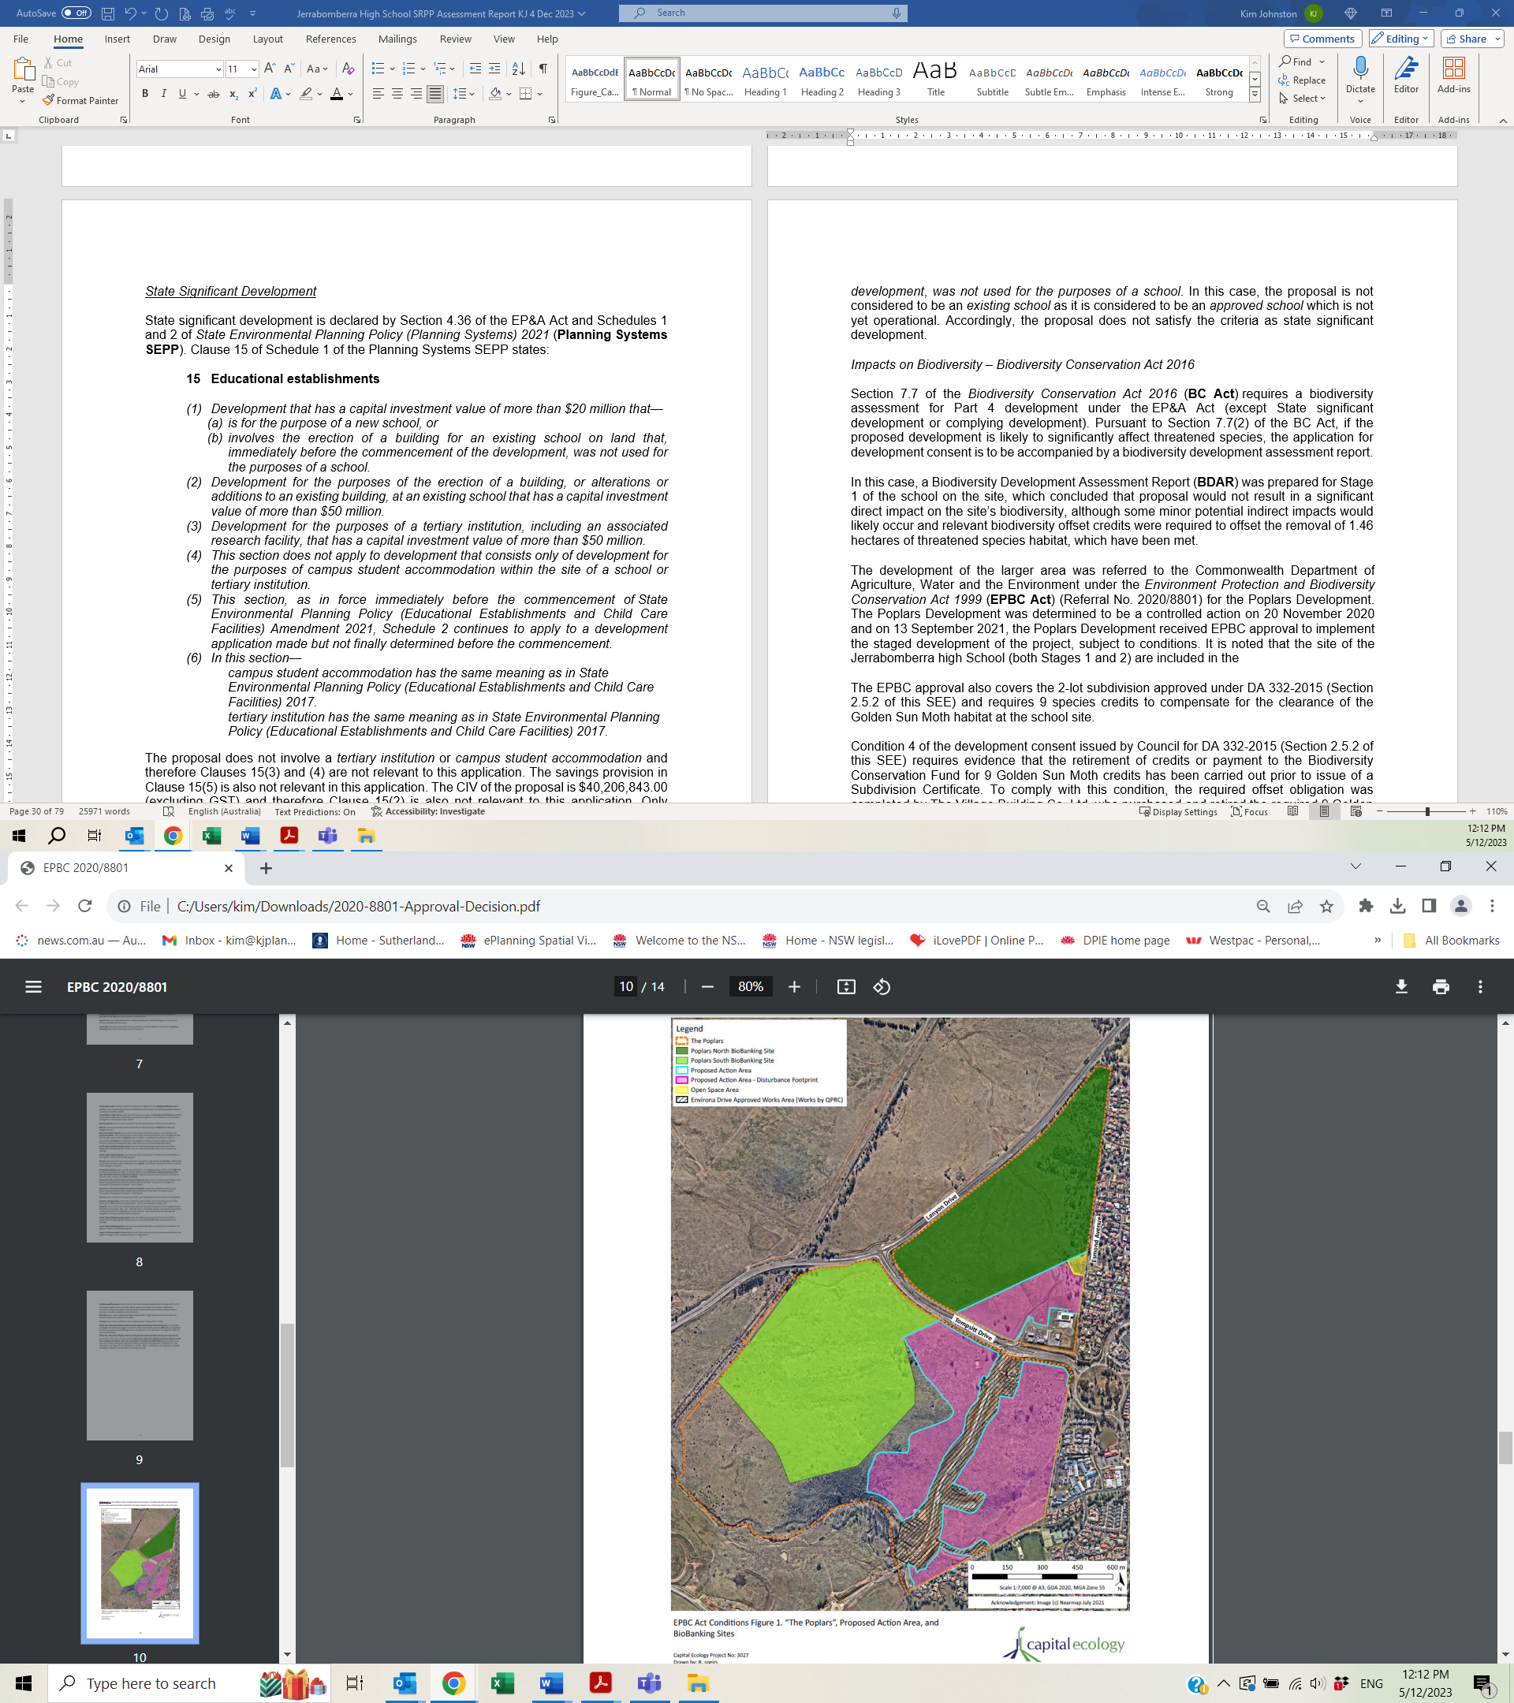
The site
Figure 30: EPBC Approval (Source: EPBC Act Public Portal)

Environmental Planning Instruments, proposed instrument, development control plan, planning agreement and the regulations

The relevant environmental planning instruments, proposed instruments, development control plans, planning agreements and the matters for consideration under the Regulation are considered below.
- Section 4.15(1)(a)(i) - Provisions of Environmental Planning Instruments

The following Environmental Planning Instruments and Development Control Plans are relevant to this application:

- State Environmental Planning Policy (Planning Systems) 2021
- State Environmental Planning Policy (Biodiversity and Conservation) 2021
- State Environmental Planning Policy (Resilience and Hazards) 2021
- State Environmental Planning Policy (Transport and Infrastructure) 2021
- Queanbeyan-Palerang Regional Local Environmental Plan 2022;
- South Jerrabomberra Development Control Plan 2015

It is noted that State Environmental Planning Policy (Industry and Employment) 2021 does not apply to the application as there is no additional signage proposed in the application. Accordingly, a condition requiring a further application being required if any signage is not exempt or complying development has been included in the recommended consent conditions.

A summary of the key matters for consideration arising from these Environmental Planning Instruments and Development Control Plans are outlined in Table 3 and considered in more detail below. The jurisdictional preconditions to the grant of consent are in bold and have been satisfied. The variation to the maximum height development standard of the LEP is further considered in the LEP assessment.

Table 3: Summary of Applicable Environmental Planning Instruments
EPI | Matters for Consideration | Comply
State Environmental Planning Policy (Planning Systems) 2021 | Chapter 2: State and Regional Development  - Section 2.19(1) declares the proposal regionally significant development – Cl 4 (Crown Development >$5 million and Cl 5(b) (Community Facility - Educational Establishment >$5 million) of Schedule 6 | Yes
State Environmental Planning Policy (Biodiversity & Conservation) 2021 | Chapter 4: Koala Habitat Protection 2021  - Section 4.4(1) - Land to which Chapter applies  - Section 4.9 — no approved koala plan of management for land | Yes  Yes
State Environmental Planning Policy (Resilience & Hazards) | Chapter 4: Remediation of Land  - Section 4.6(1) - Contamination of land | Yes
State Environmental Planning Policy (Transport and Infrastructure) 2021 | Chapter 2: Infrastructure  - Section 2.48(2) (Determination of development applications—other development) – electricity transmission - the proposal is satisfactory subject to conditions.  Chapter 3: Educational Establishments  - Section 3.36(3) - Schools—development permitted with consent  - Schedule 8 - Design quality principles in schools—Chapter 3 (required by Section 3.36(6))  - Section 3.58 – Traffic-generating development | Yes  Yes  Yes  Yes
Queanbeyan-Palerang Regional Local Environmental Plan 2022 | Permissible with consent and generally consistent with the development standards and controls, including the preconditions to the grant of consent being satisfied (in bold). The relevant clauses include:  - Clause 1.2 – aims of the Plan  - Clause 1.4 – Definitions  - Clause 2.2 & 2.3 – Land Use Table  - Clause 2.5 – Additional permitted uses for particular land (Cl 24 of Schedule 1)  - Clause 4.3(2) – Height of Buildings - Inconsistent with the height of buildings development standard (Cl 4.3(2)).  - Clause Cl 4.4(2) - FSR  - Clause Cl 5.10 - Heritage  - Clause Cl 5.21 - Flood Planning  - Clause Cl 6.2(1) - Public utility Infrastructure  - Clause Cl 6.3(2) - DCP  - Clause Cl 7.1 – Earthworks  - Clause Cl 7.8(2) – Airspace operations  - Clause Cl 7.9(3) - Aircraft Noise  - Clause Cl 7.10(3) - Aircraft Noise – South Jerrabomberra  - Clause 7.12 - Essential Services | Yes  Yes  Yes  Yes  No  Yes  Yes  Yes  Yes  Yes  Yes  Yes  Yes  Yes  Yes  Yes
South Jerrabomberra Development Control Plan | - Part 3: The Master Plan  - Part 8 – Environmental Management  - Part 10 – Neighbourhood Centre including Mixed Use Controls and Principles  - Part 11 – Business Parks and Employment Land Controls and Principles  - Part 2 Sections 2.1 to 2.9 of the Queanbeyan Development Control Plan 2012 are also relevant to the application | Yes  Yes  Yes  Yes  Yes

- State Environmental Planning Policy (Planning Systems) 2021

The proposal is regionally significant development pursuant to Section 2.19(1) as it satisfies the criteria in Clause 4 as Crown development (pursuant to Sections 4.32 & 4.33 of the EP&A Act) with a capital investment value (CIV) of more than $5 million. The proposal also satisfies the criteria in Clause 5(b) of Schedule 6 of the Planning Systems SEPP as the proposal is development for an educational establishment with a CIV of more than $5 million. Accordingly, the Southern Regional Planning Panel is the consent authority for the application. The proposal is consistent with this Policy.

- State Environmental Planning Policy (Biodiversity and Conservation) 2021

State Environmental Planning Policy (Biodiversity and Conservation) 2021 (‘Biodiversity & Conservation SEPP’) provides controls for various environmental issues, with Chapter 4 the only relevant chapter for the current application.

Chapter 4: Koala Habitat Protection 2021

This Chapter aims to encourage the conservation and management of areas of natural vegetation that provide habitat for koalas to support a permanent free-living population over their present range and reverse the current trend of koala population decline. Pursuant to Section 4,4(1), the Policy applies to the site as Queanbeyan-Palerang Regional LGA is listed in Schedule 2 and the relevant koala management area is Central and Southern Tablelands (s4.4(2)(a)).

Section 4.9 applies to the proposal as the site comprises an area of at least 1 hectare land and there is no approved koala plan of management which applies to the site (Section 4.9(1)). Before a Council may grant consent to a development application for consent to carry out development on the land, the Council must assess whether the development is likely to have any impact on koalas or koala habitat (Section 4.9(2)). Therefore, the test to be satisfied is whether the proposal will have any impact on koalas or koala habitat.

Section 4.9(3) provides that if the council is satisfied that the development is likely to have low or no impact on koalas or koala habitat, the council may grant consent to the development application. Section 4.9(4) provides that if the council is satisfied that the development is likely to have a higher level of impact on koalas or koala habitat, the council must, in deciding whether to grant consent to the development application, take into account a koala assessment report for the development. In this case, the BDAR provided for Stage 1 provides an assessment of the potential impacts on koalas and therefore satisfies this requirement.

Section 4.9(5) states that, despite subsections (3) and (4), the council may grant development consent if the applicant provides to the council—

- information, prepared by a suitably qualified and experienced person, the council is satisfied demonstrates that the land subject of the development application—
- does not include any trees belonging to the koala use tree species listed in Schedule 3 for the relevant koala management area, or
- is not core koala habitat, or

- information the council is satisfied demonstrates that the land subject of the development application—
- does not include any trees with a diameter at breast height over bark of more than 10 centimetres, or
- includes only horticultural or agricultural plantations.

For clarity, core koala habitat is defined in Section 4.2(1) of the Policy as:

core koala habitat means—
- an area of land which has been assessed by a suitably qualified and experienced person as being highly suitable koala habitat and where koalas are recorded as being present at the time of assessment of the land as highly suitable koala habitat, or
- an area of land which has been assessed by a suitably qualified and experienced person as being highly suitable koala habitat and where koalas have been recorded as being present in the previous 18 years.

It is also noted that Section 4.10 provides that a Council is not prevented from granting consent to a development application for consent to carry out development on land if the land does not have an approved koala plan of management applying to the land, or the council is satisfied that the land is not core koala habitat.

The BDAR stated that the subject land supports a number of the tree species listed in Schedule 3 of the Koala Habitat Protection SEPP and therefore the site supports ‘potential koala habitat’. Following further consideration of the potential for the site to contain core koala habitat, which would indicate whether there was likely to be impacts on the koala and koala habitat, the BDAR provided the following conclusions:

- The site is separated from the nearest Koala records by more than 6 km, all of which occurs in intact vegetation to the west, with the intervening areas characterised by urban development which includes a substantial number of significant impediments to Koala movement including roads, urban expanse and other human disturbance.

- Approximately 97% of the site has been historically cleared and the remaining vegetation is thinned, isolated, and fragmented.

- The development footprint itself does not support any potential habitat.

- There were no Koalas or signs of Koala presence detected during the surveys conducted or by previous ecological surveys of “The Poplars” property.

- The degraded vegetation and lack of Koala observations indicates that the subject land could not be classified as ‘important habitat’ for breeding.

Therefore, the BDAR concluded that the site is considered unlikely to support Koala habitat and as such is unlikely to constitute important or occupied Koala habitat now or in the future. It also concluded that the species is considered unlikely to breed on the site. The BDAR stated that, in light of the above, Council can be satisfied that the site is not Koala habitat, and it is therefore not prevented by Section 4.9(2) of this policy from granting consent to a development application within the site. The SSD assessment report for Stage 1 supported the BDAR conclusions that the site did not satisfy the definition of highly suitable koala habitat.

Having considered the BDAR, it is considered that the proposal is likely to have low or no impact on koalas or koala habitat pursuant to Section 4.9(3) of the Policy and therefore consent may be granted consent to the development application. Further, it is considered that the site does not constitute core koala habitat and therefore the proposal also satisfies Section 4.9(5)(A)(ii) and consent can be granted. Accordingly, the proposal is considered to be consistent with this Policy subject to recommended consent conditions in Attachment A requiring compliance with the CEMP.

- State Environmental Planning Policy (Resilience and Hazards) 2021

State Environmental Planning Policy (Resilience and Hazards) 2021 (‘Resilience and Hazards SEPP’) commenced on 1 March 2022 and provides controls relating to resilience and hazards matters, with Chapter 4 (remediation of land) relevant to the proposal, considered below.

Chapter 4: Remediation of Land

Chapter 4 aims to promote the remediation of contaminated land in order to reduce the risk of harm to human health or any other aspect of the environment. Section 4.6 requires contamination and remediation to be considered in determining a development application.

- A consent authority must not consent to the carrying out of any development on land unless—
- it has considered whether the land is contaminated, and
- if the land is contaminated, it is satisfied that the land is suitable in its contaminated state (or will be suitable, after remediation) for the purpose for which the development is proposed to be carried out, and
- if the land requires remediation to be made suitable for the purpose for which the development is proposed to be carried out, it is satisfied that the land will be remediated before the land is used for that purpose.

Comment: It is considered that the site is not contaminated, which is considered further below.

- Before determining an application for consent to carry out development that would involve a change of use on any of the land specified in subsection (4), the consent authority must consider a report specifying the findings of a preliminary investigation of the land concerned carried out in accordance with the contaminated land planning guidelines.

Comment: A change of use is proposed for the land (as it is currently vacant land and it is now proposed for a school), however, the site is considered to be ‘land specified’ in subclause (4) as it is proposed to be used for education purposes and there is a potential history of agricultural use on the site. A Preliminary Investigation has been prepared for the site, which is considered further below.

- The applicant for development consent must carry out the investigation required by subsection (2) and must provide a report on it to the consent authority. The consent authority may require the applicant to carry out, and provide a report on, a detailed investigation (as referred to in the contaminated land planning guidelines) if it considers that the findings of the preliminary investigation warrant such an investigation.

Comment: A Preliminary Investigation has been prepared for the site (considered further below). Given the conclusion of this preliminary investigation is that the site is not contaminated, a detailed investigation is not required.

- The land concerned is—
- land that is within an investigation area,
- land on which development for a purpose referred to in Table 1 to the contaminated land planning guidelines is being, or is known to have been, carried out,
- to the extent to which it is proposed to carry out development on it for residential, educational, recreational or child care purposes, or for the purposes of a hospital—land—
- in relation to which there is no knowledge (or incomplete knowledge) as to whether development for a purpose referred to in Table 1 to the contaminated land planning guidelines has been carried out, and
- on which it would have been lawful to carry out such development during any period in respect of which there is no knowledge (or incomplete knowledge).

Comment: The site is not within an investigation area, however, the site is to be used for educational purposes and a land use listed in Table 1 may have occurred on the site (agricultural activities) in the past. Therefore, a Preliminary Investigation has been undertaken which is considered further below.

A Preliminary Site Contamination Assessment prepared by Douglas Partners dated 21 June 2023 (PSI) has been undertaken on the site, which included a review of the site history and potential sources and areas of contamination were identified on the basis of the available site information and site walkover. The PSI also considered the previous PSI dated 16 September 2021 and Limited Contamination Assessment (LCA) dated 16 September 2021 both also prepared by Douglas Partners, carried out on the site for Stage 1 of the school. The LCA included a limited subsurface investigation. These previous reports are generally consistent with the current PSI.

The use of the site up to around 2020 was likely grazing given the absence of any structures or other development in aerial photographs. During 2020, construction of the sewer main occurred, the western and northern boundaries of the site were disturbed as part of the Environa Drive construction site and stockpile placement occurred within the south-eastern corner of the site. The PSI considered that the origin and quality of the fill at the time of its placement is unknown.

A Detailed Site Investigation carried out by Douglas Partners in 2022 for Stage 1 advised:

“If during excavation, the natural in situ soil is found to contain possible signs of contamination or is cross-contaminated with any non-VENM materials (i.e., fill material observed in the 2022 aerial photograph), the excavated natural soil cannot be classified as VENM. In this regard, it is also recommended that care should be taken during the bulk excavation of the VENM to prevent cross contamination between the VENM and non-VENM materials.

It should be noted that further testing may be warranted once material is excavated and stockpiled. VENM should not be stockpiled or processed in any way. A site for the use of the VENM should be identified prior to commencement of site excavations and once commenced, the excavated VENM should be transported directly to the reuse site.”

The PSI concluded:

- Based on the findings of the investigation, it is considered that the likelihood of gross chemical contamination to be present on the site is low.

- The material stockpiled is not considered to be VENM (based on the DSI, 2022).

- The site can be rendered suitable for the proposed Stage 2 development from a contamination perspective, subject to the following recommended investigations being undertaken, including:

- Should the stockpile remain within the proposed school site, an intrusive investigation should be undertaken to determine the quality of the material. It is understood that the material of the stockpile was placed in an uncontrolled manner (from a geotechnical point of view), therefore, it is understood that a geotechnical investigation is required. It is recommended that any intrusive contamination works should be conducted concurrently with the geotechnical investigation to reduce future investigation costs;

- Should any fill material be required to be disposed off-site, the material must be assessed in accordance with NSW EPA Waste Classification Guidelines Part 1 Classifying Waste (2014) and assigned a waste classification prior to off-site disposal.

- The proposed car parking extension area did not appear to have fill present and would not require further investigation at this point in time. However, should fill be placed within this area, further testing may be required prior to the construction of the car parking space.

- It is recommended that the following measures be undertaken at the site during any future Stage 2 development works:

- A Construction Environment Management Plan (CEMP) should be prepared including an ‘unexpected finds protocol’ and implemented during the works (i.e. hydrocarbon staining and/odours observed during works);
- An asbestos finds protocol should be prepared and implemented during construction work (to be included in the CEMP); and
- Should suspected asbestos be encountered at the site, the affected area should be fenced off and assessed by an NSW licensed asbestos assessor.

These recommendations are included in the recommended consent conditions in Attachment A.

Subsequent to the PSI being prepared in June 2023, a Geotechnical Assessment of Spoil Stockpiles - Material Assessment prepared by ACT Geotechnical Engineers Pty Ltd dated 27 July 2023 concluded that:

Our field inspections and subsurface investigation found no evidence to indicate the presence of gross contaminants within the virgin natural soil on the site. The soils within all three stockpile were all ‘clean’, and there were no chemical or hydrocarbon odours and the material is free of household waste, builders rubbles, asphalt, road base, organics, or other deleterious matter. It can therefore be reasonably concluded that the site soils are virgin excavated natural material (VENM) and are environmentally suitable to be used as controlled fill (Stockpiles #1 and #2), or landscaping works (Stockpile #3), or disposed of in land fill.

Following a review of the PSI, it is considered that the site is unlikely to be contaminated and the application has adequately addressed Section 4.6 of the Resilience and Hazards SEPP subject to the recommended consent conditions as outlined above. It is considered that the jurisdiction preconditions to the grant of consent have been satisfied.

The proposal is considered to be consistent with Chapter 4 of the Resilience and Hazards SEPP subject to consent conditions recommended in Attachment A regarding unexpected finds of contamination.

- State Environmental Planning Policy (Transport and Infrastructure) 2021

State Environmental Planning Policy (Transport and Infrastructure) 2021 (‘Transport & Infrastructure SEPP’) outlines the controls for the provision of infrastructure and schools, among other matters. Chapter 2 (Infrastructure) and Chapter 3 (Educational Establishments) are relevant to the development application.

Chapter 2: Infrastructure

The following provisions of Chapter 2 are relevant to the development application:

- Section 2.48 – Determination of development applications – other development - This section applies to a development application comprising or involving any of the following:

- the penetration of ground within 2m of an underground electricity power line or an electricity distribution pole or within 10m of any part of an electricity tower,
- development carried out—
- within or immediately adjacent to an easement for electricity purposes (whether or not the electricity infrastructure exists), or
- immediately adjacent to an electricity substation, or
- within 5m of an exposed overhead electricity power line,

In this case, the site achieves this criteria given there is underground electrical infrastructure located along the western boundary of the site. Therefore this section requires consideration (Section 2.48(1(a)). Pursuant to Section 2.48(2), the Council consulted with Essential Energy, the electricity supply authority for the site, at which time objections were raised as there was insufficient information provided with the application, with Essential Energy stated:

As the plans provided do not show the distances from Essential Energy’s infrastructure and the development, there may be a safety risk. A distance of 3m from the nearest part of the development to Essential Energy’s infrastructure (measured horizontally) is required to ensure that there is no safety risk. FROM UNDERGROUND PADMOUNT 11KV TRANSFORMER

The applicant has provided information to outline there is a 3 metre setback to the existing pad mount transformer which is considered satisfactory (Figure 31). Relevant conditions as recommended by Essential Energy are included in Attachment A.

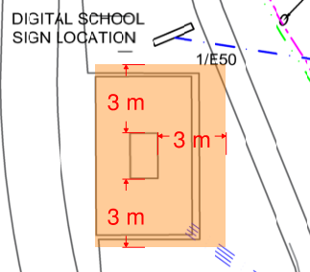
Figure 31: Distance to Pad mount transformer

- Section 2.119 - Development with frontage to classified road & Section 2.120 – Impact of road noise or vibration on non-road development – Environa Drive is not a classified road and is also not included in the “mandatory” or “recommended” category for a road noise or vibration assessment. Accordingly, these controls are not relevant to this proposal. Notwithstanding, the Acoustic Report considered the NSW Road Noise Policy (EPA, 2011) and the Development Near Rail Corridors and Busy Road – Interim Guideline (Department of Planning, 2008) and is satisfactory.

- Section 2.122 – Traffic-generating development - This section requires consideration of certain matters relating to development which is deemed to be traffic-generating. In this case, the proposal does not achieve the criteria for land uses in Column 2 (size of capacity – site with access to a road (generally). While the proposal achieves the criteria of 50 or more car parking spaces in Column 3, the site does not have access t a classified road or to road that connects to classified road. Accordingly, a referral to TfNSW is not required under this Section. Notwithstanding, the matters for consideration in this section are considered below.

- give written notice of the application to TfNSW within 7 days after the application is made - The application was referred to TfNSW as outlined below pursuant to the requirements under Chapter 3.

- take into consideration—
- any submission that RMS provides in response to that notice within 21 days after the notice was given (unless, before the 21 days have passed, TfNSW advises that it will not be making a submission) - The comments from TfNSW are considered in the key issues section of this report.

- the accessibility of the site concerned, including—
(A) the efficiency of movement of people and freight to and from the site and the extent of multi-purpose trips, and
(B) the potential to minimise the need for travel by car and to maximise movement of freight in containers or bulk freight by rail - These matters are considered in the key issues section of this report.

- any potential traffic safety, road congestion or parking implications of the development - These matters are considered in the key issues section of this report.

The matters raised by TfNSW have been considered and form relevant draft consent conditions included in Attachment A.

Chapter 3: Educational Establishments and child care facilities

Chapter 3 aims to facilitate the effective delivery of educational establishments, with Part 3.4: Schools – specific development controls relevant to the application, which is considered below.

Section 3.36(3) provides that development for the purpose of a school may be carried out by any person with development consent on land that is not in a prescribed zone if it is carried out on land within the boundaries of an existing or approved school. In this case, the RE2 zone is not a prescribed zone pursuant to Section 3.34(1), however, the proposal is proposed within the boundaries of an approved school, being Stage 1 of the school. Therefore, the proposed is permissible with consent (also refer to the QPRLEP 2022 assessment).

Pursuant to Section 3.36(6), before determining a development application for development of a kind referred to in subsection (3), the consent authority must take into consideration—

- the design quality of the development when evaluated in accordance with the design quality principles set out in Schedule 8, and

- whether the development enables the use of school facilities (including recreational facilities) to be shared with the community.

The proposed development is consistent with these principles as outlined in the Architectural Design Report dated July 2023 prepared by TKD Architects and further considered in Table 4..In relation to whether the school facilities will enable use by the community, the school has indicated that the community will share their facilities which is permissible with consent pursuant to Section 3.36(5). The SSD approval contains relevant consent conditions for the use of the school grounds by the community.

Table 4: Design Quality Principles - Schools
Design Principle | Requirement | Proposal | Comply
Principle 1—context, built form and landscape | Designed to respond to and enhance the positive qualities of their setting, landscape and heritage, including Aboriginal cultural heritage. The design and spatial organisation of buildings and the spaces between them should be informed by site conditions such as topography, orientation and climate.  Landscape should be integrated into the design of school developments to enhance on-site amenity, contribute to the streetscape and mitigate negative impacts on neighbouring sites.  School buildings and their grounds on land that is identified in or under a local environmental plan as a scenic protection area should be designed to recognise and protect the special visual qualities and natural environment of the area, and located and designed to minimise the development’s visual impact on those qualities and that natural environment. | The proposed new buildings are integrated into the site to ensure there are minimal disruptions to the natural environment and is a logical extension of the existing school buildings. The proposed new building continues the alignment of the buildings to the west and provides the central area as play and gathering space. The proposed new building also shields the site from the noise and winds along Environa Drive.  The orientation of the proposed new building to the west allows for views out to the future conservation area. The open play areas to the east provides a transition to the low density residential area to the east of the site.  The proposed landscaping provides for 102 new trees as well as planter beds and terrace planting which allows for shade trees and boundary planting to integrate the proposal into the area and the streetscape.  The site is not in a scenic protection area, however, the visual amenity of nearby land is not adversely impacted by the proposal given the proposed new building is of a satisfactory size and scale for the site. the materials palette provide a mix of texture and colours consistent the existing buildings on the site. | Yes
Principle 2—sustainable, efficient and durable | Good design combines positive environmental, social and economic outcomes. Schools and school buildings should be designed to minimise the consumption of energy, water and natural resources and reduce waste and encourage recycling.  Schools should be designed to be durable, resilient and adaptable, enabling them to evolve over time to meet future requirements. | The proposed sustainability measures for the proposed development include the following and are satisfactory:  - Energy efficient lighting and smart control systems.  - Energy efficient hot water system.  - Metering and monitoring of all services so that they can be managed efficiently.  - Roof top PVs to reduce the peak electricity demand  - Elimination of the use of gas for heating and cooling (all-electric services)  - building with good natural light and ventilation  - Water efficient fixtures and fittings (high WELS ratings),  - Rainwater collection from the roof and stored for use on-site (landscaping irrigation, toilet flushing) to reduce potable water consumption,  - Incorporation of separate bins for waste and recycling for separation of waste streams.  - Active transport and sustainable transport strategies include provision of good end of trip facilities (e.g. secure bike parking, showers and lockers for staff and change facilities for students) to encourage active transport | Yes
Principle 3—accessible and inclusive | School buildings and their grounds should provide good wayfinding and be welcoming, accessible and inclusive to people with differing needs and capabilities.  Schools should actively seek opportunities for their facilities to be shared with the community and cater for activities outside of school hours. | The proposed new building and play spaces are provided at generally the same level as the existing school facilities with covered walkway joining existing Block A with the proposed new building. Accessible toilets and ramps are proposed and lifts are proposed. a wayfinding strategy has also been provided with directional signage provided.  Potential community use of the gym and outdoor multi-sports courts from stage 1 and turf areas from stage 2 has been considered. | Yes
Principle 4—health and safety | Good school development optimises health, safety and security within its boundaries and the surrounding public domain, and balances this with the need to create a welcoming and accessible environment. | The proposal provides for optimal natural ventilation and natural light to provide for thermal comfort and enhance well-being of occupants. The proposal has a high level of pedestrian amenity and is well connected to the existing part of the school.  The proposal provides for adequate safety for students, with the administration located at the front of the site and the buildings are to be maintained in a safe and healthy way. Appropriate security measures have been included in the design with a good level of natural surveillance. | Yes
Principle 5—amenity | Schools should provide pleasant and engaging spaces that are accessible for a wide range of educational, informal and community activities, while also considering the amenity of adjacent development and the local neighbourhood.  Schools located near busy roads or near rail corridors should incorporate appropriate noise mitigation measures to ensure a high level of amenity for occupants.  Schools should include appropriate, efficient, stage and age appropriate indoor and outdoor learning and play spaces, access to sunlight, natural ventilation, outlook, visual and acoustic privacy, storage and service areas. | The proposed school addition provides for improved facilities and amenity for students. Acoustic amenity of staff and students has been considered having regard for the road and nearby airport. Potential impacts to adjoining residents has also been considered with likely limited overshadowing or acoustic impacts given the setback to these residential properties.  The proposal also provides for improved landscaping and pedestrian access to keep students and staff safe while traversing the site.  Large areas of open space are retained on the site for student enjoyment and physical activity. | Yes
Principle 6—whole of life, flexible and adaptive | School design should consider future needs and take a whole-of-life-cycle approach underpinned by site wide strategic and spatial planning. Good design for schools should deliver high environmental performance, ease of adaptation and maximise multi-use facilities. | The proposal has been designed around potential future improvements at the site and provides significant sustainability measures on the site. The proposal provides flexible learning spaces which can be used for a variety of purposes. | Yes
Principle 7—aesthetics | School buildings and their landscape setting should be aesthetically pleasing by achieving a built form that has good proportions and a balanced composition of elements. Schools should respond to positive elements from the site and surrounding neighbourhood and have a positive impact on the quality and character of a neighbourhood.  The built form should respond to the existing or desired future context, particularly, positive elements from the site and surrounding neighbourhood, and have a positive impact on the quality and sense of identity of the neighbourhood. | The proposal includes significant landscaping, which provides for aesethically pleasing areas while the proposed new buildings have been designed to be an attractive addition to the school.  The proposed new building is appropriately articulated and addresses the street. the design of the proposed additions are appropriate and integrated with the existing school buildings on the site. The necessary site services have been integrated into the site to reduce visual impacts. | Yes

Section 3.36(9) provides that a provision of a development control plan that specifies a requirement, standard or control in relation to development of a kind referred to in subsection (1), (2), (3) or (5) is of no effect, regardless of when the development control plan was made. This is relevant to this proposal as Section 3.36(3) is relevant. This is noted, however, the proposal has been considered under the provisions of the applicable DCPs and found to be generally consistent with the relevant planning controls.

Section 3.58(1) applies to the proposal for traffic generating development as the development involves an increase of more than 50 students and an enlargement or extension to the existing premises which has direct vehicular or pedestrian access to any road is proposed. Before determining a development application for development to which this section applies, the consent authority must (S 3.58(2)):

- give written notice of the application to Transport for NSW (TfNSW) within 7 days after the application is made, and
- take into consideration the matters referred to in subsection (3).

Pursuant to Section 3.58(3), the consent authority must take into consideration—

- any submission that TfNSW provides in response to that notice within 21 days after the notice was given (unless, before the 21 days have passed, TfNSW advises that it will not be making a submission), and
- the accessibility of the site concerned, including—
- the efficiency of movement of people and freight to and from the site and the extent of multi-purpose trips, and
- the potential to minimise the need for travel by car, and
- any potential traffic safety, road congestion or parking implications of the development.

The application was referred to TfNSW which did not object to the proposal subject to recommended consent conditions and the issue of student safety using public buses. These matters are also considered in the key issues section of this report and have been adequately addressed subject to the recommended consent conditions in Attachment A.

Accordingly, the proposal is considered to be consistent with the Transport & Infrastructure SEPP and satisfies the matters requiring consideration prior to determining a development application.

- Queanbeyan-Palerang Regional Local Environmental Plan 2022

The relevant local environmental plan applying to the site is the Queanbeyan-Palerang Regional Local Environmental Plan 2022 (QPRLEP 2022) which commenced on 14 November 2022. The particular aims of the LEP pursuant to Clause 1.2(2) which are relevant to the proposal include:

(aa) to protect and promote the use and development of land for arts and cultural activity, including music and other performance arts,
- to protect and improve the economic, environmental, social and cultural resources and prospects of the community,
- to facilitate the orderly and economic use and development of land having regard to ecological sustainability principles,
- to provide for a diversity of housing to meet the needs of the community into the future,
- to provide for a hierarchy of retail, commercial and industrial land uses that encourage economic and business development that caters for the retail, commercial and service needs of the community,
- to keep and protect important natural habitat and biodiversity,
- to protect water quality, aquifers and waterways,
- to keep, protect and encourage sustainable primary industry and associated commerce in rural areas,
- to identify and protect the cultural heritage of the area, including the built heritage and the Aboriginal heritage,
- to protect important scenic quality, views and vistas,
- to facilitate the orderly growth of urban release areas,
- to ensure development does not unreasonably increase the demand for public services or public facilities,
- to identify, protect and provide areas for community health and recreational activities.

The proposal is consistent with these aims as the proposal is generally consistent with the planning controls and provides the following outcomes:

- The proposal improves the social and cultural resources and prospects of the community by providing a larger and enhanced public high school,
- The proposal facilitates the orderly and economic use and development of land having regard to ecological sustainability principles in that the additional student capacity is provided on the site of a school which is currently being constructed and on cleared land;
- The proposal protects important natural habitat and biodiversity by reducing off-site impacts arising from stormwater runoff which is captured, treated and conveyed to appropriate discharge points. The proposal also does not require the removal of any significant trees or vegetation, with the natural habitat for the area enhanced through the proposed landscaping comprising the planting of 102 trees.
- The proposal does not adversely impact on any Aboriginal cultural items;
- The proposal does not result in any adversely scenic impacts as the proposed building is consistent with the existing building forms on the site and incorporates landscaping and open space areas;
- The proposal facilitates the orderly growth of new release areas in that it involves the extension of a school currently under construction and is located in the education precinct of the Poplars precinct. The proposal is also consistent with the development of the urban release area.
- The proposal is consistent with the planning controls and strategies for the area, being within the education precinct and therefore ensures development does not unreasonably increase the demand for public services or public facilities,
- The proposal provides for areas which may be used by the community out of school hours and therefore contributes to community health and recreational activities.

Zoning and Permissibility (Part 2)

The site is located within the RE2 Private Recreation zone and B7 Business Park zone pursuant to Clause 2.2 of the QPRLEP 2022 (Figure 32). The portion of the site for proposed Stage 2 is within the RE2 zone. The B7 zone is now the E3 Productivity Support pursuant to the employment zone reforms in April 2023 (notwithstanding the planning portal mapping has not been updated for this site).

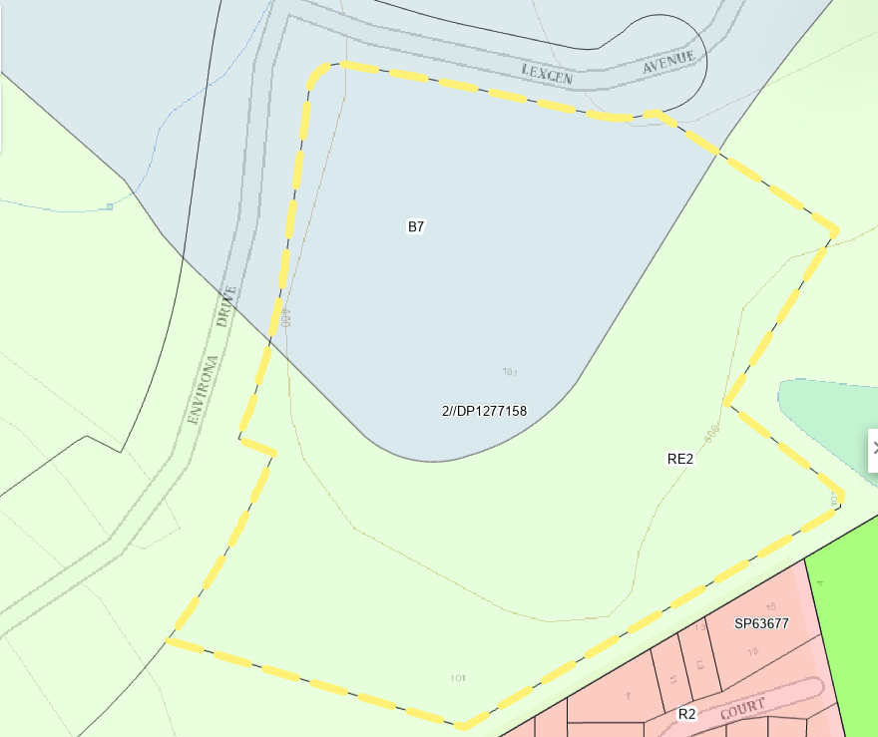
Figure 32: Zoning Map (Source: NSW Planning Portal Spatial Viewer)

According to the definitions in Clause 1.4 (contained in the Dictionary), the proposal satisfies the definition of a school, which are a type of educational establishment, with the following relevant definitions:

educational establishment means a building or place used for education (including teaching), being—
(a) a school, or
(b) a tertiary institution, including a university or a TAFE establishment, that provides formal education and is constituted by or under an Act.

school means a government school or non-government school within the meaning of the Education Act 1990.
Note— Schools are a type of educational establishment—see the definition of that term in this Dictionary.

In terms of permissibility, Clause 2.5 provides for additional permitted uses which may be carried out on the subject site with development consent pursuant to Cause 24 of Schedule 1 (Figure 33), which states:

24 Use of certain land at Lanyon Drive, Jerrabomberra
- This clause applies to part of Lot 1, DP 1263364, Lanyon Drive, Jerrabomberra, identified as “Item 6” on the Additional Permitted Uses Map.
- Development for the purposes of a single educational establishment is permitted with development consent.

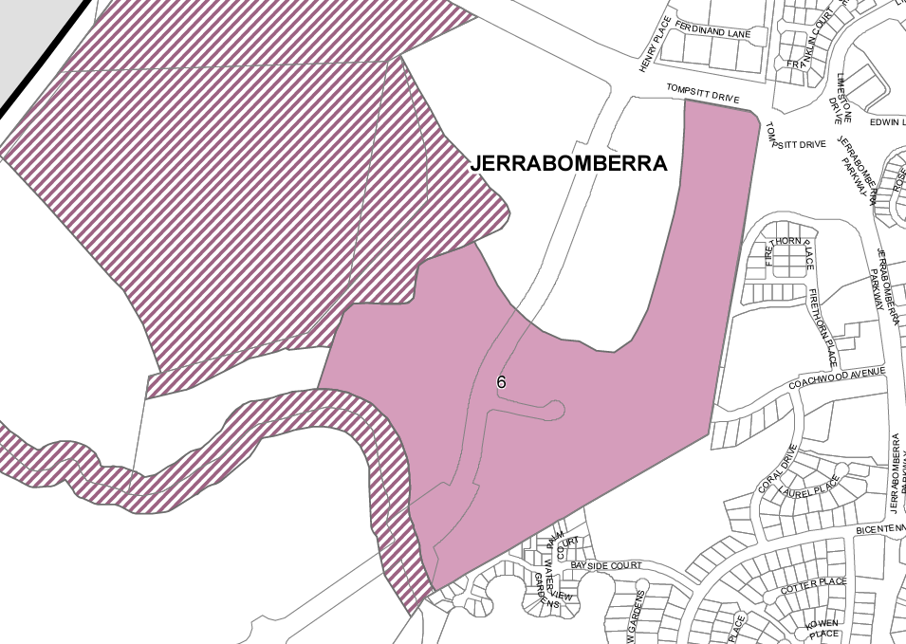
Figure 33: Additional Permitted Uses Map (Source: NSW Planning Portal Spatial Viewer/LEP)

The proposal constitutes a ‘single educational establishment’ as it comprises Stage 2 of the school located on the site. Clause 2.7 allows demolition with consent, with minor internal demolition proposed in the existing Block B (with Stage 1 of the school).

Pursuant to Section 3.36(3) of the Transport & Infrastructure SEPP, development for the purpose of a school may be carried out by any person with development consent on land that is not in a prescribed zone if it is carried out on land within the boundaries of an existing or approved school. In this case, the land is within the boundaries of an approved school (at the time of lodgement of the development application) and therefore the proposal is also permissible under the Transport & Infrastructure SEPP, notwithstanding that the RE2 zone is not a prescribed zone pursuant to Section 3.34(1) of that SEPP. Therefore, the proposal is permissible with consent on the site.

Pursuant to Clause 2.3, the relevant zone objectives include:

E3 Productivity Support
- To provide a range of facilities and services, light industries, warehouses and offices.
- To provide for land uses that are compatible with, but do not compete with, land uses in surrounding local and commercial centres.
- To maintain the economic viability of local and commercial centres by limiting certain retail and commercial activity.
- To provide for land uses that meet the needs of the community, businesses and industries but that are not suited to locations in other employment zones.
- To provide opportunities for new and emerging light industries.
- To enable other land uses that provide facilities and services to meet the day to day needs of workers, to sell goods of a large size, weight or quantity or to sell goods manufactured on-site.
- To maintain the retail hierarchy of Queanbeyan.
- To provide for a well-designed business park that appropriately responds to site constraints and adjoining residential development.

Zone RE2 Private Recreation
- To enable land to be used for private open space or recreational purposes.
- To provide a range of recreational settings and activities and compatible land uses.
- To protect and enhance the natural environment for recreational purposes.
- To protect and enhance the scenic and environmental resources of the land.
- To ensure the scale and character of development is compatible with the established land uses of the locality.

The proposal is generally consistent with the E3 zone objectives in that it provides a land use which is compatible with, but does not compete with, land uses in surrounding local and commercial centres and does not impact on the economic viability of local and commercial centres. The proposal provides for land uses that meet the needs of the community, but that are not suited to locations in other employment zones (given its location adjoining Stage 1 of the school) and is considered to satisfy the ‘other land uses’ category that provide facilities and services to meet the day to day needs of the community. There is other land in the vicinity of the site, developed as part of the Polars precinct, which is designed for innovation and business park uses.

In relation to the RE2 objectives, the proposal allows for use of the school facilities outside of school hours by the community and therefore will enable land to be used for private open space or recreational purposes. The proposal will allow for the protection and enhancement of the scenic and environmental resources of the land through the additional landscaping proposed for the site. The scale and character of the proposal is compatible with the established land uses of the locality.

Therefore, the proposal is considered to be generally consistent with the relevant zone objectives. Furthermore, the proposal is considered to be consistent with Clause 2.3(2) of the QPRLEP 2022 in that the consent authority has had regard for the objectives of the zone when determining a development application.

Relevant controls and Principal Development Standards (Parts 4, 5, 6 and 7)

The LEP also contains controls relating to development standards (Part 4), miscellaneous provisions (Part 5), provisions for urban release areas (Part 6) and additional local provisions (Part 7). The controls relevant to the proposal are considered in Table 5 below. It is noted that there is no subdivision proposed and therefore Clauses 4.1 to 4.2 (inclusive) are not relevant to the application. Height of buildings and Floor Space Ratio development standards vary across the site and are considered further below. The preconditions to the grant of consent (in bold) are satisfied.

Table 5: Consideration of the QPRLEP 2022 Controls
Control | Requirement | Proposal | Comply
Part 4: Principal development standards
Height of buildings  (Cl 4.3(2)) | 8.5 metres, 12 metres and N/A height limit area (Fig 29) | Max overall height –  15.298m  Max height (in 8.5m height) - 6.798 metres  (minor section of Block E) | No  Cl 4.6  Refer to Note 1
FSR  (Cl 4.4(2)) | 1:1 and N/A FSR limit area (Fig 30) | The proposal is located in the area of the site with no FSR limit.  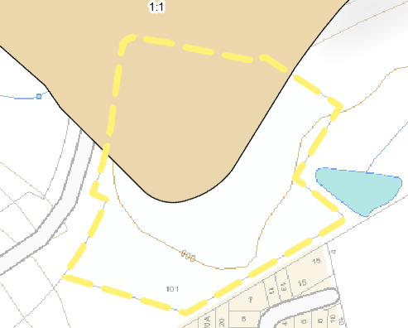 | Yes
Part 5: Miscellaneous provisions
Land acquisition  (Cl 5.1) | Acquisition of land by public authorities. | The site is not included on the acquisition map. | N/A
Heritage  (Cl 5.10) | Consideration of potential impacts to heritage | There are no heritage items located on the site, on adjoining sites or in the vicinity of the site. Aboriginal cultural heritage is considered below. | Yes  Refer to Note 2
Infrastructure development and use of existing buildings of the Crown  (Cl 5.12(1)) | This Plan does not restrict or prohibit development by or on behalf of a public authority, permitted under Transport & Infrastructure SEPP. | Permissibility is provided in Clause 2.5. | N/A
Flood planning  (Cl 5.21) | Flooding matters to be considered prior to the grant of consent. | Satisfactory – refer below | Yes  Refer to Note 3
Part 6: Urban release areas
Concurrence of Planning Secretary  (Cl 6.1) | Subdivision of land if the subdivision would result in a lot that is smaller than the minimum lot size permitted on the land. | There is no subdivision proposed. | N/A
Public utility Infrastructure (Cl 6.2(1)) | Consent must not be granted for development on land in an urban release area unless the consent authority is satisfied as to various matters. | Satisfactory – refer below. This precondition to the grant of consent has been satisfied. | Yes  Refer to Note 4
DCP  (Cl 6.3(2)) | Consent must not be granted for development on land in an urban release area unless a development control plan that provides for matters specified in subclause (3) has been prepared for the land. | The South Jerrabomberra Development Control Plan has been prepared, which applies to the site and covers the matters required by Clause 6.3(3). This precondition to the grant of consent has been satisfied. | Yes  Refer to DCP assessment
Part 7: Additional local provisions
Earthworks (Cl 7.1(3)) | Consideration of matters prior to granting consent. | Satisfactory – considered further in key issues section of this report. | Yes
Clauses 7.2 to 7.7 | Various environmental issues | The site is not included on these maps. | N/A
Airspace operations  (Cl 7.8(2)) | Consent must not be granted to development that the consent authority is satisfied affect the site arising from Canberra airport unless certain matters are addressed. | The site is within the Obstacle Limitation Surface (Outer Horizontal Surface) for Canberra Airport, however, the proposed development will not penetrate this surface as outlined by a referral from Canberra Airport. This precondition to the grant of consent has been satisfied. | Yes
Development in areas subject to aircraft noise (Cl 7.9(3)) | Consent must not be granted unless the consent authority considers various matters in relation to aircraft noise. | The site is located between the 20 and 25 ANEF contour for Canberra airport.  An acoustic report has been provided and the proposal is satisfactory. This is further considered below. This precondition to the grant of consent has been satisfied. | Yes  Refer to Note 5
Aircraft noise—development in the South Jerrabomberra Urban Release Area  (Cl 7.10(3)) | Consent must not be granted unless the consent authority is satisfied the development will meet various criteria in relation to aircraft noise. | The site is located between the 20 and 25 ANEF contour for Canberra airport on land in the South Jerrabomberra Urban Release Area. This is further considered below. This precondition to the grant of consent has been satisfied. | Yes  Refer to Note 5
Essential Services  (Cl 7.12) | Consent must not be granted unless the consent authority is satisfied as to certain matters. | Satisfactory – considered below.  This precondition to the grant of consent has been satisfied. | Yes  Refer to Note 4
Scenic Protection  (Cl 7.14) | Applies to land identified as “Scenic Protection Area”. | The site is not included on this map. | N/A
Development on certain land at South Jerrabomberra  (Cl 7.26) | Applies to land in “South Jerrabomberra” Urban Release Area in R2 zone if minimum lot size is 130m². | The site is not located in the R2 zone of the urban release area. | N/A

The matters requiring further consideration are further assessed below.

Note 1: Clause 4.6 Request - Height of Buildings development standard (Clause 4.3(2))

Variation of the Development Standard

Pursuant to Clause 4.3(2) of the QPLEP 2022, the site is subject to the following maximum height of buildings development standards (Figure 34):

- 8.5 metres in the southeastern section of the site
- 12 metres in the northwestern section of the site
- No maximum building height within the southern to southwestern section of the site.

The portion of the site for the proposed development is primarily located within the area of the site with no height plane requirement, while the southeastern corner of the proposed building is within the 8.5 metre height limit area of the site.

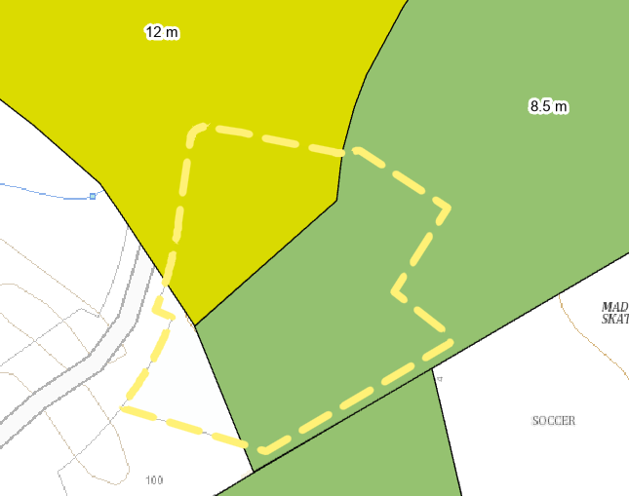
Location of proposed Block E
Figure 34: Max Building height for the site (Source: NSW Planning Portal)

The proposed building exceeds the maximum 8.5 metre height limit in this southeastern portion of the building by 6.798 metres reaching an overall height of 15.298 metres in this location (Figures 35 & 36). This represents a variation of 79.98% over the development standard. While the maximum height of the building is 17.495 metres (south elevation), this occurs in the area of the site where there is no height limit provided under the QPLEP 2022.

It is noted that the significant building height is primarily the result of the steep slope on the southern portion of the site as the proposed building is only two storeys in height as well as the need to keep the building level for accessibility.

Preconditions to be satisfied

Clause 4.6(4) of the QPLEP 2022 establishes preconditions that must be satisfied before a consent authority can exercise the power to grant development consent for development that contravenes a development standard. Clause 4.6(2) provides this permissive power to grant development consent for a development that contravenes the development standard is subject to conditions. It is noted that this application is not subject to the amendments to Clause 4.6 which commenced on 1 November 2023.

The two preconditions include:

- Tests to be satisfied pursuant to Cl 4.6(4)(a) – this includes matters under Cl 4.6(3)(a) and (b) in relation to whether the proposal is unreasonable and unnecessary in the circumstances of the case and whether there are sufficient environmental planning grounds to justify contravening the development standard and whether the proposal is in the public interest (Cl 4.6(a)(ii)); and

- Tests to be satisfied pursuant to Cl 4.6(b) – concurrence of the Planning Secretary.

These matters are considered below for the proposed height exceedance having regard to the applicant’s Clause 4.6 request.
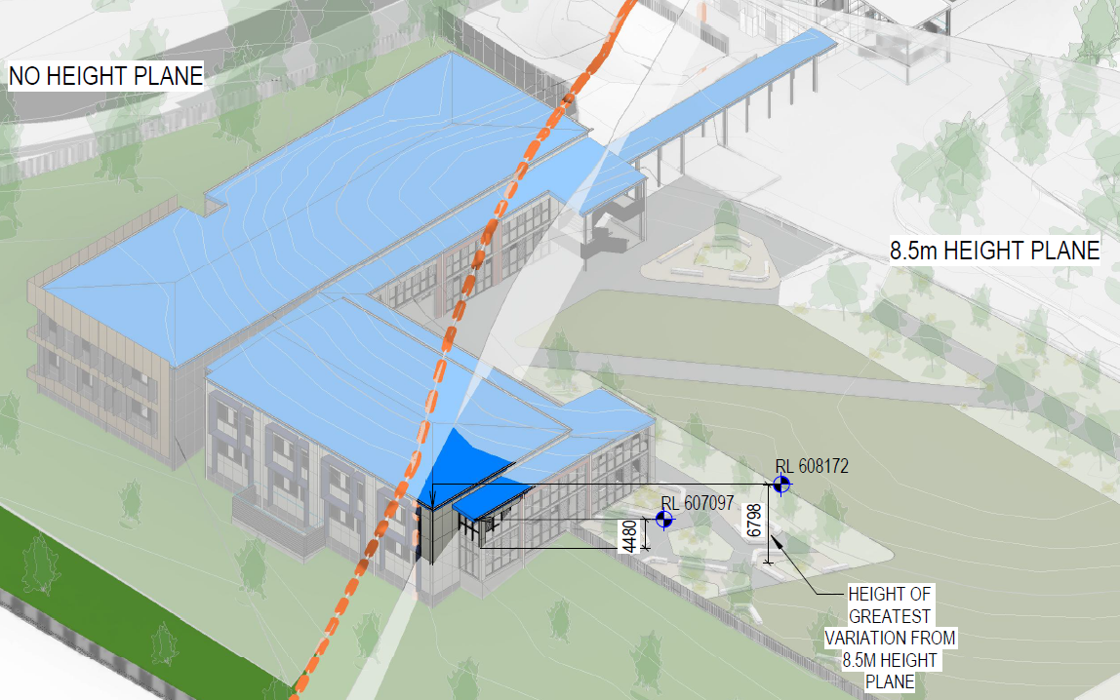
Figure 35: Proposed height exceedance (Source: TKD, 26 July 2023)

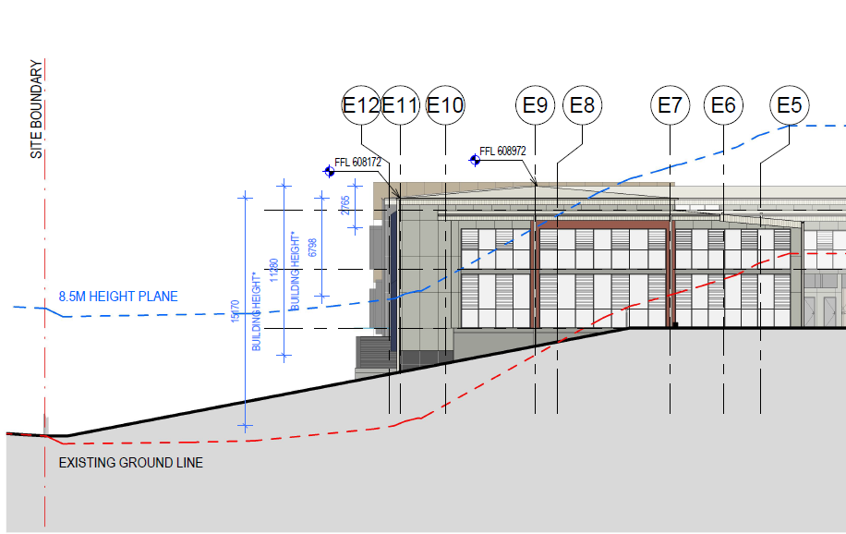
Figure 36: Proposed Height Exceedance (Source: TKD, 26 July 2023)

First Precondition

The first precondition requires the satisfaction of two (2) tests pursuant to Cl 4.6(4)(a) which includes:

- Clause 4.6(4)(a)(i) – whether the applicant’s written request has adequately addressed the matters required to be demonstrated by subclause (3), which requires the applicant to seek to justify the contravention by demonstrating:

- that compliance with the development standard is unreasonable or unnecessary in the circumstances of the case (Cl 4.6(3)(a)), and

- that there are sufficient environmental planning grounds to justify contravening the development standard (Cl 4.6(3)(b)); and

- Clause 4.6(4)(a)(ii) – whether the proposed development will be in the public interest because it is consistent with the objectives of the particular standard and the objectives for development within the zone in which the development is proposed to be carried out.

These tests for the first precondition are considered below.

Compliance with the development standard is unreasonable or unnecessary in the circumstance of this case - Clause 4.6(3)(a)

Preston CJ, in Initial Action, reconfirmed the five common ways in which an applicant might demonstrate that compliance with a development standard is unreasonable or unnecessary as outlined in Wehbe v Pittwater Council (2007) NSWLEC 827 (‘Wehbe’). The first and most commonly invoked way is to establish that compliance with the development standard is unreasonable or unnecessary because the objectives of the development standard are achieved notwithstanding non-compliance with the standard.

The applicant considers that the proposed development satisfies the first Wehbe test, in that the objectives of the standard are achieved notwithstanding noncompliance with the standards.

The objectives of the Height of Buildings development standard pursuant to Clause 4.3(1) of the QPLEP 2022 include the following:

- to establish the height of buildings consistent with the character, amenity and landscape of the area in which the buildings will be located,
- to protect residential amenity and minimise overshadowing,
- to minimise the visual impact of buildings,
- to maintain the predominantly low-rise character of buildings in the Queanbeyan-Palerang Regional local government area,
- to ensure the height of buildings complement the streetscape or the historic character of the area in which the buildings are located,
- to protect the heritage character of the Queanbeyan-Palerang Regional local government area and the significance of heritage buildings and heritage items,
- to provide appropriate height transitions between buildings, particularly at zone boundaries.

The applicant’s justification in relation to the first Wehbe test is considered below in relation to the height of buildings development standard.

- Objective (a)

Applicant’s justification:

The proposal is considered to be consistent with this objective in that the site has a number of height areas and zones, leading to inconsistency with regard to height standards and permissible uses, which rely on an additional permitted use clause. The need to provide an accessible building platform which provides continuity with the existing buildings combined with the steep topography results in a non-compliance at the southern end of proposed Block E.

The proposal still achieves an appropriate and consistent scale of building for the site given the existing school buildings on the site and the proposed landscaping assists with integration particularly given the proposed two storey building height provides for more open spaces on the site. Despite the proposed non-compliance, the building maintains height of buildings consistent with the character, amenity, and landscape of the area.

Assessment Comment:

This justification is supported given the scale and design for development on the site is consistent with the existing approved school buildings on the site and the additional landscaping is achieved by providing a two storey building rather than a higher number of single storey buildings on the site. The sloping topography and the need to provide a consistent level with other buildings on the site is considered sufficient justification for the height exceedance.

- Objective (b)

Applicant’s justification:

The proposed non-compliance does not result in any adverse amenity impacts on residential properties to the south and east, given the distance between the proposed building and the existing residential development of 36.6 metres. The incorporation of appropriate landscaping to mitigate any potential visual impact on adjoining residential properties, safeguarding their privacy and amenity also assists. The shadow diagrams depict the potential overshadowing effects of the proposed development and confirm that the small area of non-compliance does not result in any significant increase in overshadowing beyond what would be expected from a development that fully complies with the height control.

Assessment Comment:

Following a site visit and consideration of the large setback to residential development, it is considered that there will be no additional amenity impacts arising from the proposed height exceedance.

- Objective (c)

Applicant’s Justification:

The proposed non-compliance does not result in any adverse visual impacts from the streetscape or surrounding residences as the proposed building is considered to enhance the character of the streetscape by facilitating a consistent built form along Environa Drive. The campus façade along Environa Drive is thoughtfully articulated and contributes to the overall visual quality of the streetscape, reducing any potential visual impact associated with the non-compliance. Additionally, the architectural design incorporates materials that are inspired by the local landscapes and their seasonal changes. This material selection not only enhances the visual interest of the development as a whole but also reduces any visual impact of the proposal.

Assessment Comment:

This justification is supported as the proposed building form, including the height exceedance, are of a similar style and scale to the existing buildings on the site which provides for an integrated design approach for the site.

- Objective (d)
Applicant’s Justification:

The height control indicates that a built form of two storeys is envisioned for the subject site, it is important to note that the proposal maintains a height of two storeys, adhering to the predominantly low-rise character of buildings in the area. The non-compliance is not intended to establish a taller building form but rather to accommodate the topography of the site while still adhering to the predominant low-rise character and maintain an accessible campus for Jerrabomberra High School.

Assessment Comment:

This justification is supported as the proposed building form including the height exceedance are of a similar style and scale to the existing buildings on adjoining properties, maintaining an overall scale of two (2) storeys.

- Objective (e)

Applicant’s Justification:

The site is not situated in a heritage conservation area, nor does it contain an item of heritage significance. The justifications for the first objective regarding the non-compliance largely apply to this objective as well. The proposed non-compliance ensures that the height of the buildings across the site maintains a consistent built form and character that aligns with the existing streetscape context.

Assessment Comment:

This justification is supported as there are no heritage buildings on or near the site and the proposal is considered to be compatible with existing development on the site.

- Objective (f)

Applicant’s Justification:

The proposed non-compliance does not result in any adverse impacts on any heritage character as the site is not situated in a heritage conservation area, nor does it contain an item of heritage significance. The non-compliance does not compromise the character of the area.

Assessment Comment:

This justification is supported as there are no heritage buildings on or near the site and the proposal is considered to be compatible with existing development on the site.

- Objective (g)

Applicant’s Justification:

The proposed built form ensures a gradual transition between the proposed Block E and the adjacent residential buildings, ensuring compatibility and minimising any visual or scale disparities. Furthermore, the setback from the southeastern boundary is 36.6m, providing a generous buffer zone and reinforcing the appropriate height transition between Block E and the residential development and allows for landscape planting which will provide an additional buffer to the residential development.
Assessment Comment:

This justification is supported as there is an adequate setback to allow a transition to the residential development to the south of the site and there is a mix of height sones within the site. The proposal is considered to be compatible with existing development on and adjoining the site.

The Clause 4.6 request has adequately demonstrated that the proposed height exceedance is consistent with the objectives of the height development standard and meets the first Webhe test that the compliance with the development standard is unreasonable or unnecessary in the circumstance of this case (Clause 4.6(3)(a)).

There are sufficient environmental planning grounds to justify contravening the standard - Clause 4.6(3)(b)

Applicant’s justification:

- The proposed non-compliance would ensure the bulk and scale of development is consistent with the existing and desired streetscape character,
- The proposed design encourages high-quality architectural design that complements the approved high school development and enhances the streetscape,
- The proposed non-compliance will facilitate the orderly and economic development of the site for the purposes of a ‘high school’ as identified in the South Poplars Neighbourhood Structure Plan contained in the South Jerrabomberra Development Control Plan 2015.
- There are no adverse amenity impacts to adjoining properties.
- Accessibility is achieved by following the same level as the existing school on an undulating site.
- The proposed non-compliance is justified through adherence to the relevant objectives under s.1.3 of the EP&A Act.

Assessment Comment:

This justification is supported as the height exceedance allows for a development which is integrated with the existing school buildings on the site and allows for a level transition between the buildings assisting with accessibility for all students. The justification also adequately demonstrates that environmental planning grounds are achieved given it is consistent with the objects of the EP&A Act, with Objects (c) and (g) considered to be relevant which states:

Object (c) To promote the orderly and economic use and development of land
Object (g) to promote good design and amenity of the built environment,

The proposed height exceedance is considered to be consistent with these objects as the proposed height breach promotes good design arising from its compatibility with the existing school buildings on the site and is consistent with the prevailing scale and design of development in the area. The accessibility of the proposed new building is also supported and would not be possible without the height breach.

Therefore, this justification is supported and it is considered that adequate environmental planning grounds have been demonstrated for the height exceedance.

The written request has adequately addressed the matters required to be demonstrated by Clause 4.6(3)

Clause 4.6(4)(a)(i) states that development consent must not be granted for development that contravenes a development standard unless the consent authority is satisfied that the applicant’s written request has adequately addressed the matters required to be demonstrated by subclause (3).

Assessment Comment: These matters are considered to have been satisfactorily addressed as outlined in this consideration.

The proposal is in the public interest as it is consistent with the objectives of the standard and the zone objectives – Clause 4.6(4)(a)(ii)

The second opinion of satisfaction in the first precondition in cl 4.6(4)(a)(ii) is that the proposed development will be in the public interest because it is consistent with the objectives of the particular development standard that is contravened and the objectives for development for the zone in which the development is proposed to be carried out.

Applicant’s Justification:

The proposal is consistent with the objectives of the development standard and the zones as outlined above.

Assessment comment:

This matter requires demonstration that the proposal is in the public interest as it is consistent with the objectives of both the development standard and the zone objectives.

Consistency with the objectives of the height development standard has already been considered above and found to be consistent with those objectives. In relation to the zone objectives, the proposal is considered to be consistent with the objectives of the zone, despite the height breaches, as oultined in the GRLEP 2021 assessment in this report.

Therefore, it is agreed that the proposal is consistent with the objectives of the zone and the development standard objectives as outlined above. The applicant’s justification is supported and it is considered that the proposal is in the public interest. Therefore, it is considered that the written request has adequately demonstrated both of the tests required to satisfy the first precondition.

Second Precondition

Clauses 4.6(4)(b) and (5) – Concurrence of the Secretary

The second precondition that must be satisfied before the consent authority can grant consent for development that contravenes a development standard is that the concurrence of the Secretary has been obtained pursuant to Clause 4.6(4)(b) of GRLEP 2021.

Pursuant to Clause 55 of the Environmental Planning and Assessment Regulation 2021, the Secretary has granted assumed concurrence to various proposals as outlined in Planning Circular PS 20-002 issued on 5 May 2020 subject to conditions. The conditions relevant in this case are that the proposal is for regionally significant development and accordingly the Panel can assume the Secretary’s concurrence for this application. Accordingly, this second precondition has been satisfied by the proposal.

However, in Initial Action, Preston CJ, considered that the Court should still consider the matters in Cl 4.6(5) when exercising the power to grant development consent for development that contravenes a development standard.

The matters for which the Secretary is to take into consideration in deciding whether to grant of concurrence include:

- whether contravention of the development standard raises any matter of significance for State or regional environmental planning, and
- the public benefit of maintaining the development standard, and
- any other matters required to be taken into consideration by the Planning Secretary before granting concurrence.

These matters are considered below in the context of the applicant’s written request.

Assessment comment:

It is agreed that there is no matter of state or regional significance which arises out of the proposed height exceedance. In relation to whether there is a public benefit of maintaining the development standard, there is generally a public benefit arising from such compliance however, in this case, the proposed new school building is consistent with the existing school buildings on the site and allows for the new building to have an appropriate level of accessibility despite the steeply sloping land in this portion of the site.

Further, the proposed height exceedance is located within the site and is screened by landscaping such that there is likely to be limited impacts to adjoining properties. In these ways, the proposal is considered to be satisfactory and in the public interest.

It is considered that the written request has adequately demonstrated the matters required for the second precondition.

Conclusion

Accordingly, since the proposed Clause 4.6 request has adequately demonstrated compliance with both preconditions, the Clause 4.6 is recommended to be supported for the exceedance of the maximum height limit for the proposed development. It is also acknowledged that there is a need to keep the proposed floor levels within the building consistent despite the steeply sloping land in this portion of the site. Therefore, the Clause 4.6 is recommended to be supported.

Note 2: Aboriginal Cultural Heritage (Cl 5.10)

An Aboriginal Cultural Heritage Assessment has been prepared by EcoLogical Australia dated 11 October 2021 (ACHA) for the EIS for Stage 1. The ACHA was undertaken to identify and describe the cultural heritage values and significance across the study area in accordance with the Guide to investigating, assessing, and reporting on Aboriginal Cultural Heritage in NSW (OEH 2011). An archaeological survey and test excavations were undertaken and the ACHA outlined that Aboriginal consultation that had been undertaken and is ongoing, including three Registered Aboriginal Parties having participated in all aspects of the field program. It is noted that the study area for the ACHA includes the location of proposed Stage 2 of the school.

The ACHA found that:

- Two Aboriginal sites were identified within the study area (AHIMS ID 57-2-0977 and AHIMS ID 57-2-0115).
- The study area has been subjected to varying levels of ground disturbance.
- The artefacts recorded as AHIMS ID 57-2-0115 could not be identified during the survey.
- A low density subsurface artefact scatter was identified following test excavations at AHIMS ID 57-2-0977, enough information was gathered to understand the nature and extent of the archaeological deposit and the pattern of Aboriginal land use within the study area.
- AHIMS ID 57-2-0115 and AHIMS ID 57-2-0977 will be directly impacted by the proposed works.

It is noted that there are no works in the vicinity of the items as mapped in the ACHA as the items are located in the northern portion of the site. Furthermore, the overall significance of the items was considered to be low.

There were a number of recommendations provided by the ACHA based on the report findings and the archaeological investigation including:

- Recommendation 1 – Salvage/ surface collection - The Aboriginal community are given the opportunity to salvage any surface artefacts associated with AHIMS ID 57-2-0115 to attempt to mitigate impacts on the cultural heritage values of the study area.

- Recommendation 2 – No further archaeological assessments are required - No further archaeological assessment is required for the study area. Although general measures will need to be undertaken. These general measures include:
- This assessment has been undertaken to assess the proposed impacts within the study area. If the study area is changed and proposed impacts are located beyond the defined assessment boundary (Figure 1), further investigations will be required and an addendum ACHA undertaken. An addendum ACHA will require further consultation with Registered Aboriginal Parties (RAPs).

- Recommendation 3 – Submit ACHA/ATR to AHIMS - In accordance with Chapter 3 of the Guide to investigating, assessing, and reporting on Aboriginal cultural heritage in NSW (OEH 2011) the ACHA should be submitted for registration on the AHIMS register within three months of completion.

A similar consent condition to Condition C25 of the SSD approval is recommended which includes an Unexpected Finds Protocol for Aboriginal Heritage. This is included in Attachment A. Therefore, the proposal is considered to have adequately considered Aboriginal cultural heritage impacts arising from the proposal.

Note 3: Flood Planning (Cl 5.21)

The objectives of this clause state:

- to minimise the flood risk to life and property associated with the use of land,
- to allow development on land that is compatible with the flood function and behaviour on the land, taking into account projected changes as a result of climate change,
- to avoid adverse or cumulative impacts on flood behaviour and the environment,
- to enable the safe occupation and efficient evacuation of people in the event of a flood.

The proposal is considered to be consistent with these objectives in that the proposed new building is located above the 1% AEP and Probable Maximum Flood (PMF) levels and the proposal will not adversely impact on flood behaviour for adjoining properties. Staff and students will be able to evacuate the site safely as only the lower levels of the site are impacted by flooding.

Pursuant to Clause 5.21(2), consent must not be granted to development on land the consent authority considers to be within the flood planning area unless the consent authority is satisfied the development:

- is compatible with the flood function and behaviour on the land, and
- will not adversely affect flood behaviour in a way that results in detrimental increases in the potential flood affectation of other development or properties, and
- will not adversely affect the safe occupation and efficient evacuation of people or exceed the capacity of existing evacuation routes for the surrounding area in the event of a flood, and
- incorporates appropriate measures to manage risk to life in the event of a flood, and
- will not adversely affect the environment or cause avoidable erosion, siltation, destruction of riparian vegetation or a reduction in the stability of river banks or watercourses.

A Flood Statement prepared by Martens and Associates dated 21 July 2023 has been provided, which provided the following conclusions:

- Based on preliminary flood modelling, the peak flood level in the 1% annual exceedance probability flood event is 597.5 m AHD. The lowest proposed finished floor level is 599.5 m AHD which allows for 2 metre of freeboard, complying with Council freeboard requirements.
- The preliminary peak flood level in the PMF is 598.6 m AHD, providing 900mm of freeboard, allowing students and staff to safely shelter in place.

Council’s engineer has considered the Flood Statement and concurs with these conclusions, stating that the flood modelling concluded that the flood characteristics are consistent with existing conditions and differences due to the proposed high school development are negligible. The referral further stated that flooding on the site is limited to the lower areas for the 1% AEP and PMF events and the finished floor levels of the proposed school building is above the PMF level of 598.6m AHD (including climate change).

Clause 5.21(3) requires that in deciding whether to grant development consent on land to which this clause applies, the consent authority must consider the following matters—

- the impact of the development on projected changes to flood behaviour as a result of climate change,
- the intended design and scale of buildings resulting from the development,
- whether the development incorporates measures to minimise the risk to life and ensure the safe evacuation of people in the event of a flood,
- the potential to modify, relocate or remove buildings resulting from development if the surrounding area is impacted by flooding or coastal erosion.

As outlined above, Council’s engineer has reviewed the proposal and raises no objections subject to recommended draft conditions which are included in Attachment A. Accordingly, the matters in the precondition to the grant of consent have been satisfied and consent can be granted having regard to this Clause.

Note 4: Public Utility Infrastructure (Cl 6.2(1)) and Essential Services (Cl 7.12)

Clauses 6.2 and 7.12 require consideration of whether there are adequate services available for the proposal on the site and are both jurisdictional preconditions to the grant of consent.

Clause 6.2(1) requires that development consent must not be granted for development on land in an urban release area unless the consent authority is satisfied the public utility infrastructure essential for the development is available, or adequate arrangements have been made to ensure the infrastructure will be available when required. In this case, public utility infrastructure, in relation to an urban release area, includes infrastructure for the supply of water, electricity and the disposal and management of sewage.

Similarly, Clause 7.12 requires that development consent must not be granted to development unless the consent authority is satisfied all of the following services that are essential for the development are available or that adequate arrangements have been made to make them available when required:

(a) the supply of water,
(b) the supply of electricity,
(c) the disposal and management of sewage,
(d) stormwater drainage or on-site conservation,
(e) suitable vehicular access.

The site is located within an urban release area which has had significant construction and installation of utility services including sewer, stormwater, water supply and electricity along Environa Drive. There is also existing vehicular access approved and under construction for the site from Lexcen Avenue and Environa Drive.

Therefore, the infrastructure, which is essential for the proposed development, including electricity, water, reticulated sewerage, is available at the site for the proposed development. Accordingly, the matters in the precondition to the grant of consent have been satisfied and consent can be granted having regard to this Clause.

Note 5: Aircraft Noise (Cl 7.9 & 7.10)

The QPRLEP 2022 requires consideration of potential aircraft noise to the proposal in Clauses 7.9 (development in areas subject to aircraft noise) and 7.10 (Aircraft noise—development in the South Jerrabomberra Urban Release Area). An Environmental Nosie and vibration Assessment prepared by Acoustic Logic dated 1 August 2023 (Acoustic Report) has been provided with the application.

In relation to Clause 7.9, the objectives of this clause include:

- to prevent certain noise sensitive developments from being located near Canberra Airport and the airport flight paths,
- to minimise the impact of aircraft noise from the airport and the flight paths by requiring appropriate noise attenuation measures in noise sensitive buildings,
- to ensure development near the airport does not hinder or have other adverse impacts on the ongoing, safe and efficient operation of Canberra Airport.

This Clause applies to development on land near Canberra Airport, and in an ANEF contour of 20 or greater, and the consent authority considers likely to be adversely affected by aircraft noise. Pursuant to Clause 7.9(3), consent must not be granted to the development unless the consent authority:

- considers whether the development will result in an increase in the number of dwellings or people affected by aircraft noise, and
- considers the location of the development in relation to the criteria set out in Table 2.1 (Building Site Acceptability Based on ANEF Zones) in AS 2021:2015, and
- is satisfied the development will meet the indoor design sound levels shown in Table 3.3 (Indoor Design Sound Levels for Determination of Aircraft Noise Reduction) in AS 2021:2015.

Having regard to these matters, the proposal will not result in an increase in the number of dwellings affected by aircraft noise or people affected by aircraft noise as the proposal will be constructed to comply with AS 2021: 2015. A school in an ANEF contour between 20 and 25 is ‘conditional’ upon the development satisfying the internal noise levels of the standard pursuant to Table 2.1 of AS 2021:2015. The Acoustic Report concludes that subject to the recommended building construction requirements, the proposal will satisfy AS 2021: 2015.

In relation to Clause 7.10, the objective of this clause is to provide specific controls in relation to noise sensitive development in the South Jerrabomberra Urban Release Area, which includes the subject site.

Pursuant to Clause 7.10(3), consent must not be granted to development on land to which this clause applies unless the consent authority is satisfied the development will meet the indoor design sound levels shown in Table 3.3 (Indoor Design Sound Levels for Determination of Aircraft Noise Reduction) in AS 2021:2015. The proposal complies with the Australian Standard as outlined above. There are draft conditions recommended requiring compliance with the Acoustic Report in Attachment A.

Accordingly, the matters in the precondition to the grant of consent have been satisfied and consent can be granted having regard to this Clause.

The proposal is considered to be generally consistent with the QPRLEP 2022.
- Section 4.15 (1)(a)(ii) - Provisions of any Proposed Instruments

There are several proposed instruments which have been the subject of public consultation under the EP&A Act, and are relevant to the proposal, including the Draft Remediation of Land SEPP. This Draft SEPP was exhibited from 31 January 2018 to 13 April 2018. The proposed remediation of land SEPP will:

- Provide a state-wide planning framework for the remediation of land;
- Maintain the objectives and reinforce those aspects of the existing framework that have worked well;
- Require planning authorities to consider the potential for land to be contaminated when determining development applications and rezoning land;
- Clearly list the remediation works that require development consent;
- Introduce certification and operational requirements for remediation works that can be undertaken without development consent.

The proposal is consistent with these requirements as outlined in the assessment under the Resilience & Hazards SEPP.

The proposal is generally consistent with these proposed instruments.

- Section 4.15(1)(a)(iii) - Provisions of any Development Control Plan

The South Jerrabomberra Development Control Plan (SJDCP) is relevant to this application, which aims to provide background, objectives, and controls and design criteria to achieve desirable development outcomes in line with Council’s vision for the development of South Jerrabomberra.

The following sections of the DCP are relevant to the proposal:

- Part 3 – The Master Plan
- Part 8 – Environmental Management
- Part 10 – Neighbourhood Centre including Mixed Use Controls and Principles
- Part 11 – Business Parks and Employment Land Controls and Principles
- Part 2 Sections 2.1 to 2.9 of the Queanbeyan Development Control Plan 2012 are also relevant to the application.

These controls are considered below.

Part 3: The Master Plan

This Part contains the master plan for the South Jerrabomberra area and includes the key development areas and the staging of those areas (Figure 37). The site is included in the Stage 1 Poplars Precinct, described as West Jerrabomberra (Poplars).

Pursuant to Section 3.4 of the SJDCP, the desired future character of this area will be a mix of office, light industrial, small scale retail, business and community uses that serve the needs of the people who live or work in the locality in a high quality urban designed setting. Further, the Business Park precinct is an area of approximately 30ha located south of Tompsitt Drive primarily used to accommodate a business park, environmental conservation and private recreation.
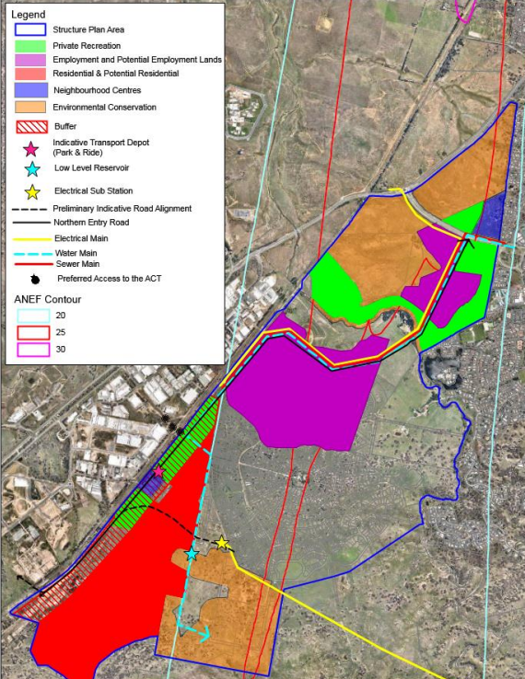
The site
Figure 37: Master Plan (Source: Map 1 of SJDCP)
It will support a diverse range of business, office and light industrial uses in a high quality built form and landscaped setting showcased through best practice site planning and urban design provisions with staff and customers in mind. Development should limit any impacts on surrounding neighbourhoods and buildings are to be designed to respect the topography and landscape features.

Section 3.5 provides for the staging of the development, which includes the Poplars precinct in Stage 1. The proposal is generally consistent with this staging plan given the school on the site, with the proposal seeking to provide the second stage of this development.

Section 3.6 contains the Neighbourhood Structure Plans for the area (contained in Appendix 3 of the SJDCP), which provides direction for the land release by development area and sets out the broad development pattern. The proposal is consistent with this structure plan as the site is noted as being for a ‘proposed high school’ (Figure 38).

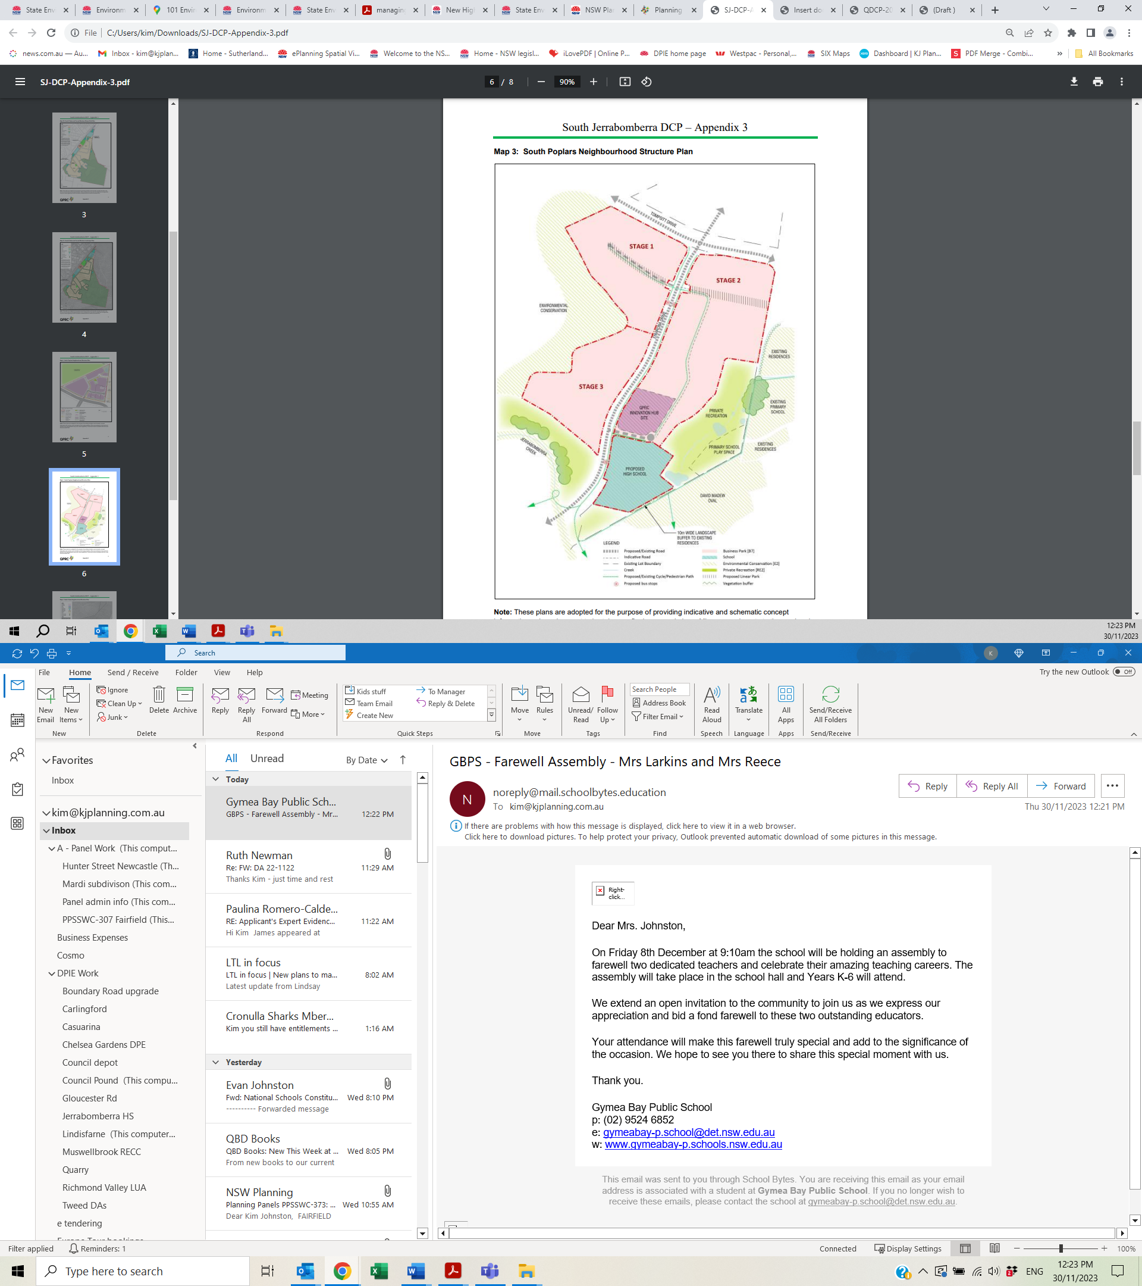
The site
Figure 38: Neighbourhood Structure Plan (Source: Map 3, Appendix 3, SJDCP)

Section 3.7 contains the neighbourhood structure plan controls, with the proposal generally consistent with these controls. Other controls in Part 3.7 include flooding, bushfire, land contamination and cultural heritage which are addressed in this report and are satisfactory. The proposal is generally consistent with the structure plan and provides a minimum of 10 metre setback to the adjoining residential development to the east and south of the site. The proposal is consistent with this desired future character and the structure plan in that it provides for community uses in the form of a school.

Part 8 – Environmental Management

This part includes controls in relation to the following matters which have been considered in this assessment:

- Soils and Salinity - These controls require that soil conservation measures are provided to minimise soil erosion and siltation during construction and following completion of development. A Sediment and Erosion Control Plan has been provided and relevant consent conditions have been recommended to ensure compliance with the plan. The QPRLEP 2022 does not include the site on the salinity mapping.

- Cut and fill – The controls limit excavation and fill on building sites to a maximum of 1.5 metres, with greater depths capable of being considered by Council, if within the building envelope, suitably retained and/or stabilised and not visible from the street. There is approximately 6.5 metres of excavation due to the existing stockpiles on the site as well as 5 metres of fill, which is considered satisfactory as outlined in the LEP assessment. Retaining walls are outlined on the Landscape Plan to be 900mm high adjoining the boundary of the car park extension. A 1:5 batter is required from Block E to the boundary given the existing slope of the land, which is satisfactory. Relevant consent conditions to be imposed.

- Water sensitive urban design (WSUD) – These controls require that development incorporates stormwater, retention and detention strategies to limit the changes to the hydrological regime (flow rate and duration) of the receiving waterways. The Stormwater plan proposes adequate arrangements for the management of stormwater on the site including detention tanks and a bioretention swale in the northeastern corner of the site. The proposal is considered to be satisfactory.

- Natural hazards – These controls require the application of measures which minimises risks to future development and users from slip, bushfire, flood and other natural hazards. this case the site is affected by bushfire prone land and flooding, which are considered in this report. The proposal is considered to be satisfactory.

- Bushfire management – This section requires that a Bushfire Threat Assessment report must form part of all development applications for lands identified as ‘bush fire prone’ in accordance with Planning for Bushfire Protection. The recommendations of the Assessment report must be incorporated into the design of the proposed development. Bushfire is further considered in this report and is satisfactory subject to the consent conditions recommended in Attachment A.

- Aboriginal heritage – An Aboriginal Cultural Heritage report prepared for Stage 1 (SSD-24461956) includes the subject site, which found there were two Aboriginal sites identified within the study area (AHIMS ID 57-2-0977 and AHIMS ID 57-2-0115). These items are not located in the area for the proposed works. This matter has been adequately addressed and relevant conditions included in Attachment A.

- Aircraft noise and operations – The controls require consideration of aircraft noise and airspace operations as outlined in the QPRLEP 2022. The proposal is satisfactory having regard to these matters as outlined in the Acoustic Report and subject to the consent conditions recommended in Attachment A.

- Tree retention, biodiversity and flora and fauna - These controls require existing significant trees to be retained with native vegetation (canopy level) to be provided by developments. There is no vegetation to be removed from the site and the Landscape Plan provides additional tree planting on the site. The site does not adjoin any biodiversity corridors or any significant vegetation which needs to be protected. The proposal is considered to be satisfactory.

- Land contamination – Consideration of land contamination is required and is considered in the Resilience & Hazards SEPP assessment. The proposal is considered to be satisfactory.

- Construction waste – Construction waste must be considered, which is outlined in the Construction Waste Management Plan. This matter is satisfactory subject to the consent conditions recommended in Attachment A.

- Landfill and earthworks – The controls require adequate justification of the need for landfill to be deposited on a site. The proposed earthworks are required to provide a level building pad for the proposed new building and the fill to be used is contained in the existing stockpiles on the site which originated from Stage 1 on the site. This matter is satisfactory subject to the consent conditions recommended in Attachment A.

- Urban and non-urban interfaces - The controls require that the potential for land use conflict is considered at the subdivision stage. While subdivision is not proposed, the proposal is satisfactory in relation to these matters in that the potential acoustic impacts arising have been considered and subject to the recommendations in the acoustic report, are satisfactory.

Part 10 – Neighbourhood Centre including Mixed Use Controls and Principles

This part includes controls in relation to the following matters which have been considered in this assessment:

- Desired future character - The proposal is generally consistent with the South poplars neighbourhood structure plan.

- Safety and security – The controls require compliance with the relevant controls of Cl 2.9 of the QDCP 2012. These matters are considered in the key issues section of the report. This matter is further considered in the key issues section of this report and is satisfactory subject to the consent conditions recommended in Attachment A.

- Site car parking – The controls require compliance with the relevant controls of Cl 2.2 of the QDCP 2012. These matters are considered in the key issues section of the report. This matter is further considered in the key issues section of this report and is satisfactory subject to the consent conditions recommended in Attachment A.

- Pedestrian access and mobility – These controls require the provision of access for people with disabilities. The design of the building is satisfactory in terms of access points and which is discussed in the key issues section of this report. Relevant consent conditions are recommended to ensure this is provided in Attachment A.

- Additional Objectives and Controls for Poplars Neighbourhood Centre – there are a number of controls in relation to the built form, public domain, access and mobility, landscaping and edge treatment and safety and surveillance. These matters are generally addressed at the subdivision stage and are therefore not directly relevant to the current proposal. Where relevant, these matters are further considered in the key issues section of this report.

Part 11 – Business Parks and Employment Land Controls and Principles

This section provides controls in relation to business park desired future character, site coverage and setbacks, car parking, building design safety and security, landscaping and vehicle access and loading. There is no development proposed in the B7 zoned portion of the site and therefore these controls are not directly relevant to the proposal. The matters outlined in this section are addressed in the key issues section of this report where relevant to the current proposal.

Queanbeyan Development Control Plan 2012

Pursuant to Clause 1.7 of the SJDCP, Sections 2.1 to 2.9 of Part 2 of the Queanbeyan Development Control Plan 2012 (QDCP) are adopted by the SJDCP. These matters include the following:

- Car Parking (Cl 2.2) – There are no car parking provisions specified in the DCP or the Transport & Infrastructure SEPP. Traffic and car parking are considered in the key issues section of the report and are considered to be satisfactory.

- Environmental Management (Cl 2.3) – This clause contains a number of matters for consideration including energy efficiency and water conservation, waste and recycling and noise and vibration. These matters are further considered in the key issues section of this report and are satisfactory.

- Contaminated Land Management (Cl 2.4) – Considered in the assessment under the Resilience & Hazards SEPP and is satisfactory.

- Flood management (Cl 2.5) – Considered in the LEP assessment and is satisfactory.

- Landscaping (Cl 2.6) – A landscape Plan has been provided which is satisfactory.

- Erosion and Sediment Control (Cl 2.7) – Erosion and Sediment Control Plan has been provided. Relevant consent conditions have been recommended in Attachment A.

- Guidelines for bushfire prone areas (Cl 2.8) – Refer to RFS referral.

- Safe design (Cl 2.9) - A CPTED Report provided and considered satisfactory subject to recommended consent conditions included at Attachment A.

The proposal has satisfactorily addressed these matters subject to recommended consent conditions in Attachment A. Accordingly, the proposal is considered to be consistent with the SJDCP.

Contributions Plans

The Queanbeyan-Palerang Regional Council South Jerrabomberra Local Infrastructure Contributions Plan 2018 applies to the land pursuant to Section 7.18 of the EP&A Act. However, pursuant to Clause 1.4 of the Plan, government schools are exempt from the need to pay a contribution (Table 4, item 7). Therefore, contribution charges are not required to be included in the recommended consent conditions.

- Section 4.15(1)(a)(iiia) – Planning agreements under Section 7.4 of the EP&A Act

A planning agreement was entered into on 5 June 2020 and amended on 8 December 2020 between the Village Building Company (VBC), Poplars Developments Pty Ltd (Poplars) and the Council titled the Jerrabomberra Innovation Precinct Infrastructure Planning Agreement (Innovation Precinct Planning Agreement) (Figure 39).

The Innovation Precinct Planning Agreement applies to development of the South Jerrabomberra Land for residential purposes and the West Jerrabomberra Land for retail, business, light industrial, educational and recreational purposes. The Agreement requires the dedication of land by VBC and Poplars for the purposes of the Northern Entry Road from Tompsitt Drive to Jerrabomberra Creek, the Innovation Hub, the Regional Sports Complex and the Rail Intermodal Site. A monetary contribution of $5.136,902 is also required from VBC for the regional sporting complex (No 4 on the Location Plan).

The agreement also requires that Council carry out the construction of the Northern Entry Road including shared paths, intersections and services, and intersection works to access the Regional Sports Complex. The construction of trunk water, sewer and reticulated water infrastructure to service West Jerrabomberra, the Regional Sports Complex and adjacent land zoned for light industrial purposes using a combination of specified Council funds and State government grant funds by Council is also required. The proposed school site proposed to be dedicated by VBC to the Minister for Planning under a separate planning agreement, however, there were no details available.

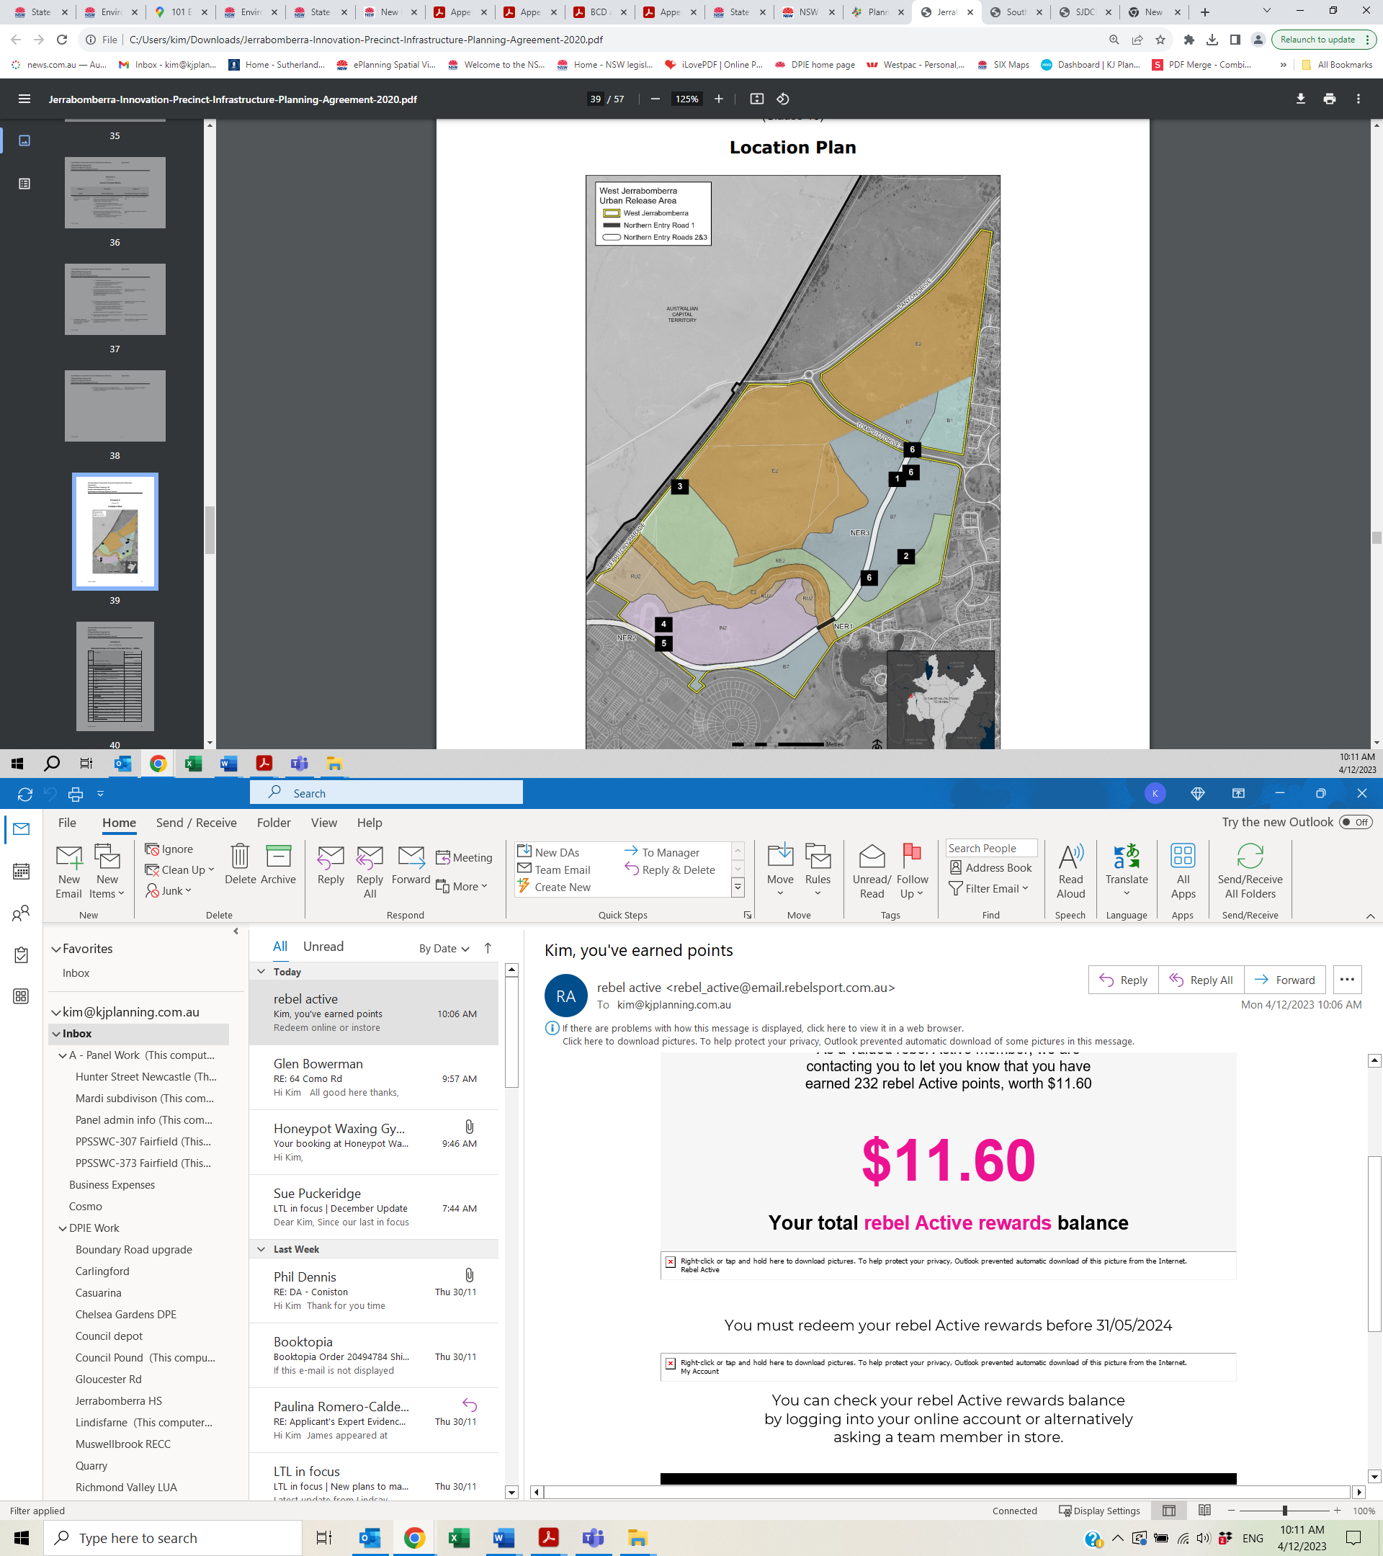
The site
Figure 39: Location Plan – Innovation Precinct Planning Agreement (Source: Schedule 5, Planning Agreement)
- Section 4.15(1)(a)(iv) - Provisions of Regulations

The following matters require consideration in relation to Part 4, Division 1 of the 2021 Regulations:

- Section 61(1) - In determining a development application for the demolition of a building, the consent authority must consider the Australian Standard AS 2601—2001: The Demolition of Structures – There is minor demolition proposed to the existing Block B. Relevant conditions are contained in the recommended consent conditions in Attachment A.

- Section 62 (consideration of fire safety) – This is not relevant as a change of building use is not proposed;

- Section 64 (consent authority may require upgrade of buildings) – This section applies to the determination of a development application that involves the rebuilding or alteration of an existing building if the proposed building work and previous building work together represent more than half of the total volume of the building. This section also applies if the measures contained in the building are inadequate to protect persons using the building, if there is a fire, or to facilitate the safe egress of persons using the building from the building, if there is a fire, or to restrict the spread of fire from the building to other buildings nearby.

There are minor internal alterations of an existing building on the site (Block B) proposed, however, such works do not represent more than half of the total volume of the building. In relation to fire safety, Council’s Building Surveyor raises no objections to the proposal subject to conditions, which have been included in the recommended consent conditions.

Accordingly, the provisions of the 2021 EP&A Regulation have been adequately considered.

Section 4.15(1)(b) - Likely Impacts of Development

The likely impacts of that development, including environmental impacts on both the natural and built environments, and social and economic impacts in the locality must be considered. In this regard, potential impacts related to the proposal have been considered in response to SEPPs, LEP and DCP controls outlined above and the Key Issues section below.

The consideration of impacts on the natural and built environments includes the following:

- Context and setting – The proposal is considered to be generally consistent with the context of the site, in that the proposed new buildings and car park areas are within an existing school and is of an appropriate scale for the site with large areas of open space and landscaping retained. The scenic qualities of the area are also retained and students and staff can traverse the site on footpaths separate from the internal road system.

The character and amenity of the locality is maintained given the large areas of open space on the site and the boundary planting comprising canopy trees to residential and street boundaries. Given the large site and adequate setbacks, the character of the surrounding development is maintained and potential impacts on adjoining properties is minimal.

- Access and traffic – The access and traffic issues are considered in the key issues section of this report. These matters are satisfactorily addressed subject to conditions.

- Public Domain – The proposal connects with existing pedestrian linkages in the area and provides additional car parking within the site.

- Utilities – All of the required utilities are available at the site, with some to be augmented as outlined in this report and where required consent conditions are recommended.

- Heritage – There are no heritage items located on the site contain or on any adjoining or nearby sites. Aboriginal cultural heritage is considered in the key issues section of this report and is adequately addressed.

- Other land resources – The site is not located within or adjacent to water catchment or mining. There are some agricultural land uses in the area, however, the proposal does not affect, or is affected by, such uses.

- Water/air/soils impacts – The potential for contaminated land is considered in the assessment under the Hazards & Resilience SEPP and the site is not affected by acid sulphate soils.

- Flora and fauna impacts – Potential ecological impacts are considered in the key issues section of this report.

- Natural environment – There are some earthworks proposed on the site, however, impacts to the natural environment have been minimised. These matters are considered in the key issues section of this report.

- Noise and vibration – An Acoustic Report has been provided which is considered in the key issues section of this report. Council’s Environmental Health Officer has reviewed the proposal and the report and considered it acceptable subject to conditions which have been included in the recommended conditions.

- Natural hazards – The site is affected by bushfire, which has been considered by the NSW RFS and a Bushfire Safety Authority has been issued. This is considered further in this report. Flooding has also been considered in the QPRLEP 2022 assessment and found to be satisfactory. Relevant conditions have been included in the recommended conditions.

- Safety, security and crime prevention – This is considered in the key issues section of this report and is considered satisfactory subject to the recommended consent conditions in Attachment A.

- Social impact – The proposal enhances the facilities at an existing school which will support current and future students in education, which is a social benefit. The proposed increase in student capacity is also considered likely to reduce the pressure on surrounding public schools. No adverse social impacts are anticipated. The proposal is considered to result in a positive social impact.

- Economic impact – The proposal will assist with employment generation in relation to teachers (approximately 34 additional staff will be required), support staff and grounds staff at the school as well as constructed related jobs, which is likely to include local tradespeople. The school would also provide additional investment in local businesses to provide goods and services to the school, particularly during the construction phase, thereby providing economic stimulation to the local economy. The proposal is considered to result in a positive economic impact.

- Site design and internal design – It is considered that the proposed new building and car parking have been set out appropriately on the site to mitigate potential impacts (subject to conditions of consent as outlined in the recommended consent conditions).

- Construction – Relevant conditions have been imposed to reduce potential construction impacts. A Construction Traffic Management Plan has been requested to ensure vehicle movements will not adversely impact on the school drop off and pick up arrangements.

- Cumulative impacts – The proposal will not result in any adverse cumulative impacts as it is generally consistent with the planning controls and is considered to be in the public interest.

Accordingly, it is considered that the proposal will not result in any significant adverse impacts in the locality as outlined above.

Section 4.15(1)(c) - Suitability of the site

The site is considered to be suitable for the development given the proposal is for additions to an existing school and the proposed new buildings have been integrated into the site. The proposed additions are considered to be compatible with the locality given they are to be constructed having regard to the topography and significant landscaping opportunities are provided throughout the site.

There are adequate services, transport infrastructure and open space in the vicinity which will assist in minimising the impact of the development in the area. The site is affected by bushfire prone land which has been considered by the NSW RFS and is considered satisfactory subject to conditions.

The site attributes are conducive to the development in that the proposal will provide additional classrooms within an existing school and additional car parking and access arrangements are provided. There are not any adjoining uses which are prohibitive of the proposal. The site’s suitability for the development is further considered in the key issues section of this report.

Section 4.15(1)(d) - Public Submissions

The community submissions are considered in Section 5 of this report.

Section 4.15(1)(e) - Public interest

The proposal is considered to generally be in the public interest as the proposal provides enhanced learning opportunities at an existing school where adequate car parking and access arrangements have been provided. The potential impacts of the proposal have been adequately mitigated as discussed in the key issues section of this report.

The proposal is also generally consistent with the applicable planning controls as outlined in this report. The proposal is also considered to result in positive social and economic impacts as outlined above and the health and safety of the public will not be affected.

The site is subject to the provisions of the South East and Tablelands Regional Plan 2036. Relevant provisions of this Strategy to the proposal include:

- Direction 21: Increase access to health and education services
- Actions 21.2 Work with the ACT Government to meet the growing and changing education needs of cross-border communities; and
- Action 21.3 Facilitate joint venture opportunities to share community and education facilities

The Regional Strategy relevantly states:

Schools near the NSW-ACT border face increased enrolments, and many schools have the capacity to use infrastructure more effectively. To achieve this, school catchment boundaries may be realigned and students directed to schools with surplus classrooms. Where appropriate, existing school assets will be renewed to provide contemporary learning spaces for students.

New schools, if required, will be established where there are no other sustainable options available within existing assets. Planning for new schools in regional NSW will consider the specific needs and characteristics of local student population trends. To improve curriculum choice, secondary schools may be combined.

Master planning for new urban release areas should optimise shared facilities for community and school uses.

The proposal involves extending an existing school to utilise existing facilities on the site and to cater for the student demand in the area. The Stage 1 of the school intends to make available some of the areas of the school for community use which is also consistent with the Strategy. Therefore, the proposal is considered to be consistent with the Regional Strategy.

The proposal is consistent with the principles of Ecologically sustainable development as outlined in the Architectural Design Report prepared by TKD Architects including the use of solar, recycling, water and energy efficient appliances and fixtures, and energy efficient classrooms though the use of passive design techniques.

Accordingly, on balance, it is considered that the proposal is consistent with the public interest.

REFERRALS AND SUBMISSIONS

Agency Referrals and Concurrence

The development application has been referred to various agencies for comment/concurrence/referral as required by the EP&A Act and outlined below in Table 6. There are no outstanding issues arising from these concurrence and referral requirements subject to the imposition of the recommended conditions of consent outlined in Attachment A.

Table 6: Referrals to External Agencies
Agency | Concurrence/  referral trigger | Comments  (Issue, resolution, conditions) | Resolved
Integrated Development (S 4.46 of the EP&A Act)
RFS | S100B - Rural Fires Act 1997  bush fire safety for development of land for special fire protection purposes. | A Bushfire Safety Authority has been provided subject to General Terms of Approval (GTA) from the NSW RFS. Relevant conditions of consent have been included in the recommended consent conditions. | Yes  (Conditions)
DPE (Water) | Section 91(2) – controlled activity approval (waterfront land) under Part 3 of Chapter 3 of the Water Management Act 2000 (WM Act).  Jerrabomberra Creek is located approximately 150m to the southwest of the site, and adjoining land to the southeast includes a small dam that forms part of a watercourse and broader wetland. Approximately 200m south of the site is Lake Jerrabomberra (artificial lake).  Waterfront Land is generally defined as the bed of any river, lake or estuary or within 40 metres of that land. | The site is within 40 metres of any waterfront land, however, Clause 41 of the Water Management (General) Regulation 2018 states:  A public authority is exempt from section 91E(1) of the Act in relation to all controlled activities that it carries out in, on or under waterfront land.  A public authority is defined in the WM Act as (among others) a Minister of the Crown, a Public Service agency, or a statutory body representing the Crown. The applicant is the NSW Department of Education, therefore the applicant is a public authority. DPE (Water) has advised that the application is exempt from this approval. | Yes
Referral/Consultation Agencies
Electricity supply authority | Section 2.48 – State Environmental Planning Policy (Transport and Infrastructure) 2021  Development near electrical infrastructure | Objections raised dated 26 October 2023 by Essential Energy as the plans do not show distance from Essential Energy’s infrastructure. These measurements were subsequently provided. | Yes
Transport for NSW | Section 2.121 & 3.58(3) – State Environmental Planning Policy (Transport and Infrastructure) 2021  Development that is deemed to be traffic generating development in Schedule 3. | Comments from TfNSW have been considered in the key issues section of this report. Relevant conditions of consent have been included in the recommended consent conditions. | Yes
Canberra Airport | Obstacle Limitation Surface (OLS) assessment | Confirmation the ground level and building do not penetrate the OLS, therefore, no further assessments or Airspace Protection Approval are required subject to the following conditions:  - Should any of the construction details change in height or location, please submit full details for reassessment.  - If a crane is required to construct the proposed deck and/or swimming pool please submit full details of the crane operation for a further OLS assessment. | Yes (Conditions)

Council Officer Referrals

The development application has been referred to various Council officers for technical review as outlined Table 7. The issues raised by Council officers are considered in the Key Issues section of this report (where relevant) and the required conditions have been included in the recommended consent conditions in Attachment A.

Table 7: Consideration of Council Referrals
Officer | Comments | Resolved
Environmental Health | No objections to the acoustic report or the Preliminary Site Investigation subject to consent conditions. | Yes
Waste | No objections stating that the Waste management plans submitted are satisfactory. No further information is required and no conditions as it is NSW Department of Education | Yes
Engineering | No objections subject to consent conditions. | Yes
Trade waste | No objections subject to consent conditions. | Yes
Building | No objections subject to consent conditions. | Yes

Community Consultation

The proposal was advertised and notified in accordance with the Council’s Community Engagement and Participation Plan (Clause 3.3) with a submission period from 9 October 2023 to 6 November 2023. The notification included notification letters sent to adjoining and adjacent properties and notification on the Council’s website. There were no submissions received.

KEY ISSUES

The following key issues are relevant to the assessment of this application having considered the relevant planning controls and the proposal in detail:

Built Form and Urban Design

The design of the proposed new buildings has been considered in the design quality principles pursuant to Section 3.36(6) of the Transport & Infrastructure SEPP and outlined in Section 4 of this report. The proposed new buildings have been designed to be a good contextual fit in the portion of the site where they are proposed and will enhance the appearance of the school.

The proposed new buildings are compatible with the contemporary buildings constructed on the site and provide the relevant facilities such as pedestrian access and car parking.

The proposed landscaping on the site also allows for the integration of the proposed new buildings into the existing school and complements the building design. A green spine connects the existing campus with the new facility and allows for intermediate seating nooks and outdoor seating. The landscaping and pathways connect all of the elements of the school together and provide a good level of access around the site for staff and students. The expansive outdoor areas and large verandah allows for outdoor learning opportunities. The proposed building forms are acceptable and appropriate for the site.

Traffic & Parking

The Transport and Accessibility Impact Assessment prepared by TTW dated 28 July 2023 (Traffic Report) addresses the traffic and transport design parameters, investigations, and outcomes of the proposal. The existing school contains a car park with 44 car spaces accessed from Lexcen Avenue, eight (8) drop-off/pick-up spaces along Lexcen Avenue and a separate bus bay along Environa Drive (Figures 40 & 41).

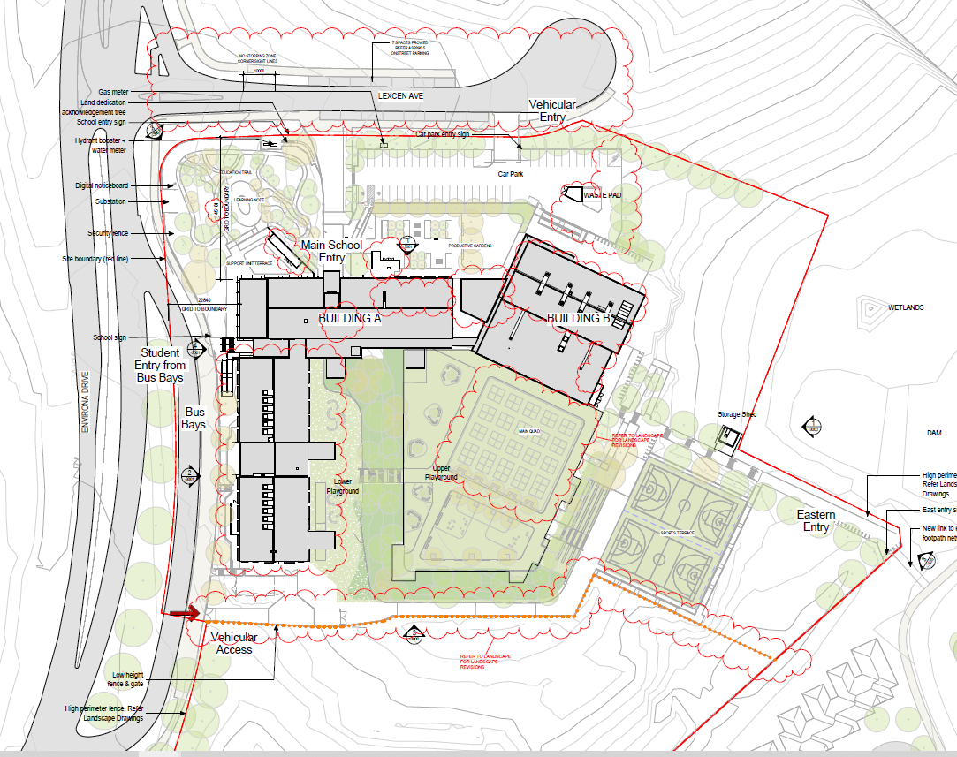
Drop-off/pick-up spaces
Car park
Bus bay
Figure 40: Approved car parking, drop off and bus bay areas (Source: SSD Approval)

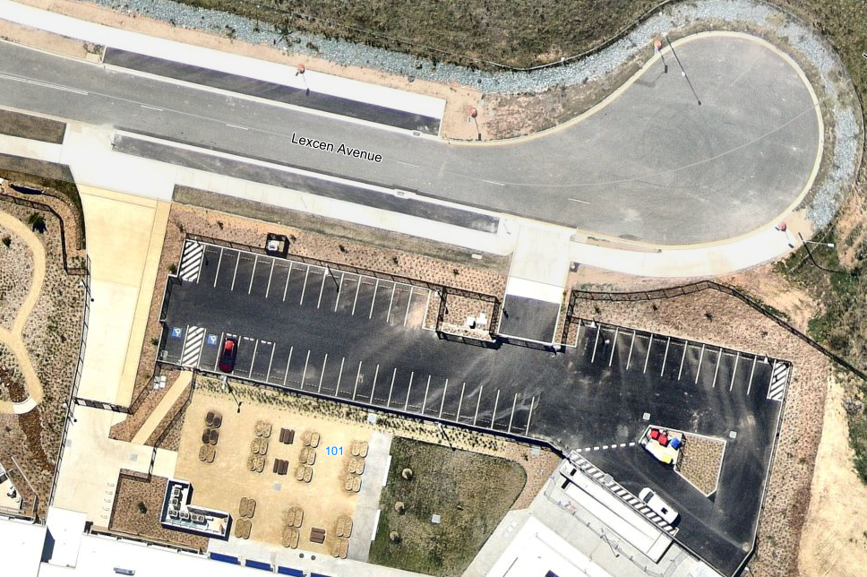
Figure 41: Existing car parking area along Lexcen Avenue (Source: Council's Engineering referral, March 2024)

The car parking and access management for the proposed school is considered below.

Pedestrian access

The proposal involves retaining pedestrian access points from Environa Drive, Lexcen Avenue, and the eastern entry connecting to Jerrabomberra Public School. The proposal also relies on additional external active transport infrastructure constructed as part of the Stage 1 works which is considered satisfactory. These arrangements are considered satisfactory for the proposed increase to the school.

Cyclists

The proposal involves the provision of 114 new bicycle/scooter storage spaces for students and staff and additional end of trip facilities. These are proposed at the eastern gate adjoining the pathway linking David Madew Park with Jerrabomberra Public School and are satisfactory.

Public Transport

There are no changes proposed to the existing arrangements for public transport on the site. Public transport usage will continue to be encouraged through the School Transport Plan and improved through ongoing consultation and governance measures. The Traffic Report concluded that the existing bus bay is sufficient for the proposed additional students and that bus bay cycling may be required to accommodate additional bus services to the school in the future.

However, while the existing school bus bay is satisfactory for southbound buses, it does not cater for northbound buses. TfNSW provided comments pursuant to Section 3.58 (traffic generating development) of the Transport & Infrastructure SEPP which raised safety concerns with buses traveling from the south of the site. These concerns were in relation to the existing Bus service 835 from Tralee and whether this service can safely drop school children off at the school without resulting in significant route variations. Such route variations come at a cost to TfNSW and are therefore undesirable, with TfNSW noting that Bus 835 would not be deviated to access the existing bus bay on the eastern side of Environa Drive.

TfNSW understands that the South Jerrabomberra Structure Plan details additional development potential to the south of the existing Tralee subdivisions which has the potential to increase the number of students catching a bus to the School from areas to the south of the school. TfNSW stated that Council needs to further consider this issue given the school is located on local roads managed by the Council.

This concern was also previously raised by TfNSW in relation to the SSD approval. In that case, the Department also identified that the central raised median with the pedestrian fence along the road also prevented buses from the south entering the school. The Applicant acknowledged this and stated that with the current road network, buses from the south would need to undertake a 2.7km detour via the Jerrabomberra Circle to access the bus bays (Figure 42).

Once the internal road network within the South Poplar precinct (north of the site and south of the Jerrabomberra Parkway/Circle) is connected to Environa Drive, buses approaching from the south could utilise the internal road network to turn around to head south on Environa Drive towards the bus zone rather than traverse the roundabout. This would reduce the distance by approximately 500m and shorten the commute as it avoids two signalised intersections on Tompsitt Drive.

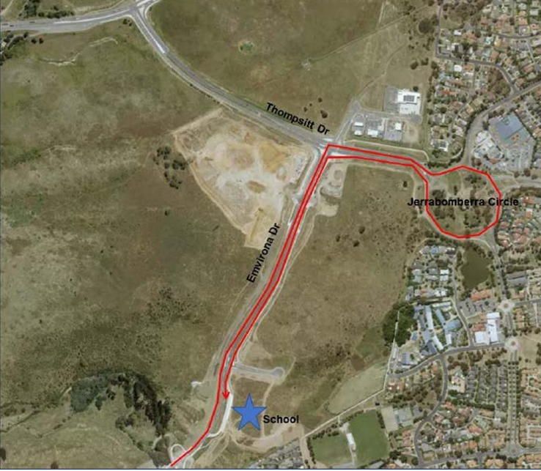
Figure 42: Potential route for buses from south to access the site (Source: Major Projects Register – Response to Submissions for SSD 2022)

TfNSW also noted that there is an indented bus bay on the northbound carriageway of Environa Drive that is capable of being used to drop off students as the demand in the Tralee catchment increases. However, the Council will need to assess, if this location is to be used, that sufficient measures are in place (provided by the developer and/or Council) to deter students from crossing the road other than at the signalized intersection located approximately 60m to the north of the indented bus bay and that sufficient infrastructure is in place at the bus bay to enable a bus to stop (e.g. required signage to enable this to be used as a bus stop during the required school times, etc).

TfNSW also noted that Lexcen Avenue, in its current arrangement, is also capable of catering for the swept path of a 12.5 metre bus, however, acknowledges that this may not be an appropriate location given the congestion that currently occurs in Lexcen Avenue with the current school operation and will get worse with increased student numbers.

The SSD approval requires that a School Transport Plan be prepared which outlines arrangements for transport access to the school, including pick up and drop off arrangements for buses. This condition will also be required for this proposal at which time the applicant is required to give further consideration to this matter. This may include the provision of a school bus service (as opposed to a public bus service) from the areas to the south of the site, which will require detailed route considerations to ensure students can access the school safely from the drop off point. Relevant consent conditions are recommended in Attachment A.

Servicing and Loading

There are no changes proposed to the servicing and loading arrangements for the site, with the existing provision for service vehicle access to the site to be retained through the existing entrance from Environa Drive. Waste collection will be via the Lexcen Avenue car park where the waste storage area is located. The staff car park on Lexcen Avenue has been designed to accommodate waste trucks up to 11 metres in length with front-loading capabilities, with a swept path analysis of this waste collection area verified in Stage 1. This car park has also been designed for a 12 seater bus to enter and leave the car park in a forward direction. Relevant consent conditions are recommended in Attachment A.

Drop Off & Pick Up (DOPU) facility

There is an existing DOPU facility in place along Lexcen Avenue which contains eight (8) spaces. The SSD approval provided only seven (7) spaces within the DOPU facility, with the eight parking space reserved as an accessible space for parents/carers of students requiring assistance. This space, however, was relocated into the approved car park in MOD 2 to the SSD approval. Therefore, there are now eight (8) spaces within the DOPU facility on Lexcen Avenue.

Parents/guardians utilising the DOPU facility are required to undertake a U-turn at the eastern end of Lexcen Avenue (cul-de-sac), use the designated DOPU facility on the southern side of the road and exit back onto Environa Drive. This DOPU facility is controlled by “No Parking” signage between the hours of 8.00am to 9.30am and 2.30pm to 4.00pm during school days to encourage vehicle turnover. Outside of these hours, the DOPU facility would be used for visitor parking.

There are no changes proposed to this DOPU facility and the use of alternative travel modes will continue to be encouraged through the School Transport Plan.

The capacity of this DOPU facility to cater for the proposed additional students was not considered in the Traffic Report, however, applying the same parameters as for Stage 1, the following observations are made:

- It was estimated that approximately 25% of students would be dropped off and picked up, which is equivalent to a total of 250 students (based on a capacity of 1000 students for Stages 1 and 2). The previous assessment assumed an occupancy rate of 1.4 students per vehicle, which results in a demand of approximately 178 vehicles.
- The school peak will occur over a 15 minute period and it would conservatively take approximately 60 seconds for a student to embark or disembark a vehicle and therefore each parking space would turn over approximately 15 times in this period.
- Given these assumptions, the eight spaces could accommodate 120 vehicles.
- There was evidence presented by a traffic expert for Stage 1 that there was additional on-street parking capacity within Lexcen Avenue for further drop-off and pick-up spaces comprising 30 spaces on the northern side of the road and a further 8 vehicles between the DOPU zone and Environa Drive. This provides 38 spaces plus the 8 spaces in the DOPU zone, totalling 46 spaces on Lexcen Avenue.
- It was further noted by Council in the assessment of Stage 1 that the operation of the DOPU facility was likely to be more of a concern in the PM peak window when parents arrive early, park and wait for students to arrive which can take significantly longer than it does to drop them off in the morning period. Therefore, the turnover of spaces was increased from 1 minute to 90 seconds, with the resulting effect being that the car spaces would turn over 10 times in a 15 minute period (instead of 15).
- The DOPU facility could accommodate 460 vehicles, which is sufficient to cater for the proposed additional students. It is further considered that the occupancy rate of 1.4 may be higher as the school progresses to a full year 7 to 12 school accounting for a larger number of siblings attending and therefore this calculation is likely to be conservative.

Therefore, it is considered that the DOPU facility is adequate for the proposed extension to the school.

Car Parking

An additional 34 car parking spaces are proposed (Figure 43) to the existing car parking area accessed from Lexcen Avenue to cater for the proposed 32 additional staff (total staff of 78 for Stages 1 and 2). Applying the approved parking rate established in Stage 1 of the project, the Traffic Report considered this to be adequate to accommodate the expected parking demand associated with the day-to-day operations of the high school.

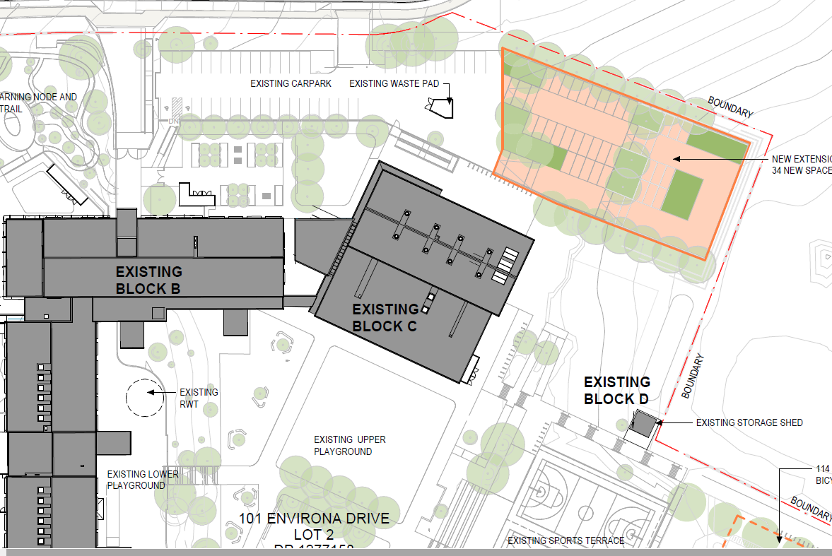
Figure 43: Proposed additional to car park (Source: TKD Architects, 26 July 2023)
This existing car parking area also includes opportunities for parents and guardians with special needs children attending the high school and minibuses associated with the NSW’s Government Assisted School Travel Plan (ASTP), to pickup/drop-off these students within the staff parking. Vehicular access into the site will be retained from Lexcen Avenue for both stages of the school.

Only staff and waste collection vehicles have access to the Lexcen Avenue car parking area, which is controlled via a boom gate with a security reader and intercom. There are also 71 car spaces available for students at David Madew Oval (under an agreement with Council), along with the additional 15 spaces along Lexcen Avenue and 16 spaces along Environa Drive, which the Traffic Report considers is adequate and suitable to meet the demand for parking.

The Traffic Report concluded that the proposed development will not create adverse or unreasonable impacts in local area and made the following key findings:

- Analysis of the school catchment indicates that 75% of students are anticipated to live within a 2.9km radius of the school, indicating that active and sustainable transport modes are likely to form the majority of student travel to the site.
- The proposed additional allocation of 34 on-site parking spaces is considered adequate for the additional car parking demands of the proposal.
- There are no proposed modifications to the operation, service, or arrangements related to public transportation, including loading, pick-up, and drop-off procedures.

Council’s Engineer reviewed the proposal, stating that an information report was prepared and submitted to the Local Development Committee (LDC) meeting on Tuesday 5 December 2023 for any feedback and/or recommendations that may be considered for inclusion in the final assessment. This Report to the LDC, however, was deferred on numerous occasions and has been further deferred until the 2 April 2024 meeting.

It is considered that the existing and proposed car parking and vehicle access arrangements for the proposal are satisfactory and relevant consent conditions are recommended to be imposed in Attachment A.

Acoustic

The site is located in close proximity to Canberra airport and proposes a school within a mixed use area including residential development and therefore potential acoustic impacts are required to be thoroughly considered. The Environmental Noise and Vibration Assessment prepared by Acoustic Logic dated 1 August 2023 (Acoustic Report) considers the proposal in relation to aircraft noise, road noise and operational noise for surrounding land uses.

The relevant SDCP controls for noise and vibration state in Clause 2.3.6 of Part 2 of the QDCP 2012:

- Development should be designed to minimise the potential for offensive noise.
- Noise buffering should not be provided by high fences, garages or blank walls to public streets. Where screening by these or similar methods is the only practical solution, the screen should be no greater than 50% of the street frontage. Such screening should have visual interest and retain some surveillance from the building behind the screen’s entries, windows or balconies when practical.
- Where proposed noise sensitive development may be affected by existing noise generators the development should be designed to incorporate adequate shielding from those noise sources.
- Entertainment venues, hotels, clubs, cinemas and the like, either licensed or unlicensed, should prepare a plan of management including provisions to: i) Ensure patrons enter and leave the premises in a quiet and orderly manner whenever the premises are open to the public. ii) Manage noise levels within the premises to prevent an unreasonable effect on the amenity of the locality.
- Commercial and retail developments, or mixed use developments, should have suitably located and designed goods delivery and garbage collection areas, vehicle entry and exits and other noise sources so that amenity of residents both within the development and in nearby buildings is reasonably protected.
- To ensure development is designed so noise and vibration from new businesses, light industrial and leisure/cultural/entertainment venues and other noise generating activities do not unacceptably affect the amenity of nearby residential and other noise or vibration sensitive uses.
- Home based businesses should not generate unreasonable levels of noise beyond their property boundary.

Council’s Health officer has considered the acoustic Report and considered it satisfactorily addresses the potential impacts arising from the proposal subject to recommended conditions, which have been included in Attachment A.

Earthworks

The civil plans for the proposal illustrate there is a total cut of 18,575m³ and fill of 14,475m³ with a balance of 4,100m³ to be removed from the site (Figure 44). Generally, the earthworks seek to provide a level pad for proposed Block E and the adjoining play space at approximately FFL 599.5 by utilising the material within the existing stockpiles in the southern portion of the site (the red and orange area below). This largely consists of spreading out the material to provide a level area.
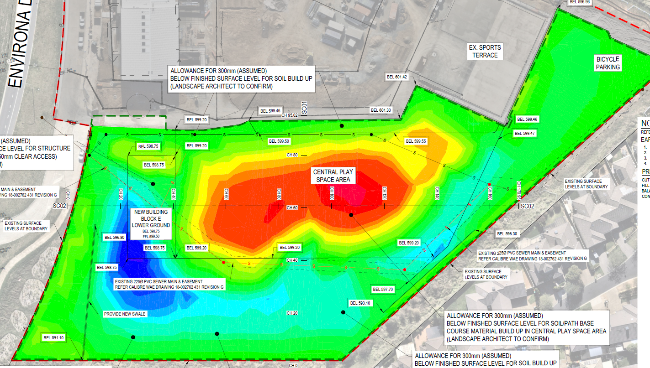
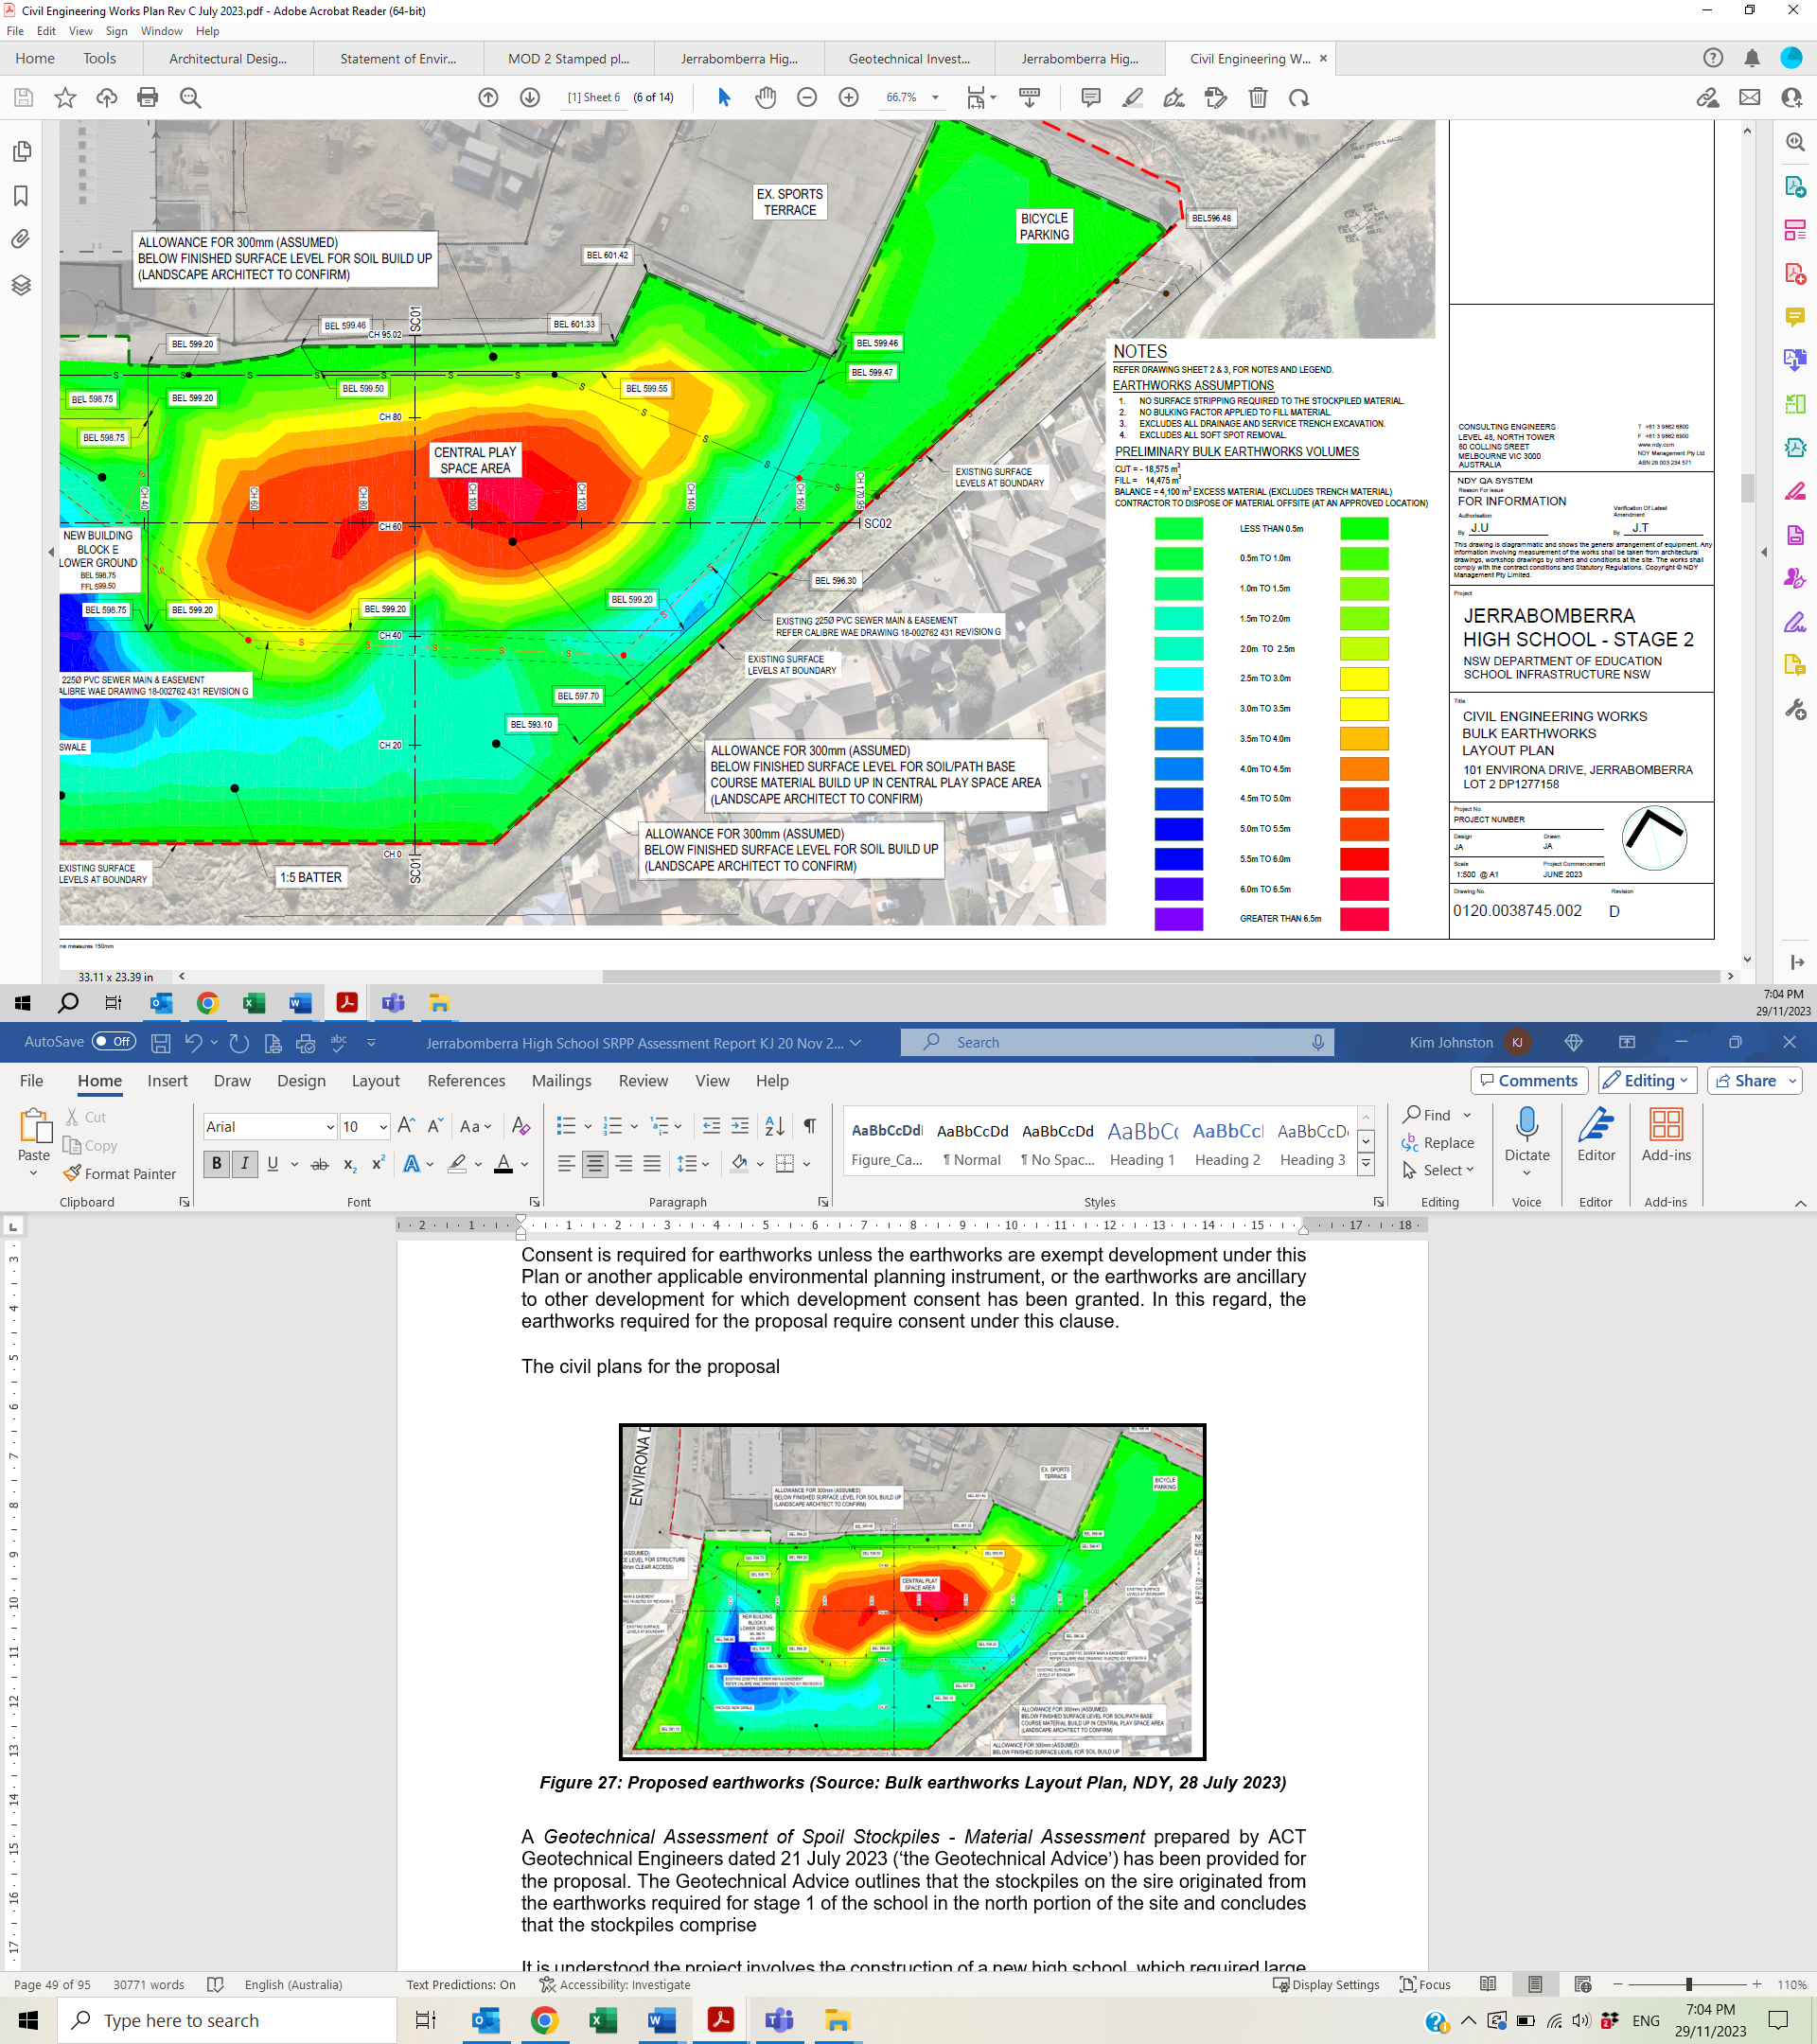
Figure 44: Proposed earthworks (Source: Bulk earthworks Layout Plan, NDY, 28 July 2023)

A report on the contents of the stockpiles on the site has been provided, the Geotechnical Assessment of Spoil Stockpiles - Material Assessment prepared by ACT Geotechnical Engineers dated 21 July 2023 (Geotechnical Advice). The Geotechnical Advice outlines that the stockpiles on the site originated from the excavations in approved Stage 1 of the school in the northern portion of the site and concludes that the stockpiles comprise ‘clean’ fill with no chemical or hydrocarbon odours and no other waste products evident in the material.

The Geotechnical Advice concluded the following in relation to the stockpiles (Figure 45):

- Stockpile #1 - Larger pile of natural, orange-brown, Clayey Sand, Gravelly Clayey Sand, Sandy Clay, and Gravelly Sandy Clay. The soils were a mix of natural alluvial/residual soils and broken-down, weathered rhyodacite bedrock, that had all been excavated from within the site. This material is suitable for use in controlled fill under structures and pavements.

- Stockpile #2 - Smaller pile of natural, orange-brown, Clayey Sand, Gravelly Clayey Sand, Sandy Clay, and Gravelly Sandy Clay. The soils were a mix of natural alluvial/residual soils and broken-down, weathered rhyodacite bedrock, that had all been excavated from within the site. This material is suitable for use in controlled fill under structures and pavements.

- Stockpile #3 - Natural, grey-brown, Silty Sand. The soils were a mix of topsoil/slope wash soils, that had all been excavated from within the site. This material is not suitable for use in controlled fill under structures and pavements, however, it will be re-used on site for landscaping works.

Clause 7.1 of the QPRLEP 2022 provides objectives and controls in relation to earthworks which is relevant to the proposal. The objective of this clause is to ensure that earthworks for which development consent is required will not have a detrimental impact on environmental functions and processes, neighbouring uses, cultural or heritage items or features of the surrounding land. A further objective is to allow earthworks of a minor nature without requiring separate development consent.

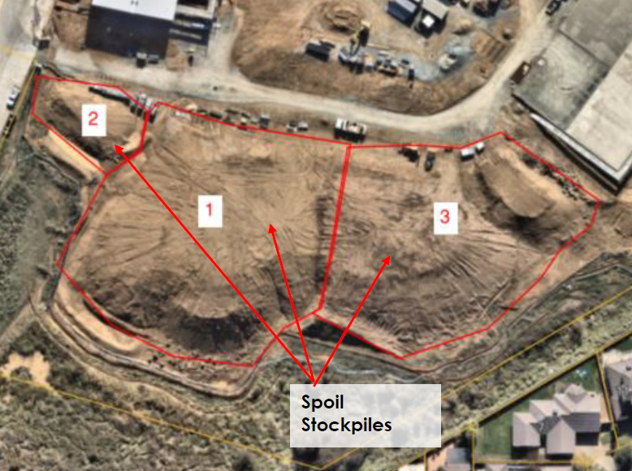
Figure 45: Stockpiles (Source: Geotechnical Advice, July 2023)

Consent is required for earthworks unless the earthworks are exempt development under this Plan or another applicable environmental planning instrument, or the earthworks are ancillary to other development for which development consent has been granted. In this regard, the earthworks required for the proposal require consent under this clause.

Pursuant to Clause 7.1(3), in deciding whether to grant development consent, the consent authority must consider the following matters—

- the likely disruption of, or any detrimental effect on, drainage patterns and soil stability in the locality of the development,
- the effect of the development on the likely future use or redevelopment of the land,
- the quality of the fill or the soil to be excavated, or both,
- the effect of the development on the existing and likely amenity of adjoining properties,
- the source of the fill material and the destination of any excavated material,
- the likelihood of disturbing relics,
- the proximity to, and potential for adverse impacts on, a waterway, drinking water catchment or environmentally sensitive area,
- appropriate measures proposed to avoid, minimise or mitigate the impacts of the development.

The proposed earthworks are considered unlikely to adversely impact on drainage patterns or soil stability in the locality of the development as the earthworks are generally seeking to create a level building area, without any significant changes to the natural ground levels on the site.

The proposed earthworks are also confined to the proposed building footprint and carpark areas and the proposed stormwater management arrangements are satisfactory. Similarly, the proposal is unlikely to adversely impact on the future use or redevelopment of the land given there is limited excavation of material and the earthworks are essentially seeking to level out an area for building works.
In relation to the quality of the fill or the soil to be excavated, the Geotechnical Advice concludes that the fill material in the stockpiles originated from the site and the majority of the material will be re-used on the site which is satisfactory. Relevant conditions have been recommended requiring only clean fill material to be used on the site as well as conditions requiring classification of materials from the site.

There is likely to be minimal impacts on the amenity of the adjoining properties in that there are limited earthworks proposed near the eastern and southern boundaries as shown by the light green colour above. Furthermore, there are significant setbacks to adjoining properties from 10 metres to 36 metres. The source of the fill material is from the site, while the balance of the material not required on the site is to be disposed of at an approved location (relevant consent conditions are recommended).

The site is considered to have a low likelihood of relics being discovered, however, in the event that material is discovered, works will need to cease to allow further investigation and assessment as outlined in the recommended consent conditions. The proposed stormwater management arrangements are satisfactory in that there is unlikely to be any significant adverse impacts to nearby waterways arising from the proposed earthworks. Appropriate measures are proposed to minimise the impacts of the development including the sediment and erosion control and stormwater management arrangements for the proposal.

Consent conditions are recommended requiring further geotechnical reports at future stages of construction to ensure that the proposal is constructed in accordance with the requirements of the relevant Australian Standards and the NCC. Consent conditions are also recommended to address the management of soil, stormwater, source and quality of imported fill, management of excavated material and unexpected finds during construction.

Accordingly, it is considered that the proposed earthworks are satisfactory and the proposal is satisfactory having regard to the matters required to be considered before granting consent pursuant to Clause 7.1(3) of the QPRLEP 2022. Accordingly, consent can be granted to the proposed earthworks subject to the draft conditions recommended in Attachment A.

Waste Management

An Operational Waste Management Plan prepared by EcCell Environmental Management Pty Ltd dated 30 July 2023 (Waste Plan) has been provided which details the type and quantity of waste to be generated during operation of the development and outlines the appropriate waste storage, source separation and collection facilities on the site.

The relevant SDCP controls for waste and recycling state in Clause 2.3.5 of Part 2 of the QDCP 2012:

- Development applications for all non-residential development must be accompanied by a waste management plan that addresses:
- Best practice recycling and reuse of construction and demolition materials.
- Use of sustainable building materials that can be reused or recycled at the end of their life.
- Handling methods and location of waste storage areas such that handling and storage has no negative impact on the streetscape, building presentation or amenity of occupants and pedestrians.
- Storage areas need to be of sufficient size to store and provide access to bins capable of dealing with the types and quantities of waste for the development.
- Storage areas for commercial premises which have larger quantities of putrescible waste e.g. food premises or supermarkets need to be provided with wash down facilities connected to sewer. These storage areas need to be roofed to prevent ingress of stormwater to the sewerage system.
- Procedures for the ongoing sustainable management of green waste; garbage and recyclables including glass, metals and paper; including access, estimated volumes; required bin capacity and onsite storage requirements.

There are no waste generation rates for schools and therefore the Waste Plan considered the assessment of waste generated from similarly structured schools. The assumptions used in deriving the indicative quantities of waste (Table 8) included an occupancy rate of 5 days per week, 1000 students and there likely to be twice weekly collections.

Table 8: Waste Generation Rates from Waste Plan
Material Type | Vol. (L) per collection | Bin Size (L) | # Bins | Bin Area (sqm)
Paper Cardboard | 890 | 1100 | 1 | 1.7
Comingled | 997 | 1100 | 1 | 1.7
Soft Plastic | 961 | 1100 | 1 | 1.7
Organics | 178 | 240 | 1 | 0.43
Return & Earn | 107 | 120 | 1 | 0.27
General | 1080 | 1100 | 1 | 1.7
Total |  |  | 6 | 7.5sqm

The existing waste storage area located in the car parking area along the northern site boundary will be retained by this proposal, which will not be adversely impacted by the proposed extension to this car parking area (Figure 46).

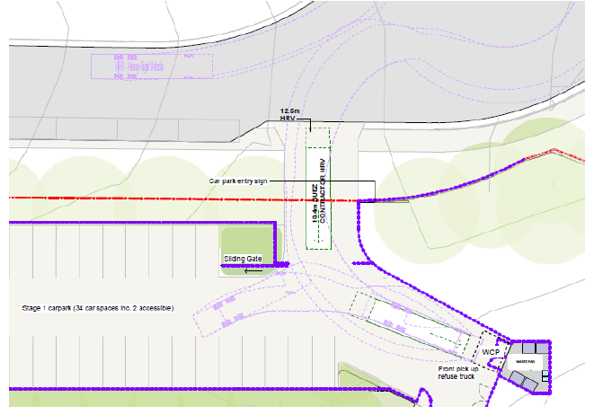
Figure 46: Proposed waste storage area and collection swept paths (Source: Waste Plan, 30 July 2023)

The general waste management arrangements for the site include:

- The use of mobile garbage bins (MGBs) for the different waste streams throughout the school and separation will be utilised at the point of generation. The MGBs will be located in the offices, canteen, classrooms and open space playground prior to collection by the cleaners.

- Small quantities of hazardous wastes may be generated (e.g. light bulbs, e-waste, batteries, oil, chemicals or paint), with separate containers for the safe storage of these wastes in the school will be provided where applicable in the waste storage area. These materials will be collected by an appropriate contractor or sub-contractor as defined in the buy NSW Contract agreement.

- Composting - currently all of the schools food organic waste will be processed offsite, through the collection of this material from a waste contractor.

- Signage - will be provided in all waste disposal, storage and collection areas demonstrating how to use the waste management system, including what materials are acceptable in each bin. All waste streams will be stored in clearly labelled; colour coded bins as appropriate to ensure that waste streams are not inadvertently mixed.

- Waste collection arrangements - the appointed waste contractors will wheel the MGBs for each waste stream from the storage area to the waste collection vehicle and then wheel the MGBs back at nominated times in accordance with the relevant waste contract. The collection point and storage area are both located in the school grounds (car park).

Waste collection vehicles will not obstruct access to adjacent premises, roadways, the footpath or the primary pedestrian entrances to the school. In addition, waste collection will be carried out with due care for public safety including other road users, cyclists and pedestrians. Waste collection should be scheduled outside of the peak school hours from 8 to 9.30am and from 2.30 to 4pm to reduce any risk from the truck and bin movements affecting the school children.

The proposal is considered to provide satisfactory waste management and collection arrangements for the site and is generally consistent with the SJDCP requirements. Council’s waste referral raises no objections to the proposal. Relevant consent conditions are recommended in Attachment A including ensuring the waste collection is not undertaken in the peak morning (8am to 9.30am) and afternoon (2.30-4pm) times at the school.

Safety, Security and Crime Prevention

Crime Prevention through Environmental Design (‘CPTED’) is a crime prevention strategy that focuses on the planning, design and structure of cities and neighbourhoods. CPTED has been considered in the design of the proposal in the Crime Prevention Through Environmental Design (CPTED) Report prepared by Mecone dated August 2023 (CPTED Report), which employs four (4) key strategies to reduce opportunities for crime. These strategies are considered below for the proposal.

- Territorial Re-enforcement – This will be achieved at the school through the use of the fencing, landscaping and design cues which distinguish between public and private domain areas. The palisade school fencing is proposed around the site as well as trees and other vegetation to clearly mark public and private (school) areas. The proposed new building has been designed to align with the existing Block A in relation to levels and design which illustrates that the area behind the buildings is school grounds. Relevant conditions are recommended to ensure the school will be well maintained so that staff and students can easily connect with this space, which contributes to ownership and safety.

- Surveillance – There is significant natural surveillance throughout the site, with the main school buildings located along the main entry point to the site and open vistas are provided throughout the site to allow for areas to be overlooked by staff and students, particularly from the open gallery access areas along the eastern elevation of proposed Block E (Figure 47). Landscaping proposed within the site is largely comprised of canopy trees which allows clear sight lines throughout the site to be maintained. Lighting and CCTV is also provided which will assist with safety and surveillance.

- Access Control - A good level of access control is provided on the site as shown in the various pedestrian pathways and signage throughout the school, which channels and encourages people and vehicles into, out of and around the development. The location of the proposed new building (Block E) as well as the existing building (Block A) assist in providing visual cues that the site has restricted entry beyond the buildings on the site. The 2.1 metre high school fencing further strengthens access control on the site.

- Space/Activity Management – The school is staffed to an appropriate degree to ensure space and activity management is supervised and landscaping is maintained to ensure surveillance throughout the site is maintained. Maintenance of buildings, lighting and CCTV is also required on a regular basis.

The CPTED Report concluded that the proposal is satisfactory subject to the recommendations outlined in Section 6 of the CPTED Report including the following matters:

- Vandalism/Graffiti management
- Maintenance of landscaping to less than 1 metre in height to maintain sightlines, particularly at the proposed car park extension.
- Security lighting
- Restricted location for the power board near Block E
- Access restrictions for pedestrian and vehicular entrances to the site and Block E
- Block E windows to Environa Drive are not to be frosted glass.
- Requirement for installation of CCTV

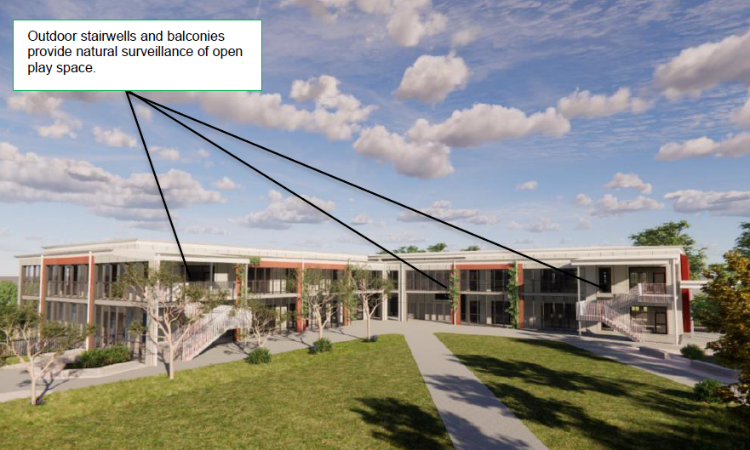
Figure 47: Natural surveillance through the site (Source: Figure 14 of the CPTED Report)
The proposal is considered to be satisfactory having regard to the CPTED principles subject to the recommendations outlined in Section of the CPTED Report which are included in the recommended consent conditions in Attachment A.

CONCLUSION

This development application has been considered in accordance with the requirements of the EP&A Act and the Regulations as outlined in this report. Following a thorough assessment of the relevant planning controls, issues raised in Agency submissions and the key issues identified in this report, it is considered that the application can be supported subject to the recommended conditions.

The key issues of building height, built form and urban design, traffic and car parking, acoustic issues, earthworks, waste management and safety, security and crime prevention matters have been considered in detail and found to be satisfactory, subject to the recommended consent conditions. The recommended consent conditions are consistent with the SSD approval, with the only modification required to the SSD approval being in relation to the approved plans for Building B (draft condition 13). The applicant agrees to the draft consent conditions pursuant to Section 4.33(1)(b) of the EP&A Act.

It is considered that the key issues as outlined in Section 6 have been resolved satisfactorily through the recommended draft conditions at Attachment A.

RECOMMENDATION

That:

- The Clause 4.6 request be supported to allow the height exceedance above the maximum height of 8.5 metres; and

- Development Application DA.2023.0420 for alterations and additions to Jerrabomberra High School comprising the construction of a new school building (Block E), an extension to the existing car park (34 additional car spaces and 114 bicycle spaces), outdoor play space, internal alterations to existing Block B and associated infrastructure and landscape works at 101 Environa Drive South Jerrabomberra be APPROVED pursuant to Section 4.16(1)(a) and 4.33 of the Environmental Planning and Assessment Act 1979 subject to the conditions of consent attached to this report at Attachment A.

The following attachments are provided:

- Attachment A: Draft Conditions of consent.

